**SSN COLLEGE OF ENGINEERING**

**DEPARTMENT OF CSE**

**VII SEMESTER – CSE 'A' & ‘B’ SECTION**

**UCS1711- MOBILE APPLICATION DEVELOPMENT LAB**

**ACADEMIC YEAR: 2023-2024 (ODD) BATCH: 2020-2024**

**Due Date: 22.8.23 & 24.8.23**

**Ex. No. 1 Application using GUI components, Font, Colors, Layout Managers and Event Listeners**

**Objective :**

To create an Android mobile application to generate a Health Insurance registration form to register the patient details under each group.

**Android widgets used :**

1. TextView - to display the title and all the labels
2. EditText- to add inputs
3. Textarea - to input address
4. DatePicker - to input date of birth
5. RadioButton - to select gender
6. Checkbox - for some data like mobile/telepj=hone etc.
7. Buttons - to submit and clear form

**Source Code :**

XML File:

Form layout:

<?xml version="1.0" encoding="utf-8"?>

<ScrollView

xmlns:android="http://schemas.android.com/apk/res/android"

android:layout_width="match_parent"

android:layout_height="match_parent"

android:scrollbars="vertical"

android:scrollbarSize="6dp">

<LinearLayout

android:layout_width="match_parent"

android:layout_height="wrap_content"

android:orientation="vertical"

android:padding="16dp">

<!-- Title -->

<TextView

android:layout_width="wrap_content"

android:layout_height="wrap_content"

android:text="NNK Health Insurance"

android:textSize="20sp"

android:layout_gravity="center"

android:textStyle="bold"

android:typeface="sans" />

<TextView

android:layout_width="wrap_content"

android:layout_height="wrap_content"

android:text="Patient Details"

android:textSize="18sp"

android:textStyle="bold" />

<LinearLayout

android:layout_width="match_parent"

android:layout_height="wrap_content"

android:orientation="vertical">

<TextView

android:layout_width="wrap_content"

android:layout_height="wrap_content"

android:text="Patient Name" />

<EditText

android:id="@+id/editName"

android:layout_width="match_parent"

android:layout_height="wrap_content"

android:hint="Enter Name"

android:fontFamily="sans-serif-medium"

android:textColor="@color/black" />

</LinearLayout>

<LinearLayout

android:layout_width="match_parent"

android:layout_height="wrap_content"

android:orientation="vertical">

<TextView

android:layout_width="wrap_content"

android:layout_height="wrap_content"

android:text="Phone Number" />

<EditText

android:id="@+id/editPhone"

android:layout_width="match_parent"

android:layout_height="wrap_content"

android:hint="Enter Phone Number"

android:inputType="phone" />

</LinearLayout>

<LinearLayout

android:layout_width="match_parent"

android:layout_height="wrap_content"

android:orientation="vertical">

<TextView

android:layout_width="wrap_content"

android:layout_height="wrap_content"

android:text="Address" />

<EditText

android:id="@+id/editAddress"

android:layout_width="match_parent"

android:layout_height="wrap_content"

android:hint="Enter Address" />

</LinearLayout>

<LinearLayout

android:layout_width="match_parent"

android:layout_height="wrap_content"

android:orientation="vertical">

<TextView

android:layout_width="wrap_content"

android:layout_height="wrap_content"

android:text="Age" />

<EditText

android:id="@+id/editAge"

android:layout_width="match_parent"

android:layout_height="wrap_content"

android:hint="Enter Age"

android:inputType="number" />

</LinearLayout>

<LinearLayout

android:layout_width="match_parent"

android:layout_height="wrap_content"

android:orientation="vertical"

android:gravity="center">

<TextView

android:layout_width="wrap_content"

android:layout_height="wrap_content"

android:text="Date of Birth" />

<DatePicker

android:id="@+id/datePicker"

android:layout_width="wrap_content"

android:layout_height="wrap_content" />

</LinearLayout>

<LinearLayout

android:layout_width="match_parent"

android:layout_height="wrap_content"

android:orientation="vertical">

<TextView

android:layout_width="wrap_content"

android:layout_height="wrap_content"

android:text="Gender" />

<RadioGroup

android:id="@+id/radioGroupGender"

android:layout_width="match_parent"

android:layout_height="wrap_content"

android:orientation="horizontal">

<RadioButton

android:id="@+id/radioMale"

android:layout_width="wrap_content"

android:layout_height="wrap_content"

android:text="Male" />

<RadioButton

android:id="@+id/radioFemale"

android:layout_width="wrap_content"

android:layout_height="wrap_content"

android:text="Female" />

<RadioButton

android:id="@+id/radioOther"

android:layout_width="wrap_content"

android:layout_height="wrap_content"

android:text="Other" />

</RadioGroup>

</LinearLayout>

<!-- Marital Status -->

<LinearLayout

android:layout_width="match_parent"

android:layout_height="wrap_content"

android:orientation="vertical">

<TextView

android:layout_width="wrap_content"

android:layout_height="wrap_content"

android:text="Marital Status" />

<Spinner

android:id="@+id/spinnerMaritalStatus"

android:layout_width="match_parent"

android:layout_height="wrap_content" />

</LinearLayout>

<!-- Employment Status Checkboxes -->

<TextView

android:layout_width="wrap_content"

android:layout_height="wrap_content"

android:text="Employer Details"

android:textSize="18sp"

android:textStyle="bold" />

<LinearLayout

android:layout_width="match_parent"

android:layout_height="wrap_content"

android:orientation="vertical">

<TextView

android:layout_width="wrap_content"

android:layout_height="wrap_content"

android:text="Patient Employer" />

<EditText

android:id="@+id/editEmployer"

android:layout_width="match_parent"

android:layout_height="wrap_content"

android:hint="Enter Employer" />

</LinearLayout>

<TextView

android:layout_width="wrap_content"

android:layout_height="wrap_content"

android:text="Employment Status"

android:textSize="18sp"

android:textStyle="bold" />

<CheckBox

android:id="@+id/checkFullTime"

android:layout_width="wrap_content"

android:layout_height="wrap_content"

android:text="Full Time" />

<CheckBox

android:id="@+id/checkPartTime"

android:layout_width="wrap_content"

android:layout_height="wrap_content"

android:text="Part Time" />

<!-- Family Member Emergency Contact Details -->

<TextView

android:layout_width="wrap_content"

android:layout_height="wrap_content"

android:text="Emergency Contact Details"

android:textSize="18sp"

android:textStyle="bold" />

<LinearLayout

android:layout_width="match_parent"

android:layout_height="wrap_content"

android:orientation="vertical">

<TextView

android:layout_width="wrap_content"

android:layout_height="wrap_content"

android:text="Name of Family Member" />

<EditText

android:id="@+id/editEmergencyName"

android:layout_width="match_parent"

android:layout_height="wrap_content"

android:hint="Enter Name" />

</LinearLayout>

<LinearLayout

android:layout_width="match_parent"

android:layout_height="wrap_content"

android:orientation="vertical">

<TextView

android:layout_width="wrap_content"

android:layout_height="wrap_content"

android:text="Relationship" />

<EditText

android:id="@+id/editEmergencyRelationship"

android:layout_width="match_parent"

android:layout_height="wrap_content"

android:hint="Enter Relationship" />

</LinearLayout>

<LinearLayout

android:layout_width="match_parent"

android:layout_height="wrap_content"

android:orientation="vertical">

<TextView

android:layout_width="wrap_content"

android:layout_height="wrap_content"

android:text="Address" />

<EditText

android:id="@+id/editEmergencyAddress"

android:layout_width="match_parent"

android:layout_height="wrap_content"

android:hint="Enter Address" />

</LinearLayout>

<LinearLayout

android:layout_width="match_parent"

android:layout_height="wrap_content"

android:orientation="vertical">

<TextView

android:layout_width="wrap_content"

android:layout_height="wrap_content"

android:text="Phone Number" />

<EditText

android:id="@+id/editEmergencyPhone"

android:layout_width="match_parent"

android:layout_height="wrap_content"

android:hint="Enter Phone Number"

android:inputType="phone" />

</LinearLayout>

<!-- ... (remaining layout code) ... -->

<!-- Employment Status Checkboxes -->

<!-- Family Member Emergency Contact Details -->

<!-- Submit and Reset Buttons -->

<LinearLayout

android:layout_width="match_parent"

android:layout_height="wrap_content"

android:gravity="center"

android:orientation="horizontal"

android:paddingTop="16dp">

<Button

android:id="@+id/submitButton"

android:layout_width="wrap_content"

android:layout_height="wrap_content"

android:text="Submit" />

<Button

android:id="@+id/resetButton"

android:layout_width="wrap_content"

android:layout_height="wrap_content"

android:text="Reset"

android:layout_marginStart="16dp" />

</LinearLayout>

</LinearLayout>

</ScrollView>

Display Layout:

<?xml version="1.0" encoding="utf-8"?>

<LinearLayout

xmlns:android="http://schemas.android.com/apk/res/android"

android:layout_width="match_parent"

android:layout_height="wrap_content"

android:orientation="vertical"

android:padding="16dp">

<TextView

android:id="@+id/nameTextView"

android:layout_width="wrap_content"

android:layout_height="wrap_content"

android:text="Name:" />

<TextView

android:id="@+id/phoneTextView"

android:layout_width="wrap_content"

android:layout_height="wrap_content"

android:layout_below="@id/nameTextView"

android:text="Phone:" />

<TextView

android:id="@+id/addressTextView"

android:layout_width="wrap_content"

android:layout_height="wrap_content"

android:layout_below="@id/phoneTextView"

android:text="Address:" />

<TextView

android:id="@+id/maritalStatusTextView"

android:layout_width="wrap_content"

android:layout_height="wrap_content"

android:layout_below="@id/addressTextView"

android:text="Marital Status:" />

<TextView

android:id="@+id/ageTextView"

android:layout_width="wrap_content"

android:layout_height="wrap_content"

android:layout_below="@id/maritalStatusTextView"

android:text="Age:" />

<TextView

android:id="@+id/dobTextView"

android:layout_width="wrap_content"

android:layout_height="wrap_content"

android:layout_below="@id/ageTextView"

android:text="Date of Birth:" />

<TextView

android:id="@+id/genderTextView"

android:layout_width="wrap_content"

android:layout_height="wrap_content"

android:layout_below="@id/dobTextView"

android:text="Gender:" />

<TextView

android:id="@+id/employerTextView"

android:layout_width="wrap_content"

android:layout_height="wrap_content"

android:layout_below="@id/genderTextView"

android:text="Employer:" />

<TextView

android:id="@+id/employmentStatusTextView"

android:layout_width="wrap_content"

android:layout_height="wrap_content"

android:layout_below="@id/employerTextView"

android:text="Employment Status:" />

<!-- ... (other TextViews) ... -->

<TextView

android:id="@+id/emergencyNameTextView"

android:layout_width="wrap_content"

android:layout_height="wrap_content"

android:layout_below="@id/employmentStatusTextView"

android:text="Emergency Contact Name:" />

<TextView

android:id="@+id/emergencyRelationshipTextView"

android:layout_width="wrap_content"

android:layout_height="wrap_content"

android:layout_below="@id/emergencyNameTextView"

android:text="Emergency Contact Relationship:" />

<TextView

android:id="@+id/emergencyAddressTextView"

android:layout_width="wrap_content"

android:layout_height="wrap_content"

android:layout_below="@id/emergencyRelationshipTextView"

android:text="Emergency Contact Address:" />

<TextView

android:id="@+id/emergencyPhoneTextView"

android:layout_width="wrap_content"

android:layout_height="wrap_content"

android:layout_below="@id/emergencyAddressTextView"

android:text="Emergency Contact Phone:" />

<Button

android:id="@+id/backButton"

android:layout_width="wrap_content"

android:layout_height="wrap_content"

android:layout_gravity="center_horizontal"

android:layout_marginTop="16dp"

android:layout_marginBottom="16dp"

android:text="Back" />

<!-- ... (remaining layout code) ... -->

</LinearLayout>

Java File:

package com.example.myapplication;

import android.content.Intent;

import android.os.Bundle;

import android.view.View;

import android.widget.ArrayAdapter;

import android.widget.Button;

import android.widget.CheckBox;

import android.widget.EditText;

import android.widget.RadioButton;

import android.widget.RadioGroup;

import android.widget.Spinner;

import androidx.appcompat.app.AppCompatActivity;

public class MainActivity extends AppCompatActivity {

private EditText editName, editPhone, editAddress, editAge, editEmergencyName,

editEmergencyRelationship, editEmergencyAddress, editEmergencyPhone, editEmployer,editText;

private Spinner spinnerMaritalStatus;

private RadioGroup radioGroupGender;

private RadioButton radioMale, radioFemale, radioOther;

private CheckBox checkFullTime, checkPartTime;

private Button btn;

@Override

protected void onCreate(Bundle savedInstanceState) {

super.onCreate(savedInstanceState);

setContentView(R.layout.activity_main);

editName = findViewById(R.id.editName);

editPhone = findViewById(R.id.editPhone);

editAddress = findViewById(R.id.editAddress);

editAge = findViewById(R.id.editAge);

editEmergencyName = findViewById(R.id.editEmergencyName);

editEmergencyRelationship = findViewById(R.id.editEmergencyRelationship);

editEmergencyAddress = findViewById(R.id.editEmergencyAddress);

editEmergencyPhone = findViewById(R.id.editEmergencyPhone);

editEmployer = findViewById(R.id.editEmployer);

spinnerMaritalStatus = findViewById(R.id.spinnerMaritalStatus);

radioGroupGender = findViewById(R.id.radioGroupGender);

radioMale = findViewById(R.id.radioMale);

radioFemale = findViewById(R.id.radioFemale);

radioOther = findViewById(R.id.radioOther);

checkFullTime = findViewById(R.id.checkFullTime);

checkPartTime = findViewById(R.id.checkPartTime);

ArrayAdapter<CharSequence> maritalStatusAdapter = ArrayAdapter.createFromResource(

this, R.array.marital_status_array, android.R.layout.simple_spinner_item);

maritalStatusAdapter.setDropDownViewResource(android.R.layout.simple_spinner_dropdown_item);

spinnerMaritalStatus.setAdapter(maritalStatusAdapter);

// ... (initialize other views)

Button submitButton = findViewById(R.id.submitButton);

Button resetButton = findViewById(R.id.resetButton);

submitButton.setOnClickListener(new View.OnClickListener() {

@Override

public void onClick(View v) {

// Get values from views

String name = editName.getText().toString();

String phone = editPhone.getText().toString();

String address = editAddress.getText().toString();

String age = editAge.getText().toString();

String maritalStatus = spinnerMaritalStatus.getSelectedItem().toString();

String employer = editEmployer.getText().toString();

String emergencyName = editEmergencyName.getText().toString();

String emergencyRelationship = editEmergencyRelationship.getText().toString();

String emergencyAddress = editEmergencyAddress.getText().toString();

String emergencyPhone = editEmergencyPhone.getText().toString();

// Get values from other views

// ...

// Create an Intent to start the DisplayDetailsActivity

Intent intent = new Intent(MainActivity.this, DisplayDetails.class);

intent.putExtra("name", name);

intent.putExtra("phone", phone);

intent.putExtra("address", address);

intent.putExtra("age", age);

intent.putExtra("maritalStatus", maritalStatus);

intent.putExtra("employer", employer);

intent.putExtra("emergencyName", emergencyName);

intent.putExtra("emergencyRelationship", emergencyRelationship);

intent.putExtra("emergencyAddress", emergencyAddress);

intent.putExtra("emergencyPhone", emergencyPhone);

// Put other values in the intent

startActivity(intent);

}

});

resetButton.setOnClickListener(new View.OnClickListener() {

@Override

public void onClick(View v) {

// Clear form fields

editName.getText().clear();

editPhone.getText().clear();

editAddress.getText().clear();

editAge.getText().clear();

editEmergencyName.getText().clear();

editEmergencyRelationship.getText().clear();

editEmergencyAddress.getText().clear();

editEmergencyPhone.getText().clear();

editEmployer.getText().clear();

// Clear radio buttons, checkboxes, and other fields

radioGroupGender.clearCheck();

checkFullTime.setChecked(false);

checkPartTime.setChecked(false);

}

});

}

Display Details:

package com.example.myapplication;

import android.content.Intent;

import android.os.Bundle;

import android.widget.Button;

import android.widget.TextView;

import android.view.View;

import androidx.appcompat.app.AppCompatActivity;

import com.example.myapplication.R;

public class DisplayDetails extends AppCompatActivity {

@Override

protected void onCreate(Bundle savedInstanceState) {

super.onCreate(savedInstanceState);

setContentView(R.layout.activity_display_details);

// Initialize TextViews to display details

TextView nameTextView = findViewById(R.id.nameTextView);

TextView phoneTextView = findViewById(R.id.phoneTextView);

TextView addressTextView = findViewById(R.id.addressTextView);

TextView maritalStatusTextView = findViewById(R.id.maritalStatusTextView);

TextView ageTextView = findViewById(R.id.ageTextView);

TextView dobTextView = findViewById(R.id.dobTextView);

TextView genderTextView = findViewById(R.id.genderTextView);

TextView employerTextView = findViewById(R.id.employerTextView);

TextView employmentStatusTextView = findViewById(R.id.employmentStatusTextView);

// Initialize more TextViews for other details

TextView emergencyNameTextView = findViewById(R.id.emergencyNameTextView);

TextView emergencyRelationshipTextView = findViewById(R.id.emergencyRelationshipTextView);

TextView emergencyAddressTextView = findViewById(R.id.emergencyAddressTextView);

TextView emergencyPhoneTextView = findViewById(R.id.emergencyPhoneTextView);

// Initialize more TextViews for other emergency contact details

// Get intent data

Intent intent = getIntent();

if (intent != null) {

String name = intent.getStringExtra("name");

String phone = intent.getStringExtra("phone");

String address = intent.getStringExtra("address");

String maritalStatus = intent.getStringExtra("maritalStatus");

String age = intent.getStringExtra("age");

String dob = intent.getStringExtra("dob");

String gender = intent.getStringExtra("gender");

String employer = intent.getStringExtra("employer");

String employmentStatus = intent.getStringExtra("employmentStatus");

// Get more data for other TextViews

String emergencyName = intent.getStringExtra("emergencyName");

String emergencyRelationship = intent.getStringExtra("emergencyRelationship");

String emergencyAddress = intent.getStringExtra("emergencyAddress");

String emergencyPhone = intent.getStringExtra("emergencyPhone");

// Get more data for other emergency contact TextViews

// Display data in TextViews

nameTextView.setText("Name: " + name);

phoneTextView.setText("Phone: " + phone);

addressTextView.setText("Address: " + address);

maritalStatusTextView.setText("Marital Status: " + maritalStatus);

ageTextView.setText("Age: " + age);

dobTextView.setText("Date of Birth: " + dob);

genderTextView.setText("Gender: " + gender);

employerTextView.setText("Employer: " + employer);

employmentStatusTextView.setText("Employment Status: " + employmentStatus);

// Display more data in other TextViews

emergencyNameTextView.setText("Emergency Contact Name: " + emergencyName);

emergencyRelationshipTextView.setText("Emergency Contact Relationship: " + emergencyRelationship);

emergencyAddressTextView.setText("Emergency Contact Address: " + emergencyAddress);

emergencyPhoneTextView.setText("Emergency Contact Phone: " + emergencyPhone);

// Display more emergency contact data in other TextViews

}

Button backButton = findViewById(R.id.backButton);

backButton.setOnClickListener(new View.OnClickListener() {

@Override

public void onClick(View v) {

onBackPressed(); // This will simulate pressing the hardware back button

}

});

}

}

Strings.xml

<resources>

<string name="app_name">My Application</string>

<string-array name="marital_status_array">

<item>Single</item>

<item>Married</item>

<item>Divorced</item>

<item>Widowed</item>

</string-array>

</resources>

**Output Screenshots :**

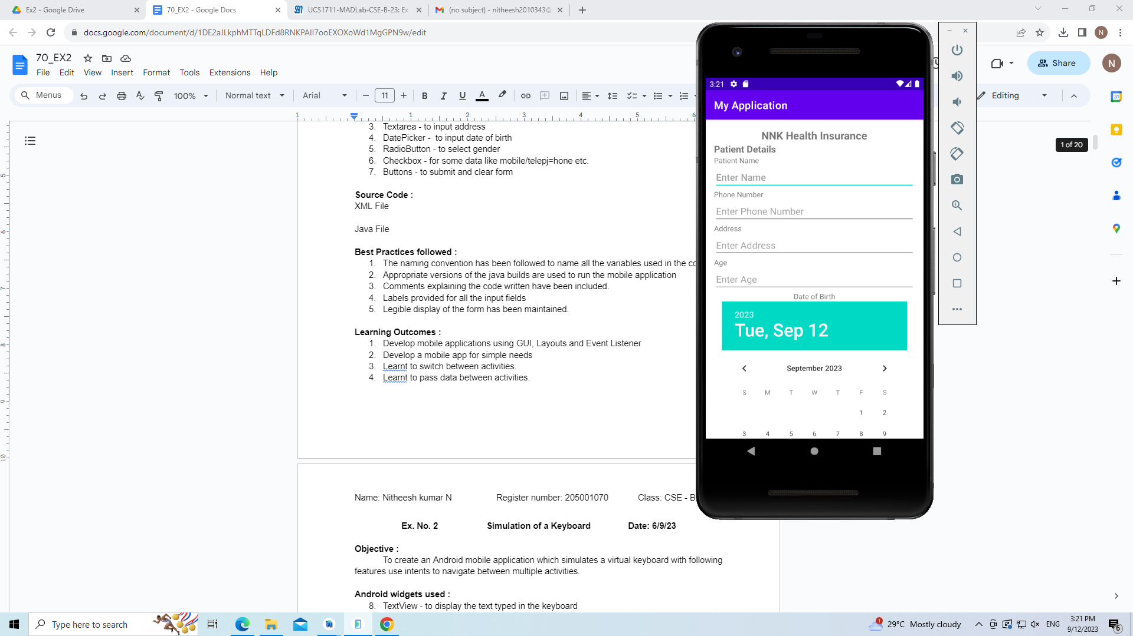 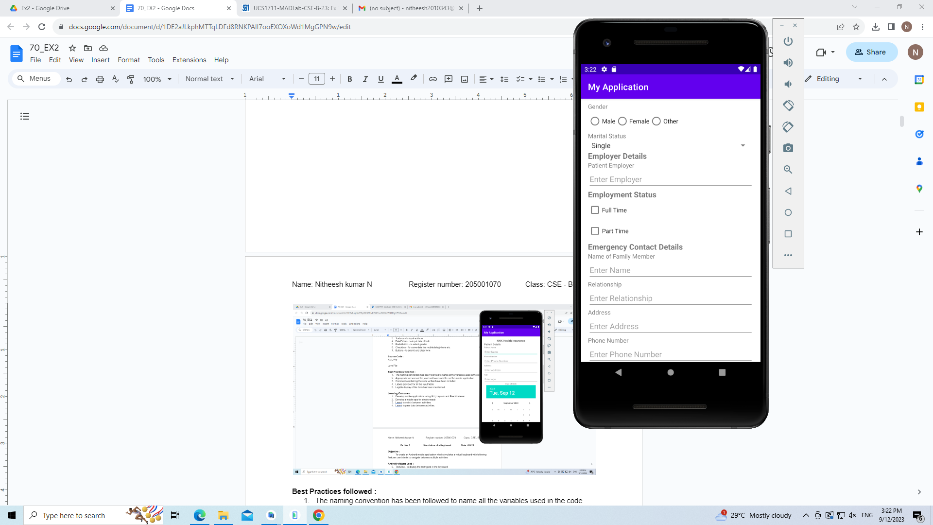

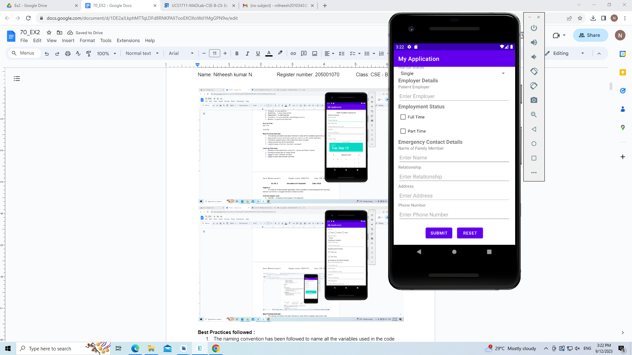 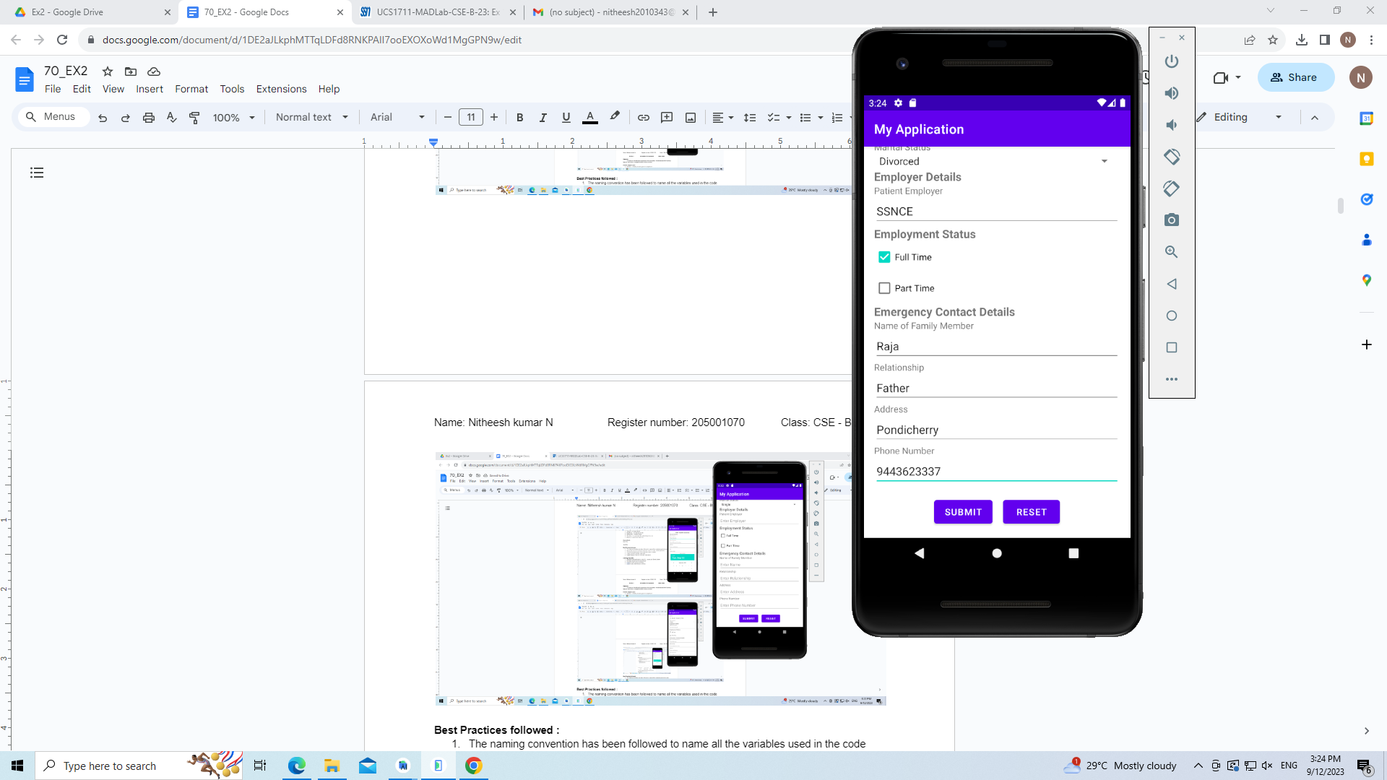

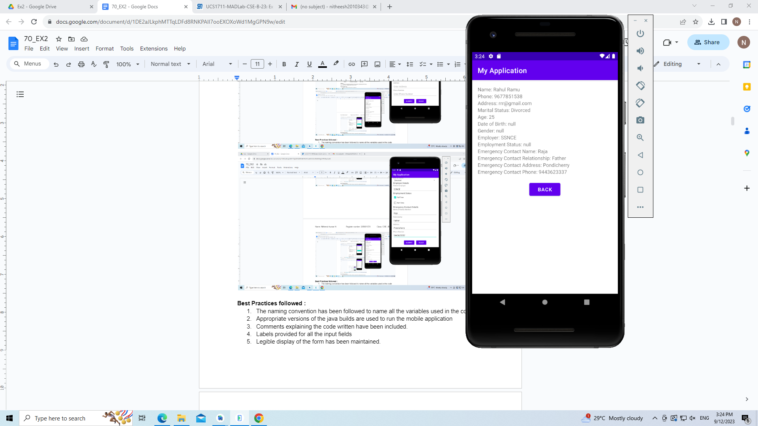 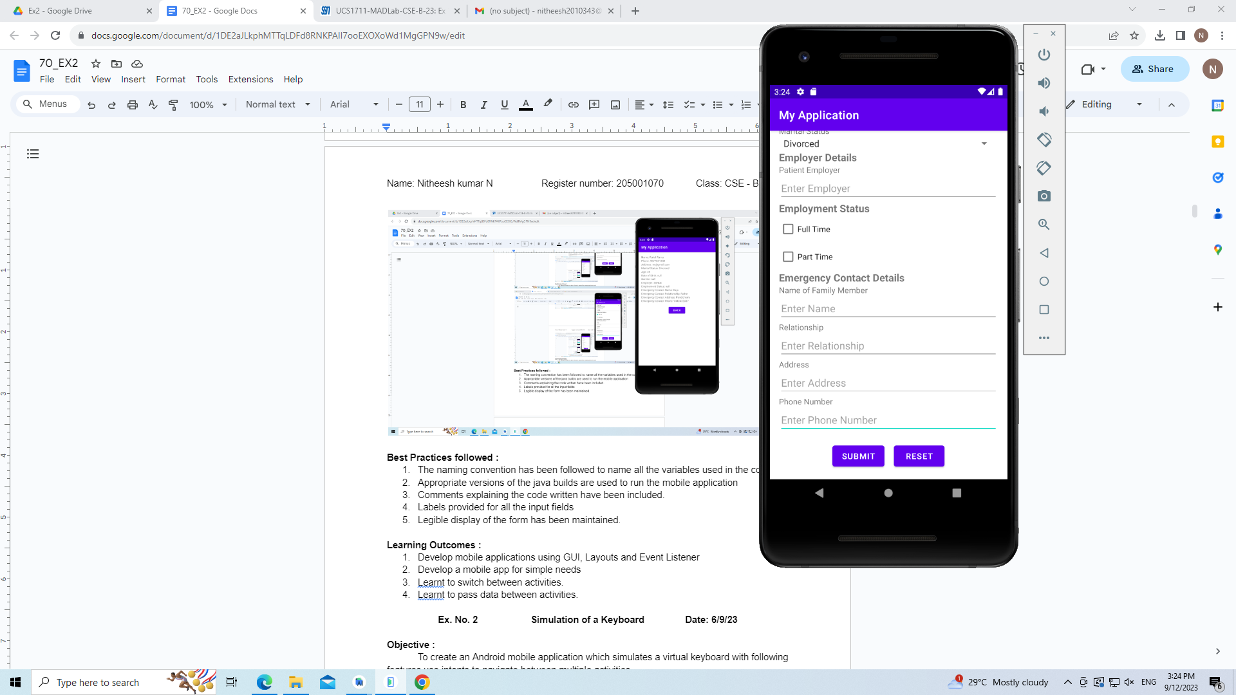

**Best Practices followed :**

1. The naming convention has been followed to name all the variables used in the code
2. Appropriate versions of the java builds are used to run the mobile application
3. Comments explaining the code written have been included.
4. Labels provided for all the input fields
5. Legible display of the form has been maintained.

**Learning Outcomes :**

1. Develop mobile applications using GUI, Layouts and Event Listener
2. Develop a mobile app for simple needs
3. Learnt to switch between activities.
4. Learnt to pass data between activities.

**Ex. No. 2 Simulation of a Keyboard Date: 6/9/23**

**Objective :**

To create an Android mobile application which simulates a virtual keyboard with following features use intents to navigate between multiple activities.

**Android widgets used :**

1. TextView - to display the text typed in the keyboard
2. Buttons - to create keys in the keyboard
3. GridLayout - to achieve layout of the keyboard

**Source Code :**

**KeyPad Screen**

XML File:

<?xml version="1.0" encoding="utf-8"?>

<androidx.constraintlayout.widget.ConstraintLayout xmlns:android="http://schemas.android.com/apk/res/android"

xmlns:app="http://schemas.android.com/apk/res-auto"

xmlns:tools="http://schemas.android.com/tools"

android:layout_width="match_parent"

android:layout_height="match_parent"

tools:context=".MainActivity">

<TableRow

android:id="@+id/tableRow"

android:layout_width="409dp"

android:layout_height="42dp"

android:layout_marginTop="400dp"

app:layout_constraintEnd_toEndOf="parent"

app:layout_constraintStart_toStartOf="parent"

app:layout_constraintTop_toTopOf="parent">

<Button

android:id="@+id/textView"

android:layout_width="41dp"

android:layout_height="match_parent"

android:onClick="sendMessage"

android:text="q" />

<Button

android:id="@+id/textView2"

android:layout_width="43dp"

android:layout_height="match_parent"

android:onClick="sendMessage"

android:text="w" />

<Button

android:id="@+id/textView3"

android:layout_width="41dp"

android:layout_height="match_parent"

android:onClick="sendMessage"

android:text="e" />

<Button

android:id="@+id/textView4"

android:layout_width="41dp"

android:layout_height="match_parent"

android:onClick="sendMessage"

android:text="r" />

<Button

android:id="@+id/textView5"

android:layout_width="41dp"

android:layout_height="match_parent"

android:onClick="sendMessage"

android:text="t" />

<Button

android:id="@+id/textView6"

android:layout_width="41dp"

android:layout_height="match_parent"

android:onClick="sendMessage"

android:text="y" />

<Button

android:id="@+id/textView7"

android:layout_width="41dp"

android:layout_height="match_parent"

android:onClick="sendMessage"

android:text="u" />

<Button

android:id="@+id/textView8"

android:layout_width="41dp"

android:layout_height="match_parent"

android:onClick="sendMessage"

android:text="i" />

<Button

android:id="@+id/textView9"

android:layout_width="41dp"

android:layout_height="match_parent"

android:onClick="sendMessage"

android:text="o" />

<Button

android:id="@+id/textView10"

android:layout_width="41dp"

android:layout_height="match_parent"

android:onClick="sendMessage"

android:text="p" />

<TableLayout

android:layout_width="match_parent"

android:layout_height="match_parent">

<TableRow

android:layout_width="match_parent"

android:layout_height="match_parent" />

<TableRow

android:layout_width="match_parent"

android:layout_height="match_parent" />

<TableRow

android:layout_width="match_parent"

android:layout_height="match_parent" />

<TableRow

android:layout_width="match_parent"

android:layout_height="match_parent" />

</TableLayout>

</TableRow>

<TableRow

android:id="@+id/tableRow2"

android:layout_width="392dp"

android:layout_height="40dp"

android:layout_marginTop="10dp"

app:layout_constraintEnd_toEndOf="parent"

app:layout_constraintStart_toStartOf="parent"

app:layout_constraintTop_toBottomOf="@+id/tableRow">

<Button

android:id="@+id/textView12"

android:layout_width="43dp"

android:layout_height="match_parent"

android:justificationMode="inter_word"

android:onClick="sendMessage"

android:text="a" />

<Button

android:id="@+id/textView13"

android:layout_width="43dp"

android:layout_height="match_parent"

android:justificationMode="inter_word"

android:onClick="sendMessage"

android:text="s" />

<Button

android:id="@+id/textView14"

android:layout_width="43dp"

android:layout_height="match_parent"

android:justificationMode="inter_word"

android:onClick="sendMessage"

android:text="d" />

<Button

android:id="@+id/textView15"

android:layout_width="43dp"

android:layout_height="match_parent"

android:justificationMode="inter_word"

android:onClick="sendMessage"

android:text="f" />

<Button

android:id="@+id/textView16"

android:layout_width="43dp"

android:layout_height="match_parent"

android:justificationMode="inter_word"

android:onClick="sendMessage"

android:text="g" />

<Button

android:id="@+id/textView17"

android:layout_width="43dp"

android:layout_height="match_parent"

android:justificationMode="inter_word"

android:onClick="sendMessage"

android:text="h" />

<Button

android:id="@+id/textView18"

android:layout_width="43dp"

android:layout_height="match_parent"

android:justificationMode="inter_word"

android:onClick="sendMessage"

android:text="j" />

<Button

android:id="@+id/textView19"

android:layout_width="43dp"

android:layout_height="match_parent"

android:justificationMode="inter_word"

android:onClick="sendMessage"

android:text="k" />

<Button

android:id="@+id/textView20"

android:layout_width="40dp"

android:layout_height="match_parent"

android:justificationMode="inter_word"

android:onClick="sendMessage"

android:text="l" />

</TableRow>

<TableRow

android:id="@+id/tableRow3"

android:layout_width="432dp"

android:layout_height="42dp"

android:layout_marginStart="8dp"

android:layout_marginTop="10dp"

app:layout_constraintEnd_toEndOf="parent"

app:layout_constraintStart_toStartOf="parent"

app:layout_constraintTop_toBottomOf="@+id/tableRow2">

<Button

android:id="@+id/textView21"

android:layout_width="75dp"

android:layout_height="match_parent"

android:onClick="sendMessage"

android:text="Caps" />

<Button

android:id="@+id/textView25"

android:layout_width="41dp"

android:layout_height="match_parent"

android:justificationMode="inter_word"

android:onClick="sendMessage"

android:text="z" />

<Button

android:id="@+id/textView26"

android:layout_width="41dp"

android:layout_height="match_parent"

android:justificationMode="inter_word"

android:onClick="sendMessage"

android:text="x" />

<Button

android:id="@+id/textView27"

android:layout_width="41dp"

android:layout_height="match_parent"

android:justificationMode="inter_word"

android:onClick="sendMessage"

android:text="c" />

<Button

android:id="@+id/textView28"

android:layout_width="41dp"

android:layout_height="match_parent"

android:justificationMode="inter_word"

android:onClick="sendMessage"

android:text="v" />

<Button

android:id="@+id/textView29"

android:layout_width="41dp"

android:layout_height="match_parent"

android:justificationMode="inter_word"

android:onClick="sendMessage"

android:text="b" />

<Button

android:id="@+id/textView30"

android:layout_width="41dp"

android:layout_height="match_parent"

android:justificationMode="inter_word"

android:onClick="sendMessage"

android:text="n" />

<Button

android:id="@+id/textView31"

android:layout_width="46dp"

android:layout_height="match_parent"

android:justificationMode="inter_word"

android:onClick="sendMessage"

android:text="m" />

<Button

android:id="@+id/textView33"

android:layout_width="63dp"

android:layout_height="match_parent"

android:onClick="sendMessage"

android:text="Del" />

</TableRow>

<TableRow

android:layout_width="390dp"

android:layout_height="38dp"

android:layout_marginStart="20dp"

android:layout_marginTop="10dp"

android:layout_marginEnd="16dp"

app:layout_constraintEnd_toEndOf="parent"

app:layout_constraintStart_toStartOf="parent"

app:layout_constraintTop_toBottomOf="@+id/tableRow3">

<Button

android:id="@+id/number_pad"

android:layout_width="68dp"

android:layout_height="match_parent"

android:onClick="toggleNum"

android:text="\?123" />

<Button

android:id="@+id/textView35"

android:layout_width="44dp"

android:layout_height="match_parent"

android:text=":)" />

<Button

android:id="@+id/textView36"

android:layout_width="38dp"

android:layout_height="match_parent"

android:onClick="sendMessage"

android:text="," />

<Button

android:id="@+id/textView38"

android:layout_width="130dp"

android:layout_height="match_parent"

android:onClick="sendMessage"

android:text="|____|" />

<Button

android:id="@+id/textView39"

android:layout_width="38dp"

android:layout_height="match_parent"

android:onClick="sendMessage"

android:text="." />

<Button

android:id="@+id/textView40"

android:layout_width="71dp"

android:layout_height="match_parent"

android:onClick="sendMessage"

android:text="Ret" />

</TableRow>

<TextView

android:id="@+id/textView22"

android:layout_width="174dp"

android:layout_height="50dp"

android:layout_marginTop="180dp"

app:layout_constraintEnd_toEndOf="parent"

app:layout_constraintHorizontal_bias="0.5"

app:layout_constraintStart_toStartOf="parent"

app:layout_constraintTop_toTopOf="parent" />

</androidx.constraintlayout.widget.ConstraintLayout>

Java File

package com.example.keyboard;

import androidx.appcompat.app.AppCompatActivity;

import android.content.Intent;

import android.os.Bundle;

import android.widget.Button;

import android.widget.TextView;

public class MainActivity extends AppCompatActivity {

Boolean capsOn;

@Override

protected void onCreate(Bundle savedInstanceState) {

super.onCreate(savedInstanceState);

setContentView(R.layout.activity_main);

Intent intent = getIntent();

// receive the value by getStringExtra() method and

// key must be same which is send by first activity

String str = intent.getStringExtra("prev_text");

TextView mTextView = (TextView) findViewById(R.id.textView22);

mTextView.setText(str);

capsOn=false;

}

public void toggleNum(android.view.View view){

TextView mTextView = (TextView) findViewById(R.id.textView22);

String old = (String) mTextView.getText();

Intent intent = new Intent(this, NumberPad.class);

intent.putExtra("prev_text",old);

startActivity(intent);

}

public void sendMessage(android.view.View view)

{

Button b = (Button)view;

String buttonText = b.getText().toString();

TextView mTextView = (TextView) findViewById(R.id.textView22);

if(buttonText.equals("Del")){

String old = (String) mTextView.getText();

if(old.length()>=1)

mTextView.setText(old.substring(0,old.length()-1));

}

else if(buttonText.equals("|____|")){

String old = (String) mTextView.getText();

mTextView.setText(old+" ");

}

else if(buttonText.equals("Ret")){

String old = (String) mTextView.getText();

mTextView.setText(old+"\n");

}

else if(buttonText.equals("Caps")){

capsOn = !capsOn;

}

else{

String old = (String) mTextView.getText();

if(!capsOn)

mTextView.setText(old+buttonText);

else

mTextView.setText(old+(buttonText.toUpperCase()));

}

}

}

**Number Pad Screen**

XML File

<?xml version="1.0" encoding="utf-8"?>

<androidx.constraintlayout.widget.ConstraintLayout xmlns:android="http://schemas.android.com/apk/res/android"

xmlns:app="http://schemas.android.com/apk/res-auto"

xmlns:tools="http://schemas.android.com/tools"

android:layout_width="match_parent"

android:layout_height="match_parent"

tools:context=".MainActivity">

<TableRow

android:id="@+id/tableRow"

android:layout_width="409dp"

android:layout_height="42dp"

android:layout_marginTop="400dp"

app:layout_constraintEnd_toEndOf="parent"

app:layout_constraintStart_toStartOf="parent"

app:layout_constraintTop_toTopOf="parent">

<Button

android:id="@+id/textView"

android:layout_width="41dp"

android:layout_height="match_parent"

android:onClick="sendMessage"

android:text="1" />

<Button

android:id="@+id/textView2"

android:layout_width="43dp"

android:layout_height="match_parent"

android:onClick="sendMessage"

android:text="2" />

<Button

android:id="@+id/textView3"

android:layout_width="41dp"

android:layout_height="match_parent"

android:onClick="sendMessage"

android:text="3" />

<Button

android:id="@+id/textView4"

android:layout_width="41dp"

android:layout_height="match_parent"

android:onClick="sendMessage"

android:text="4" />

<Button

android:id="@+id/textView5"

android:layout_width="41dp"

android:layout_height="match_parent"

android:onClick="sendMessage"

android:text="5" />

<Button

android:id="@+id/textView6"

android:layout_width="41dp"

android:layout_height="match_parent"

android:onClick="sendMessage"

android:text="6" />

<Button

android:id="@+id/textView7"

android:layout_width="41dp"

android:layout_height="match_parent"

android:onClick="sendMessage"

android:text="7" />

<Button

android:id="@+id/textView8"

android:layout_width="41dp"

android:layout_height="match_parent"

android:onClick="sendMessage"

android:text="8" />

<Button

android:id="@+id/textView9"

android:layout_width="41dp"

android:layout_height="match_parent"

android:onClick="sendMessage"

android:text="9" />

<Button

android:id="@+id/textView10"

android:layout_width="41dp"

android:layout_height="match_parent"

android:onClick="sendMessage"

android:text="0" />

<TableLayout

android:layout_width="match_parent"

android:layout_height="match_parent">

<TableRow

android:layout_width="match_parent"

android:layout_height="match_parent" />

<TableRow

android:layout_width="match_parent"

android:layout_height="match_parent" />

<TableRow

android:layout_width="match_parent"

android:layout_height="match_parent" />

<TableRow

android:layout_width="match_parent"

android:layout_height="match_parent" />

</TableLayout>

</TableRow>

<TableRow

android:id="@+id/tableRow2"

android:layout_width="422dp"

android:layout_height="38dp"

android:layout_marginTop="10dp"

app:layout_constraintEnd_toEndOf="parent"

app:layout_constraintStart_toStartOf="parent"

app:layout_constraintTop_toBottomOf="@+id/tableRow">

<Button

android:id="@+id/textView12"

android:layout_width="43dp"

android:layout_height="match_parent"

android:justificationMode="inter_word"

android:onClick="sendMessage"

android:text="\@" />

<Button

android:id="@+id/textView13"

android:layout_width="43dp"

android:layout_height="match_parent"

android:justificationMode="inter_word"

android:onClick="sendMessage"

android:text="#" />

<Button

android:id="@+id/textView14"

android:layout_width="43dp"

android:layout_height="match_parent"

android:justificationMode="inter_word"

android:onClick="sendMessage"

android:text="\u20B9" />

<Button

android:id="@+id/textView15"

android:layout_width="43dp"

android:layout_height="match_parent"

android:justificationMode="inter_word"

android:onClick="sendMessage"

android:text="_" />

<Button

android:id="@+id/textView16"

android:layout_width="43dp"

android:layout_height="match_parent"

android:justificationMode="inter_word"

android:onClick="sendMessage"

android:text="&amp;" />

<Button

android:id="@+id/textView17"

android:layout_width="43dp"

android:layout_height="match_parent"

android:justificationMode="inter_word"

android:onClick="sendMessage"

android:text="-" />

<Button

android:id="@+id/textView18"

android:layout_width="43dp"

android:layout_height="match_parent"

android:justificationMode="inter_word"

android:onClick="sendMessage"

android:text="+" />

<Button

android:id="@+id/textView19"

android:layout_width="43dp"

android:layout_height="match_parent"

android:justificationMode="inter_word"

android:onClick="sendMessage"

android:text="(" />

<Button

android:id="@+id/textView20"

android:layout_width="40dp"

android:layout_height="match_parent"

android:justificationMode="inter_word"

android:onClick="sendMessage"

android:text=")" />

<Button

android:id="@+id/textView41"

android:layout_width="40dp"

android:layout_height="match_parent"

android:justificationMode="inter_word"

android:onClick="sendMessage"

android:text="/" />

</TableRow>

<TableRow

android:id="@+id/tableRow3"

android:layout_width="432dp"

android:layout_height="42dp"

android:layout_marginStart="8dp"

android:layout_marginTop="10dp"

app:layout_constraintEnd_toEndOf="parent"

app:layout_constraintStart_toStartOf="parent"

app:layout_constraintTop_toBottomOf="@+id/tableRow2">

<Button

android:id="@+id/textView21"

android:layout_width="75dp"

android:layout_height="match_parent"

android:onClick="sendMessage"

android:text="=\\&lt;" />

<Button

android:id="@+id/textView25"

android:layout_width="41dp"

android:layout_height="match_parent"

android:justificationMode="inter_word"

android:onClick="sendMessage"

android:text="*" />

<Button

android:id="@+id/textView26"

android:layout_width="41dp"

android:layout_height="match_parent"

android:justificationMode="inter_word"

android:onClick="sendMessage"

android:text="''" />

<Button

android:id="@+id/textView27"

android:layout_width="41dp"

android:layout_height="match_parent"

android:justificationMode="inter_word"

android:onClick="sendMessage"

android:text="'" />

<Button

android:id="@+id/textView28"

android:layout_width="41dp"

android:layout_height="match_parent"

android:justificationMode="inter_word"

android:onClick="sendMessage"

android:text=":" />

<Button

android:id="@+id/textView29"

android:layout_width="41dp"

android:layout_height="match_parent"

android:justificationMode="inter_word"

android:onClick="sendMessage"

android:text=";" />

<Button

android:id="@+id/textView30"

android:layout_width="41dp"

android:layout_height="match_parent"

android:justificationMode="inter_word"

android:onClick="sendMessage"

android:text="!" />

<Button

android:id="@+id/textView31"

android:layout_width="46dp"

android:layout_height="match_parent"

android:justificationMode="inter_word"

android:onClick="sendMessage"

android:text="?" />

<Button

android:id="@+id/textView33"

android:layout_width="63dp"

android:layout_height="match_parent"

android:onClick="sendMessage"

android:text="Del" />

</TableRow>

<TableRow

android:layout_width="410dp"

android:layout_height="38dp"

android:layout_marginStart="20dp"

android:layout_marginTop="10dp"

android:layout_marginEnd="16dp"

app:layout_constraintEnd_toEndOf="parent"

app:layout_constraintStart_toStartOf="parent"

app:layout_constraintTop_toBottomOf="@+id/tableRow3">

<Button

android:id="@+id/activity_main"

android:layout_width="65dp"

android:layout_height="match_parent"

android:onClick="toggleNum"

android:text="ABC"

/>

<Button

android:id="@+id/textView35"

android:layout_width="61dp"

android:layout_height="match_parent"

android:text="123" />

<Button

android:id="@+id/textView36"

android:layout_width="38dp"

android:layout_height="match_parent"

android:onClick="sendMessage"

android:text="," />

<Button

android:id="@+id/textView38"

android:layout_width="130dp"

android:layout_height="match_parent"

android:onClick="sendMessage"

android:text="|____|" />

<Button

android:id="@+id/textView39"

android:layout_width="38dp"

android:layout_height="match_parent"

android:onClick="sendMessage"

android:text="." />

<Button

android:id="@+id/textView40"

android:layout_width="71dp"

android:layout_height="match_parent"

android:onClick="sendMessage"

android:text="Ret" />

</TableRow>

<TextView

android:id="@+id/textView22"

android:layout_width="174dp"

android:layout_height="50dp"

android:layout_marginTop="180dp"

app:layout_constraintEnd_toEndOf="parent"

app:layout_constraintHorizontal_bias="0.5"

app:layout_constraintStart_toStartOf="parent"

app:layout_constraintTop_toTopOf="parent" />

</androidx.constraintlayout.widget.ConstraintLayout>

Java File

package com.example.keyboard;

import android.content.Intent;

import android.os.Bundle;

import android.widget.Button;

import android.widget.TextView;

import androidx.annotation.Nullable;

import androidx.appcompat.app.AppCompatActivity;

public class NumberPad extends AppCompatActivity {

@Override

protected void onCreate(@Nullable Bundle savedInstanceState){

super.onCreate(savedInstanceState);

setContentView(R.layout.number_pad);

Intent intent = getIntent();

// receive the value by getStringExtra() method and

// key must be same which is send by first activity

String str = intent.getStringExtra("prev_text");

TextView mTextView = (TextView) findViewById(R.id.textView22);

mTextView.setText(str);

}

public void toggleNum(android.view.View view){

TextView mTextView = (TextView) findViewById(R.id.textView22);

String old = (String) mTextView.getText();

Intent intent = new Intent(this, MainActivity.class);

intent.putExtra("prev_text",old);

startActivity(intent);

}

public void sendMessage(android.view.View view)

{

Button b = (Button)view;

String buttonText = b.getText().toString();

TextView mTextView = (TextView) findViewById(R.id.textView22);

if(buttonText.equals("Del")){

String old = (String) mTextView.getText();

if(old.length()>=1)

mTextView.setText(old.substring(0,old.length()-1));

}

else if(buttonText.equals("|____|")){

String old = (String) mTextView.getText();

mTextView.setText(old+" ");

}

else if(buttonText.equals("Ret")){

String old = (String) mTextView.getText();

mTextView.setText(old+"\n");

}

else{

String old = (String) mTextView.getText();

mTextView.setText(old+buttonText);

}

}

}

**Output Screenshots :**

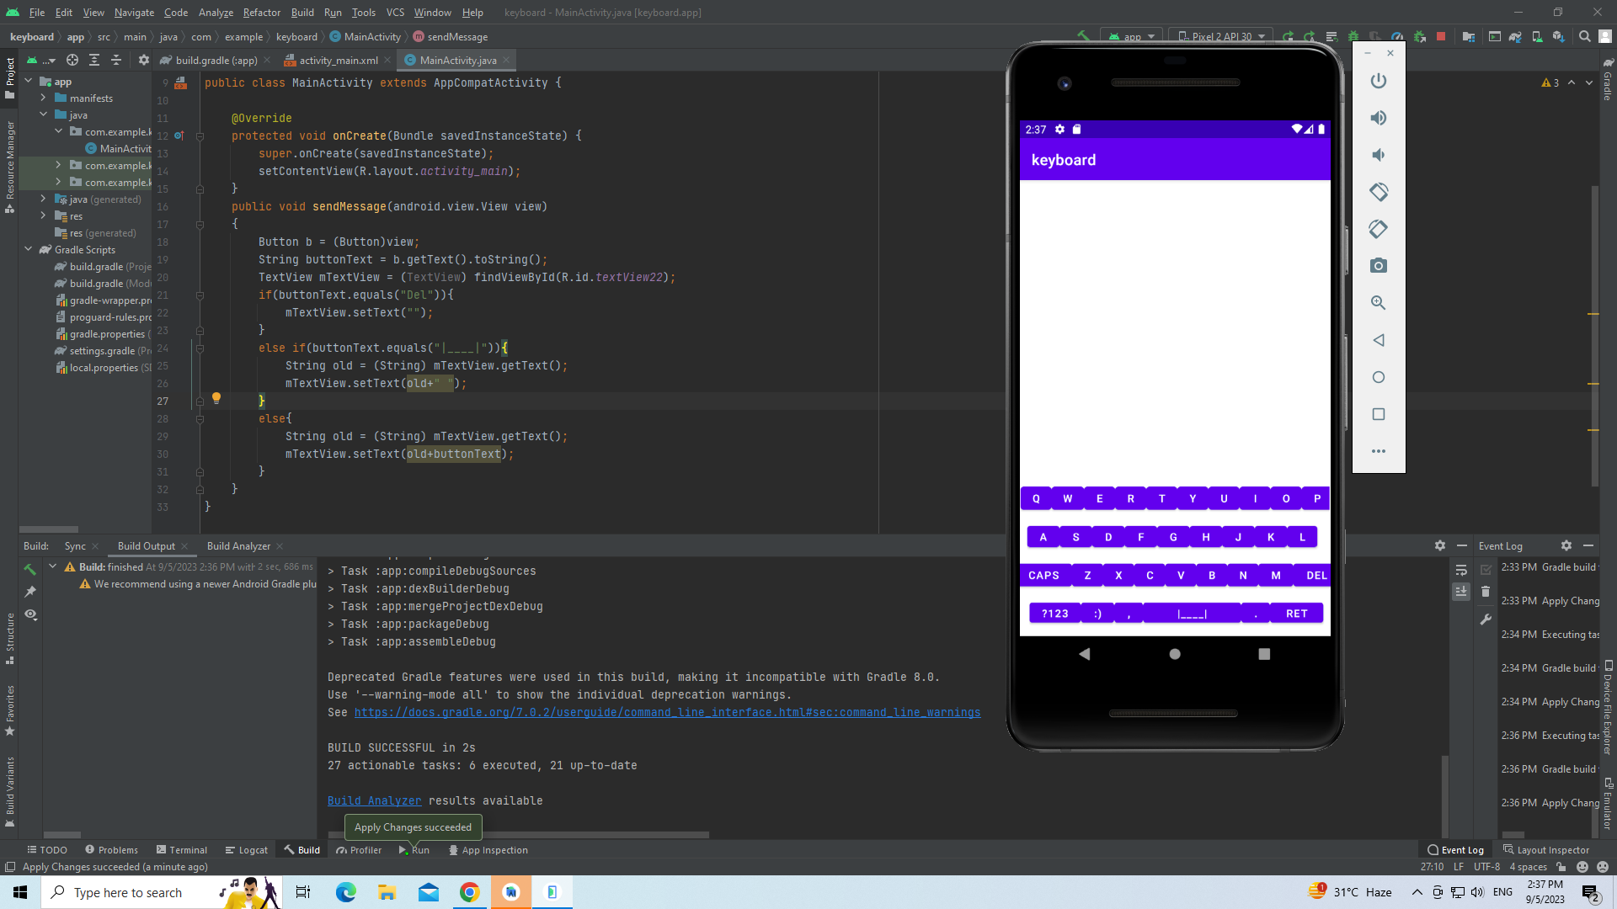 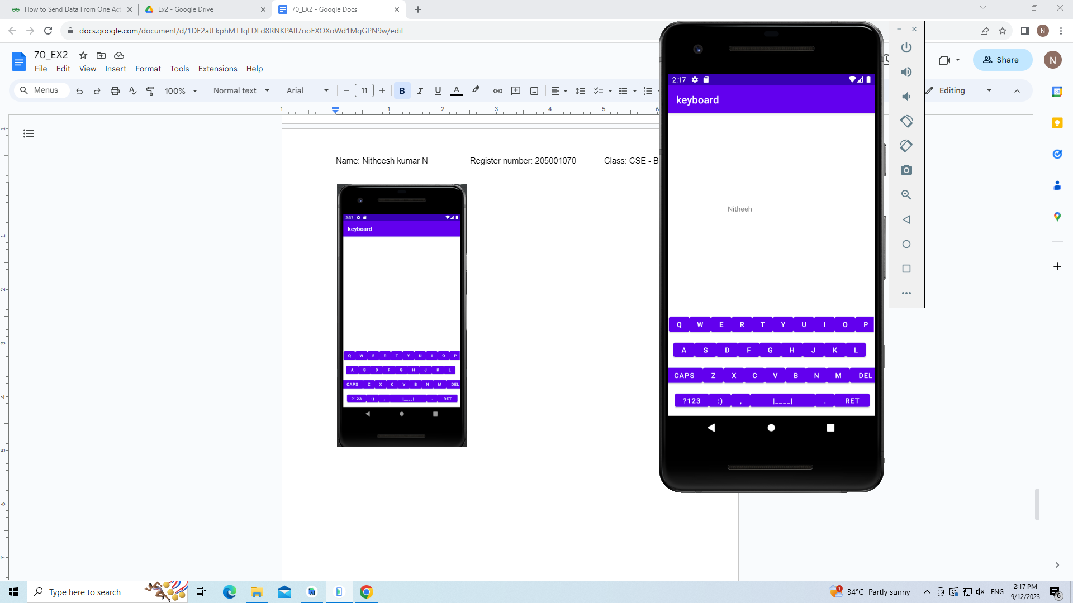

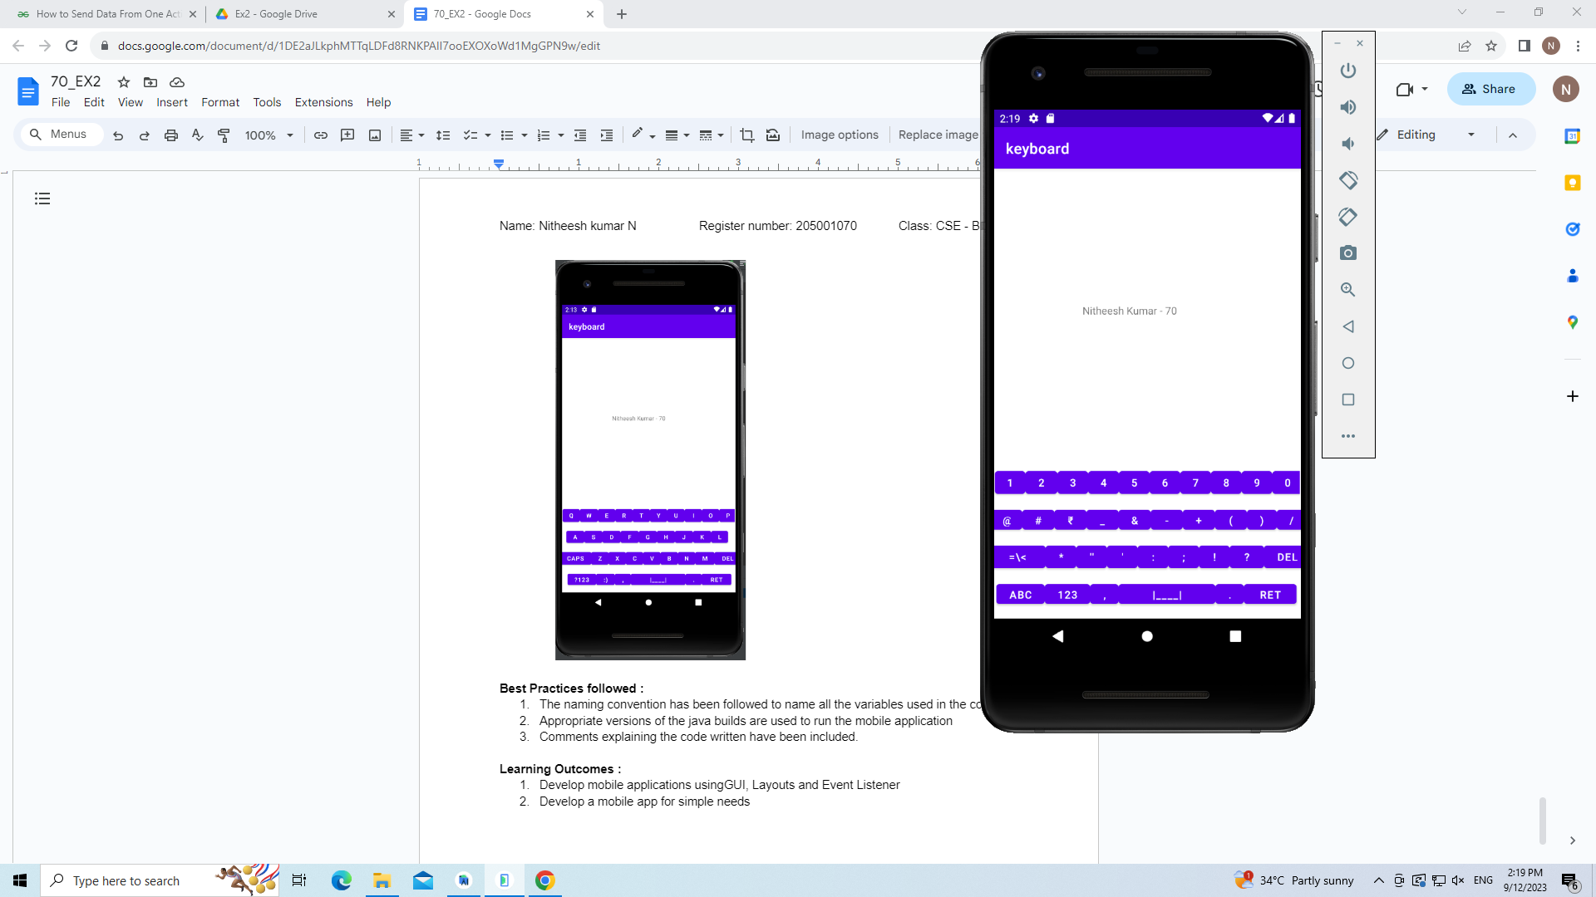 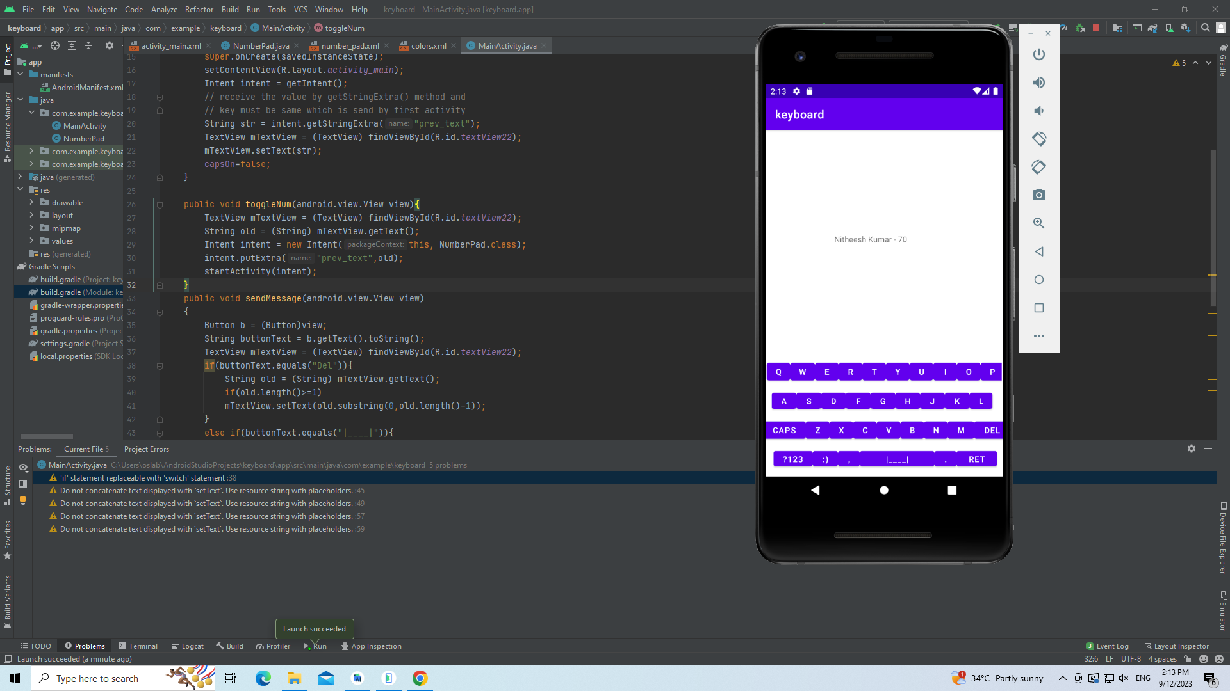

**Best Practices followed :**

1. The naming convention has been followed to name all the variables used in the code
2. Appropriate versions of the java builds are used to run the mobile application
3. Comments explaining the code written have been included.

**Learning Outcomes :**

1. Develop mobile applications using GUI, Layouts and Event Listener
2. Develop a mobile app for simple needs
3. Learnt to switch between activities.
4. Learnt to pass data between activities.

**Ex. No. 3 Application Development using basic graphical primitives Date: 19/9/23**

**Objective :**

To design a CAR using Shape drawables with the help of relevant shapes such as Line, Circle, Rectangle and Arc.

a. Move the car forward by pressing the forward button so that the car moves from a predefined starting point to the predefined endpoint.

b. On pressing the backward button, rotate the car to 180 degrees from the current point to the starting point.

c. Implement a Tap-to-zoom animation on any image.

d. Implement the Card flipping animation.

**Android widgets used :**

1. TextView - to display the text typed in the keyboard
2. Buttons - to create keys in the keyboard
3. GridLayout - to achieve layout of the keyboard
4. ImageView - to add image in the screen

**Source Code:**

XML Files:

**car.xml**

<layer-list xmlns:android="http://schemas.android.com/apk/res/android">

<!-- Car Body (Rectangle) -->

<item android:drawable="@drawable/car_body" />

<!-- &lt;!&ndash; Car Roof (Rectangle) &ndash;&gt;-->

<item

android:drawable="@drawable/car_roof"

android:gravity="top"

/>

<!-- Car Windows (Rectangles) -->

<item

android:drawable="@drawable/car_window"

android:top="10dp"

android:left="20dp"

android:right="45dp"

android:bottom="20dp"

/>

<item

android:drawable="@drawable/car_window"

android:top="10dp"

android:left="75dp"

android:right="5dp"

android:bottom="20dp"

/>

<!-- Car Wheels (Circles) -->

<item

android:drawable="@drawable/car_wheel"

android:gravity="left|bottom"

android:left="10dp"

android:bottom="0dp"

/>

<item

android:drawable="@drawable/car_wheel"

android:gravity="right|bottom"

android:right="10dp"

android:bottom="0dp"

/>

</layer-list>

**car_roof.xml**

<shape xmlns:android="http://schemas.android.com/apk/res/android">

<solid android:color="#000000" /> <!-- White color -->

<corners android:radius="16dp" />

<size android:width="20dp" android:height="15dp" />

</shape>

**road.xml**

<layer-list xmlns:android="http://schemas.android.com/apk/res/android">

<!-- Road Background (Gray) -->

<item>

<shape android:shape="rectangle">

<solid android:color="#808080" /> <!-- Gray color -->

</shape>

</item>

Lane Markings (White Lines)

<item android:drawable="@drawable/lane_marking"

android:top="10dp"

android:right="80dp"

android:left="10dp"

android:bottom="10dp"/>

<item android:drawable="@drawable/lane_marking"

android:top="10dp"

android:right="45dp"

android:left="45dp"

android:bottom="10dp"/>

<item android:drawable="@drawable/lane_marking"

android:top="10dp"

android:right="10dp"

android:left="80dp"

android:bottom="10dp"/>

</layer-list>

**Lane_marking.xml**

<shape xmlns:android="http://schemas.android.com/apk/res/android">

<solid android:color="#FFFFFF" /> <!-- White color -->

<size android:width="10dp" android:height="2dp" />

</shape>

**Car_window.xml**

<?xml version="1.0" encoding="utf-8"?>

<shape xmlns:android="http://schemas.android.com/apk/res/android">

<solid android:color="#FFFFFF" /> <!-- White color -->

<corners android:radius="4dp" />

<size android:width="20dp" android:height="20dp" />

</shape>

**Car_body.xml**

<shape xmlns:android="http://schemas.android.com/apk/res/android">

<solid android:color="#FFA500" /> <!-- Orange color -->

<corners android:radius="16dp" />

<size android:width="100dp" android:height="40dp"/>

</shape>

**Car_wheel.xml**

<shape xmlns:android="http://schemas.android.com/apk/res/android">

<solid android:color="#000000" /> <!-- Black color -->

<size android:width="20dp" android:height="20dp" />

<corners android:radius="10dp" />

</shape>

**Main_activity.xml**

<?xml version="1.0" encoding="utf-8"?>

<androidx.constraintlayout.widget.ConstraintLayout xmlns:android="http://schemas.android.com/apk/res/android"

xmlns:app="http://schemas.android.com/apk/res-auto"

xmlns:tools="http://schemas.android.com/tools"

android:layout_width="match_parent"

android:layout_height="match_parent"

tools:context=".MainActivity">

<ImageView

android:id="@+id/carImageView"

android:layout_width="wrap_content"

android:layout_height="wrap_content"

android:layout_marginTop="206dp"

android:src="@drawable/car"

app:layout_constraintTop_toTopOf="parent"

tools:layout_editor_absoluteX="0dp" />

<ImageView

android:id="@+id/roadImageView"

android:layout_width="410dp"

android:layout_height="111dp"

android:layout_marginTop="246dp"

android:layout_marginEnd="1dp"

android:src="@drawable/road"

app:layout_constraintEnd_toEndOf="parent"

app:layout_constraintHorizontal_bias="1.0"

app:layout_constraintStart_toStartOf="parent"

app:layout_constraintTop_toTopOf="parent" />

<Button

android:id="@+id/forwardButton"

android:layout_width="wrap_content"

android:layout_height="wrap_content"

android:layout_marginStart="57dp"

android:layout_marginTop="91dp"

android:text="Forward"

app:layout_constraintStart_toStartOf="parent"

app:layout_constraintTop_toBottomOf="@+id/roadImageView" />

<Button

android:id="@+id/sunFlipId"

android:layout_width="wrap_content"

android:layout_height="wrap_content"

android:layout_marginStart="140dp"

android:layout_marginEnd="170dp"

android:layout_marginBottom="45dp"

android:text="Flip Image"

app:layout_constraintBottom_toBottomOf="parent"

app:layout_constraintEnd_toEndOf="parent"

app:layout_constraintHorizontal_bias="1.0"

app:layout_constraintStart_toStartOf="parent" />

<Button

android:id="@+id/backwardButton"

android:layout_width="wrap_content"

android:layout_height="wrap_content"

android:layout_marginTop="91dp"

android:layout_marginEnd="54dp"

android:text="Backward"

app:layout_constraintEnd_toEndOf="parent"

app:layout_constraintTop_toBottomOf="@+id/roadImageView" />

<ImageView

android:id="@+id/sunId"

android:layout_width="79dp"

android:layout_height="55dp"

android:layout_marginStart="278dp"

android:layout_marginTop="43dp"

android:layout_marginEnd="54dp"

app:layout_constraintEnd_toEndOf="parent"

app:layout_constraintStart_toStartOf="parent"

app:layout_constraintTop_toTopOf="parent"

app:srcCompat="?attr/actionModeCloseDrawable" />

<!-- Add other UI elements here if needed -->

</androidx.constraintlayout.widget.ConstraintLayout>

**MainActivity.java**

package com.example.car;

import androidx.appcompat.app.AppCompatActivity;

import android.animation.ObjectAnimator;

import android.os.Bundle;

import android.os.Handler;

import android.view.View;

import android.view.animation.AccelerateDecelerateInterpolator;

import android.widget.Button;

import android.widget.ImageView;

public class MainActivity extends AppCompatActivity {

private ImageView carImageView;

private ImageView sunImageView;

private Button forwardButton;

private Button backwardButton;

private Button sunFlipButton;

private int carXPosition = 0; // Initial X position of the car

private final int endpoint = 800;// Predefined endpoint

private final int startpoint = 0;

boolean isClicked=false;

@Override

protected void onCreate(Bundle savedInstanceState) {

super.onCreate(savedInstanceState);

setContentView(R.layout.activity_main);

carImageView = findViewById(R.id.carImageView);

sunImageView = findViewById(R.id.sunId);

forwardButton = findViewById(R.id.forwardButton);

backwardButton = findViewById(R.id.backwardButton);

sunFlipButton = findViewById(R.id.sunFlipId);

forwardButton.setOnClickListener(new View.OnClickListener() {

boolean isOperationInProgress = false;

@Override

public void onClick(View v) {

if (!isOperationInProgress) {

isOperationInProgress = true;

backwardButton.setEnabled(false);

forwardButton.setEnabled(false);

final Handler handler = new Handler();

final Runnable carMovement = new Runnable() {

@Override

public void run() {

carXPosition += 10;

if (carXPosition <= endpoint) {

carImageView.setX(carXPosition);

handler.postDelayed(this, 100); // 100 milliseconds delay

} else {

isOperationInProgress = false;

backwardButton.setEnabled(true);

forwardButton.setEnabled(true);

}

}

};

handler.post(carMovement);

}

}

});

backwardButton.setOnClickListener(new View.OnClickListener() {

boolean isOperationInProgress = false;

private boolean isCarFlipped = false;

@Override

public void onClick(View v) {

if (!isOperationInProgress) {

isOperationInProgress = true;

backwardButton.setEnabled(false);

forwardButton.setEnabled(false);

flipCar();

final Handler handler = new Handler();

final Runnable carMovement = new Runnable() {

@Override

public void run() {

carXPosition -= 10;

if (carXPosition >= startpoint) {

carImageView.setX(carXPosition);

handler.postDelayed(this, 100); // 100 milliseconds delay

} else {

isOperationInProgress = false;

backwardButton.setEnabled(true);

forwardButton.setEnabled(true);

flipCar();

}

}

};

handler.post(carMovement);

}

}

private void flipCar() {

ObjectAnimator flipAnimator;

if (isCarFlipped) {

flipAnimator = ObjectAnimator.ofFloat(carImageView, "rotationY", 180f, 0f);

isCarFlipped = false;

} else {

flipAnimator = ObjectAnimator.ofFloat(carImageView, "rotationY", 0f, 180f);

isCarFlipped = true;

}

flipAnimator.setDuration(500);

flipAnimator.setInterpolator(new AccelerateDecelerateInterpolator());

flipAnimator.start();

}

});

sunImageView.setOnClickListener(new View.OnClickListener(){

@Override

public void onClick(View v) {

if(!isClicked){

sunImageView.setScaleX(2);

sunImageView.setScaleY(2);

isClicked=true;

}

else{

sunImageView.setScaleX(1);

sunImageView.setScaleY(1);

isClicked=false;

}

}

});

sunFlipButton.setOnClickListener(new View.OnClickListener() {

private boolean isArrowFlipped = false;

@Override

public void onClick(View v) {

ObjectAnimator flipAnimator;

if (isArrowFlipped) {

flipAnimator = ObjectAnimator.ofFloat(sunImageView, "rotationY", 180f, 0f);

isArrowFlipped = false;

} else {

flipAnimator = ObjectAnimator.ofFloat(sunImageView, "rotationY", 0f, 180f);

isArrowFlipped = true;

}

flipAnimator.setDuration(500);

flipAnimator.setInterpolator(new AccelerateDecelerateInterpolator());

flipAnimator.start();

}

});

}

}

**Output Screenshots:**

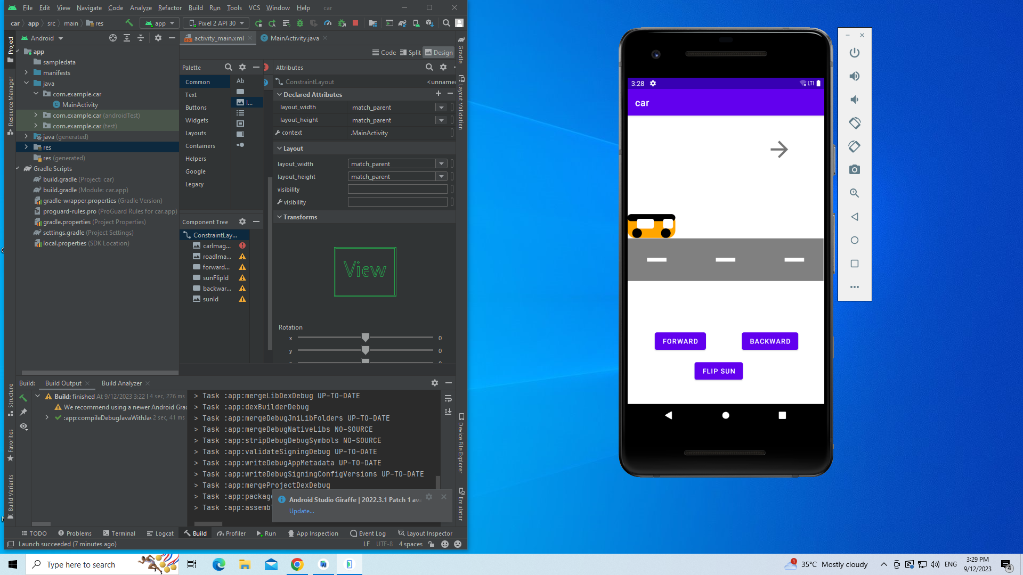 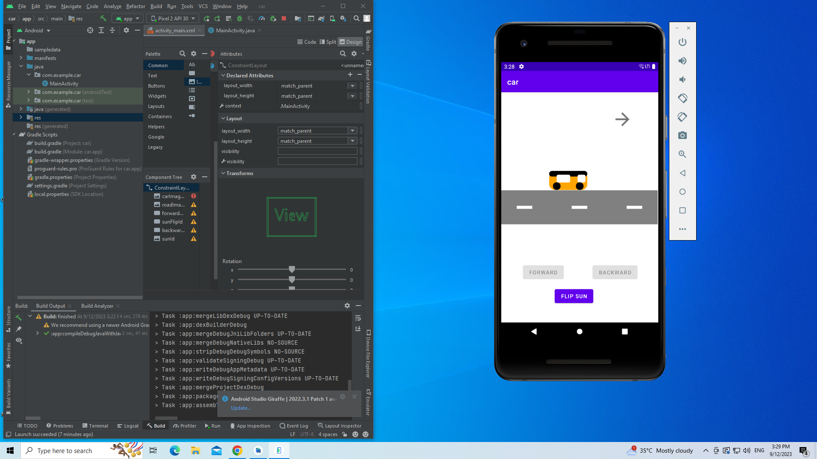

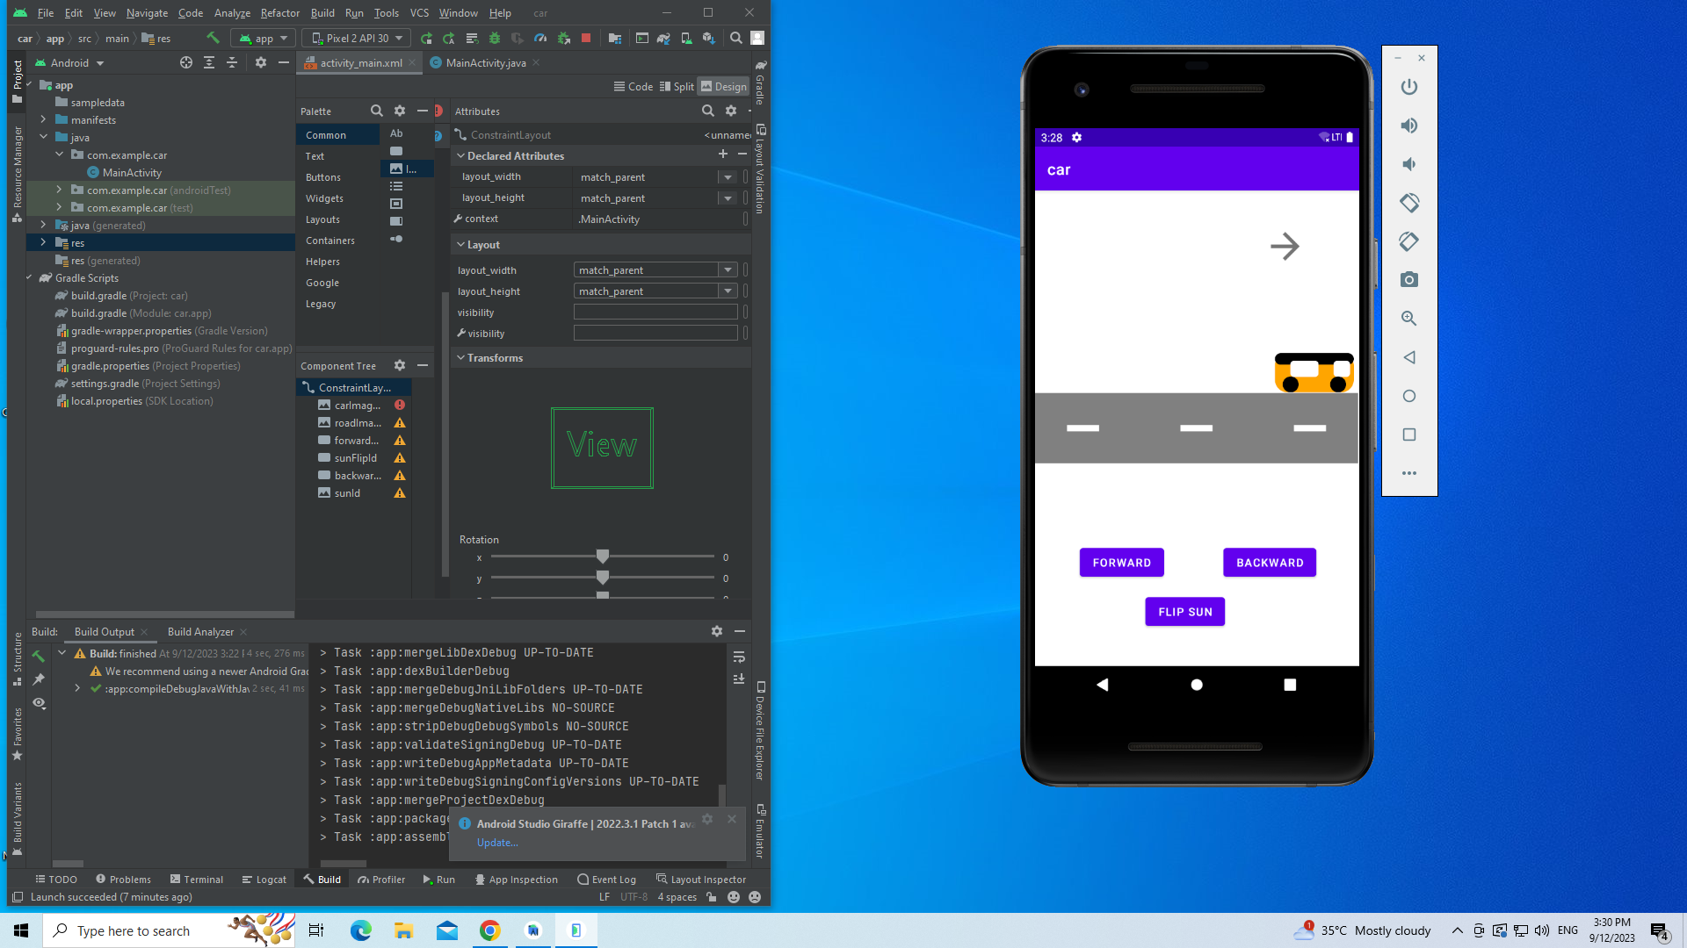 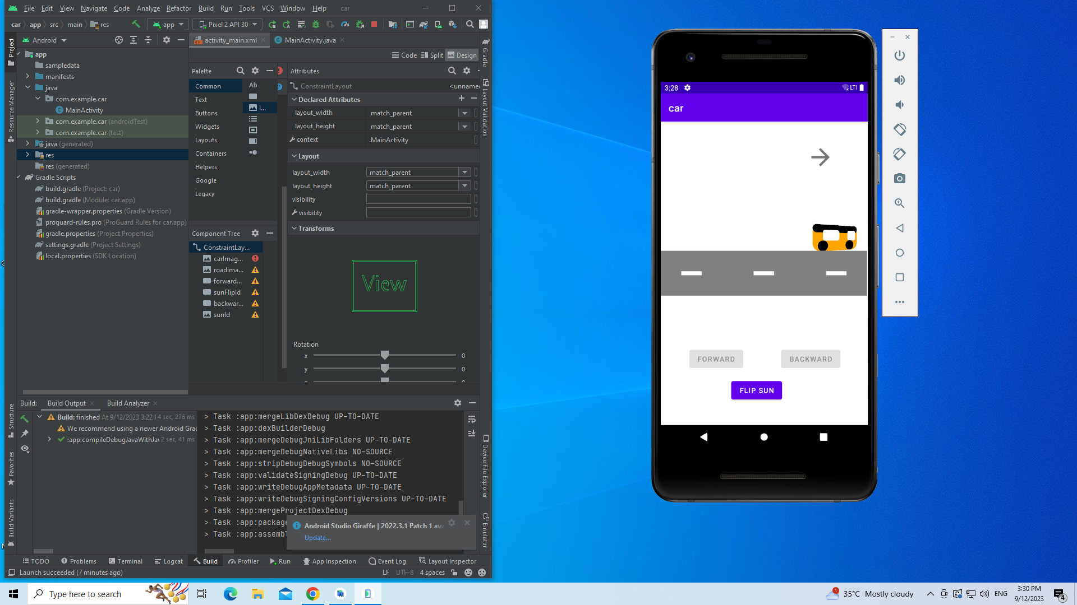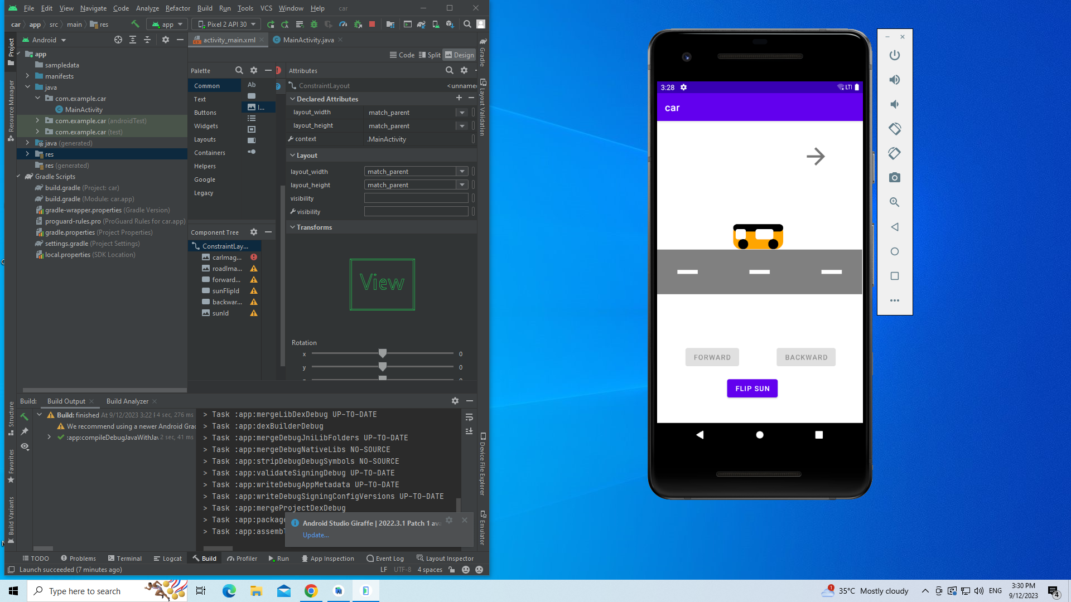 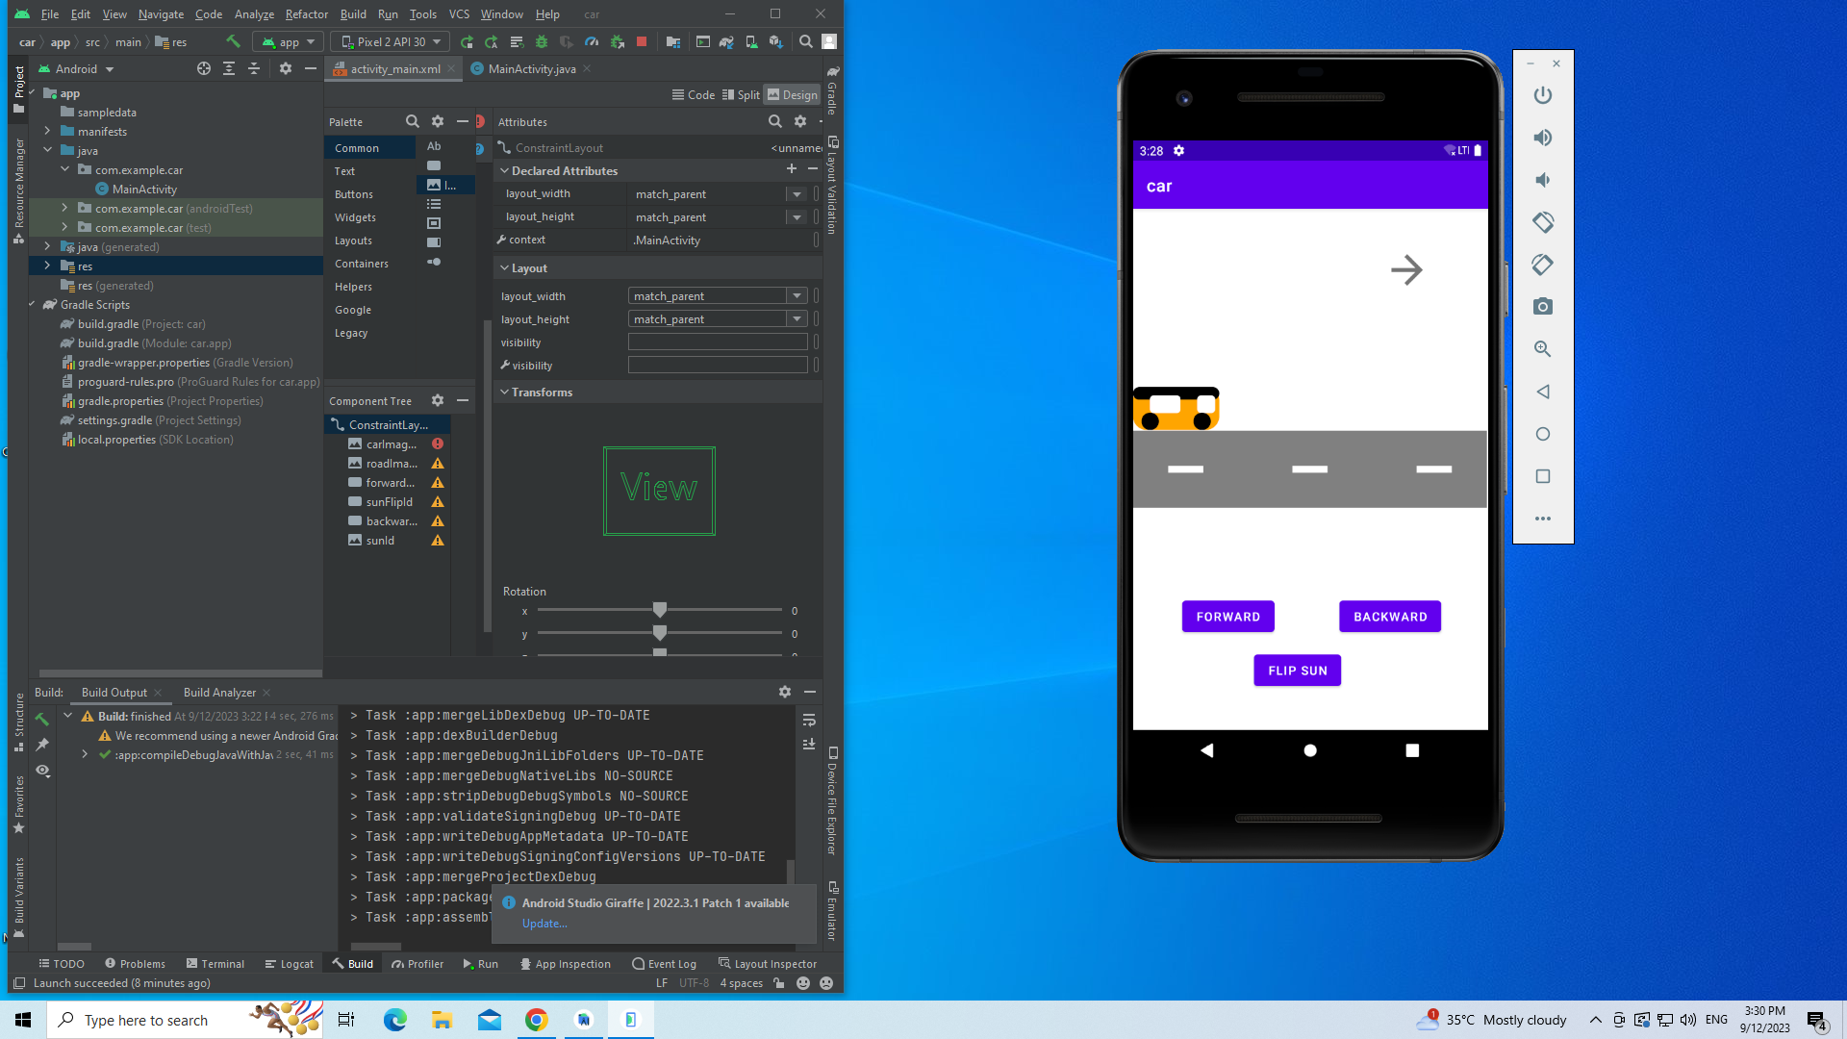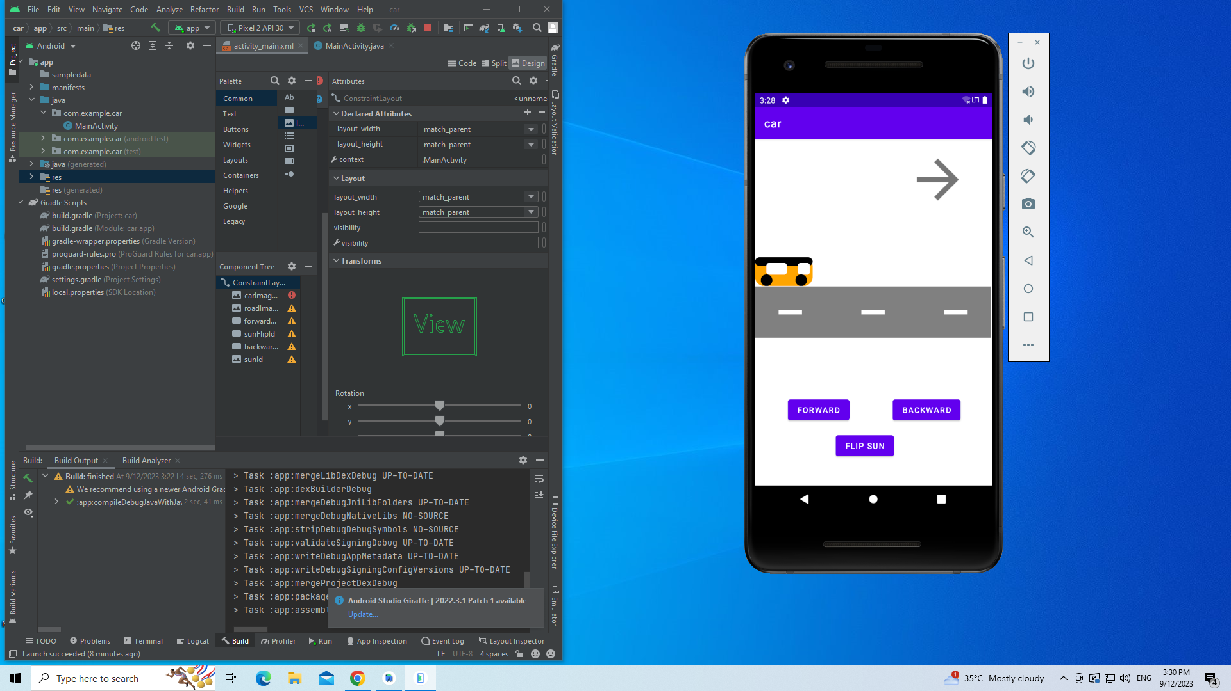 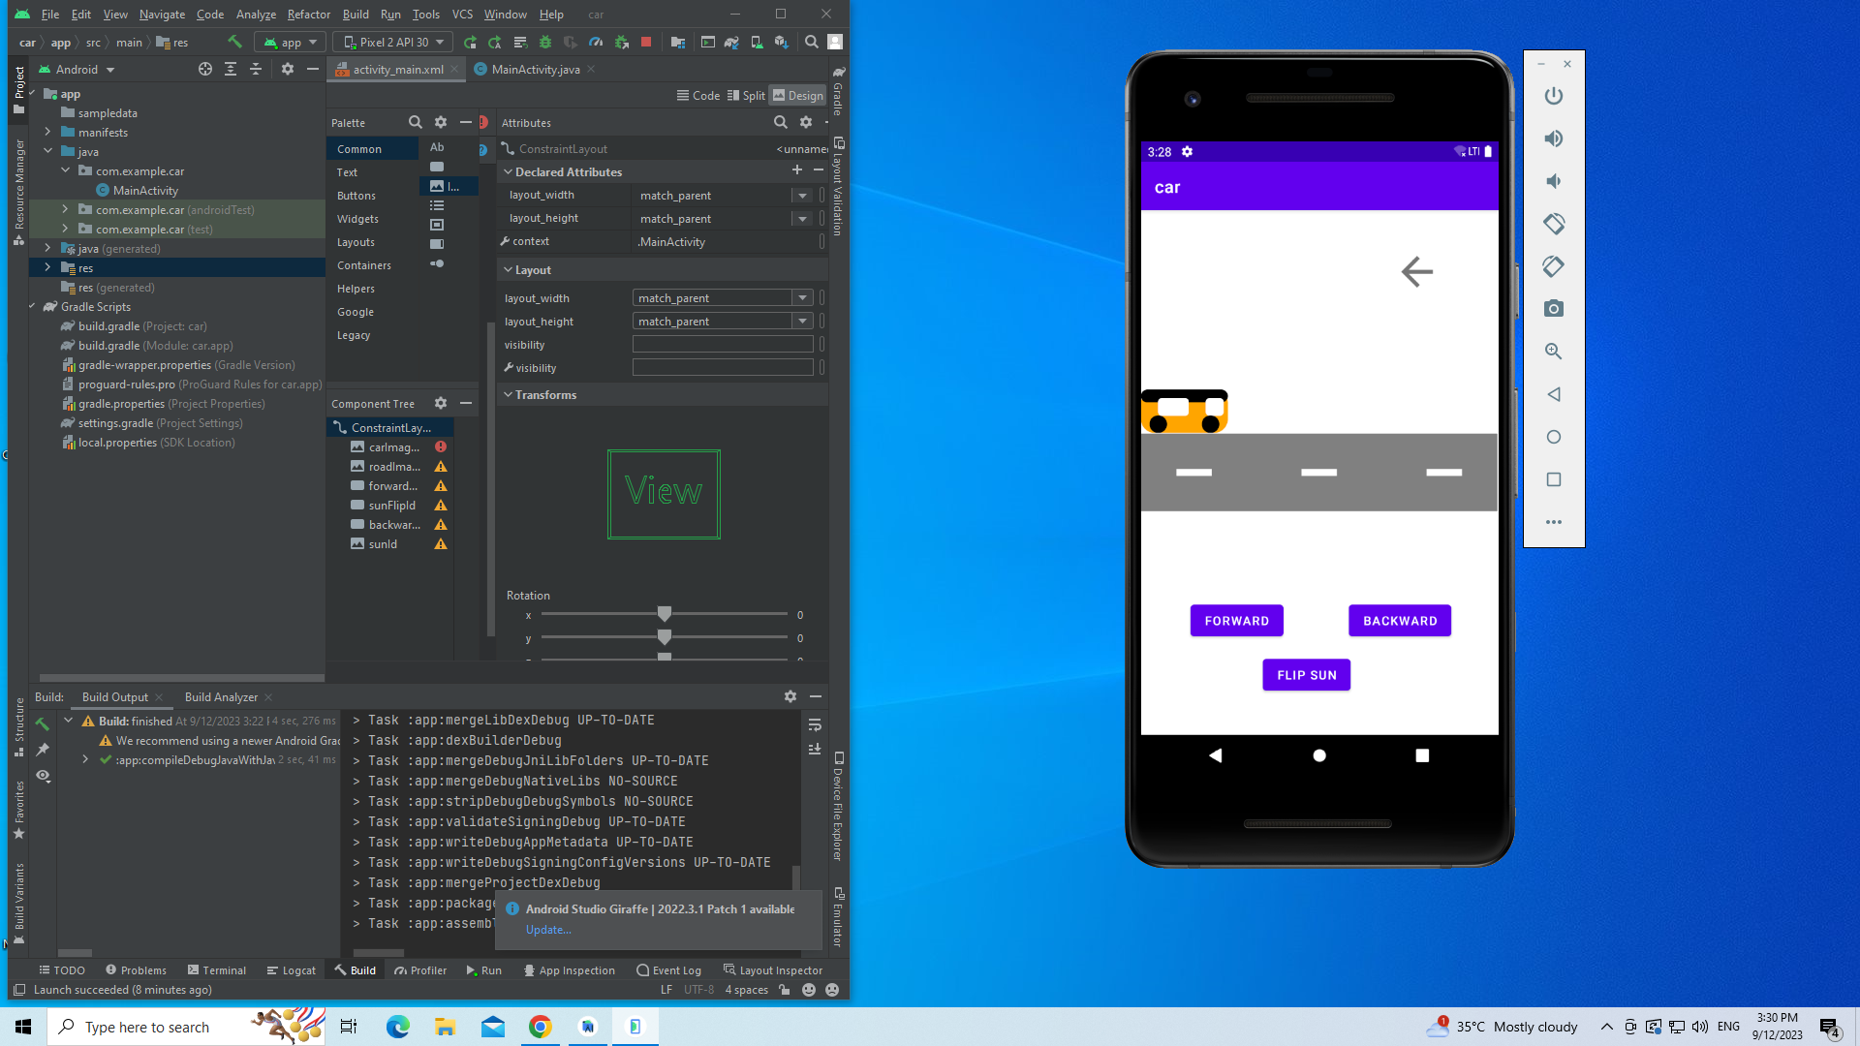 

**Best Practices followed :**

1. The naming convention has been followed to name all the variables used in the code
2. Appropriate versions of the java builds are used to run the mobile application
3. Comments explaining the code written have been included.

**Learning Outcomes :**

1. Develop mobile applications using GUI, Layouts and Event Listener
2. Develop a mobile app for simple needs
3. Learnt to build custom images by defining .xml file
4. Learnt to rotate,scale images.
5. Learnt to combine images and functions to create a moving effect

**Ex. No. 4 Android Application Development using Database Deadline: 08.10.23**

**Objective :**

To develop a Product information application in Android that enables to perform CRUD operations on data stored in SQLite Database.

**Android widgets used :**

1. TextView
2. EditView
3. RadioGroup
4. RadioButton
5. Spinner
6. Button
7. LinearLayout
8. TableLayout

**Source Code:**

**Activity_main.xml**

<?xml version="1.0" encoding="utf-8"?>

<LinearLayout xmlns:android="http://schemas.android.com/apk/res/android"

xmlns:app="http://schemas.android.com/apk/res-auto"

xmlns:tools="http://schemas.android.com/tools"

android:layout_width="match_parent"

android:layout_height="match_parent"

android:orientation="vertical"

tools:context=".MainActivity" >

<LinearLayout

android:layout_width="match_parent"

android:layout_height="150dp"

android:orientation="horizontal">

<TextView

android:layout_width="match_parent"

android:layout_height="match_parent"

android:gravity="center|center_vertical|center_horizontal"

android:text="Product Database"

android:textColor="#000000"

android:textSize="40sp"

android:textStyle="bold"

android:typeface="monospace" />

</LinearLayout>

<Button

android:id="@+id/button_insert"

android:layout_width="200dp"

android:layout_height="wrap_content"

android:layout_marginTop="80dp"

android:layout_gravity="center|center_horizontal"

android:text="Insert"

android:textColor="#FFFFFF"

android:textSize="20sp"

android:textStyle="bold"

android:typeface="monospace" />

<Button

android:id="@+id/button_update"

android:layout_width="200dp"

android:layout_height="wrap_content"

android:layout_marginTop="25dp"

android:layout_gravity="center|center_horizontal"

android:text="Update"

android:textColor="#FFFFFF"

android:textSize="20sp"

android:textStyle="bold"

android:typeface="monospace" />

<Button

android:id="@+id/button_delete"

android:layout_width="200dp"

android:layout_height="wrap_content"

android:layout_marginTop="25dp"

android:layout_gravity="center|center_horizontal"

android:text="Delete"

android:textColor="#FFFFFF"

android:textSize="20sp"

android:textStyle="bold"

android:typeface="monospace" />

<Button

android:id="@+id/button_retrieve"

android:layout_width="200dp"

android:layout_height="wrap_content"

android:layout_marginTop="25dp"

android:layout_gravity="center|center_horizontal"

android:text="Retrieve"

android:textColor="#FFFFFF"

android:textSize="20sp"

android:textStyle="bold"

android:typeface="monospace" />

<Button

android:id="@+id/button_retrieve_all"

android:layout_width="200dp"

android:layout_height="wrap_content"

android:layout_gravity="center|center_horizontal"

android:layout_marginTop="25dp"

android:text="Retrieve All"

android:textColor="#FFFFFF"

android:textSize="20sp"

android:textStyle="bold"

android:typeface="monospace" />

</LinearLayout>

**Insert_activity.xml**

<?xml version="1.0" encoding="utf-8"?>

<LinearLayout xmlns:android="http://schemas.android.com/apk/res/android"

xmlns:app="http://schemas.android.com/apk/res-auto"

xmlns:tools="http://schemas.android.com/tools"

android:layout_width="match_parent"

android:layout_height="match_parent"

android:orientation="vertical"

tools:context=".InsertActivity">

<LinearLayout

android:layout_width="match_parent"

android:layout_height="48dp"

android:orientation="horizontal">

<TextView

android:layout_width="match_parent"

android:layout_height="52dp"

android:gravity="center|center_vertical|center_horizontal"

android:text="Insert"

android:textColor="#000000"

android:textSize="24sp"

android:textStyle="bold"

android:typeface="monospace" />

</LinearLayout>

<TableLayout

android:layout_width="match_parent"

android:layout_height="wrap_content"

android:layout_margin="5dp">

<TableRow

android:layout_width="match_parent"

android:layout_height="match_parent"

android:minHeight="80dp">

<TextView

android:id="@+id/product_id"

android:layout_width="wrap_content"

android:layout_height="wrap_content"

android:layout_marginStart="24dp"

android:gravity="center|left"

android:text="Product\nID"

android:textColor="#000000"

android:textSize="16sp"

android:textStyle="bold"

android:typeface="monospace" />

<EditText

android:id="@+id/entered_product_id"

android:layout_width="200dp"

android:layout_height="match_parent"

android:layout_marginStart="24dp"

android:inputType="number"

android:minHeight="80dp"

android:text=""

android:textSize="16sp"

android:textStyle="bold" />

</TableRow>

<TableRow

android:layout_width="match_parent"

android:layout_height="match_parent"

android:minHeight="80dp">

<TextView

android:id="@+id/product_name"

android:layout_width="wrap_content"

android:layout_height="wrap_content"

android:layout_marginStart="24dp"

android:gravity="center|left"

android:text="Product\nName"

android:textColor="#000000"

android:textSize="16sp"

android:textStyle="bold"

android:typeface="monospace" />

<Spinner

android:id="@+id/entered_product_name"

android:layout_width="50dp"

android:layout_height="match_parent"

android:layout_marginStart="24dp"

android:gravity="center|center_horizontal|center_vertical"

android:textAlignment="center"

android:textSize="16sp"

android:textStyle="bold"

android:typeface="monospace" />

</TableRow>

<TableRow

android:layout_width="match_parent"

android:layout_height="match_parent"

android:minHeight="150dp">

<TextView

android:id="@+id/product_brand"

android:layout_width="wrap_content"

android:layout_height="wrap_content"

android:layout_marginStart="24dp"

android:layout_marginTop="10dp"

android:gravity="center|left"

android:text="Product\nBrand"

android:textColor="#000000"

android:textSize="16sp"

android:textStyle="bold"

android:typeface="monospace" />

<RadioGroup

android:id="@+id/brand"

android:layout_width="50dp"

android:layout_height="match_parent"

android:layout_marginStart="24dp">

<RadioButton

android:id="@+id/brand1"

android:layout_width="match_parent"

android:layout_height="wrap_content"

android:text="Cadburys"

android:textSize="16sp"

android:textStyle="bold"

android:typeface="monospace" />

<RadioButton

android:id="@+id/brand2"

android:layout_width="match_parent"

android:layout_height="wrap_content"

android:text="Pepsico"

android:textSize="16sp"

android:textStyle="bold"

android:typeface="monospace" />

<RadioButton

android:id="@+id/brand3"

android:layout_width="match_parent"

android:layout_height="wrap_content"

android:text="Hersheys"

android:textSize="16sp"

android:textStyle="bold"

android:typeface="monospace" />

</RadioGroup>

</TableRow>

<TableRow

android:layout_width="match_parent"

android:layout_height="match_parent"

android:minHeight="80dp">

<TextView

android:id="@+id/product_description"

android:layout_width="wrap_content"

android:layout_height="wrap_content"

android:layout_marginStart="24dp"

android:gravity="center|left"

android:text="Product\nDescription"

android:textColor="#000000"

android:textSize="16sp"

android:textStyle="bold"

android:typeface="monospace" />

<EditText

android:id="@+id/entered_product_description"

android:layout_width="200dp"

android:layout_height="match_parent"

android:layout_marginStart="24dp"

android:inputType="text"

android:minHeight="80dp"

android:text=""

android:textSize="16sp"

android:textStyle="bold" />

</TableRow>

<TableRow

android:layout_width="match_parent"

android:layout_height="match_parent"

android:minHeight="80dp">

<TextView

android:id="@+id/product_price"

android:layout_width="wrap_content"

android:layout_height="wrap_content"

android:layout_marginStart="24dp"

android:gravity="center|left"

android:text="Product\nPrice"

android:textColor="#000000"

android:textSize="16sp"

android:textStyle="bold"

android:typeface="monospace" />

<EditText

android:id="@+id/entered_product_price"

android:layout_width="200dp"

android:layout_height="match_parent"

android:layout_marginStart="24dp"

android:inputType="number"

android:minHeight="80dp"

android:text=""

android:textSize="16sp"

android:textStyle="bold" />

</TableRow>

</TableLayout>

<androidx.constraintlayout.widget.ConstraintLayout

android:layout_width="match_parent"

android:layout_height="70dp">

<Button

android:id="@+id/cancel"

android:layout_width="wrap_content"

android:layout_height="wrap_content"

android:layout_marginStart="77dp"

android:layout_marginTop="16dp"

android:layout_marginEnd="228dp"

android:layout_marginBottom="38dp"

android:text="Cancel"

android:textColor="#FFFFFF"

android:textSize="16sp"

android:textStyle="bold"

android:typeface="monospace"

app:layout_constraintBottom_toBottomOf="parent"

app:layout_constraintEnd_toEndOf="parent"

app:layout_constraintHorizontal_bias="1.0"

app:layout_constraintStart_toStartOf="parent"

app:layout_constraintTop_toTopOf="parent"

app:layout_constraintVertical_bias="0.2"

/>

<Button

android:id="@+id/insert"

android:layout_width="wrap_content"

android:layout_height="wrap_content"

android:layout_marginStart="222dp"

android:layout_marginTop="15dp"

android:layout_marginEnd="83dp"

android:layout_marginBottom="39dp"

android:text="Insert"

android:textColor="#FFFFFF"

android:textSize="16sp"

android:textStyle="bold"

android:typeface="monospace"

app:layout_constraintBottom_toBottomOf="parent"

app:layout_constraintEnd_toEndOf="parent"

app:layout_constraintHorizontal_bias="1.0"

app:layout_constraintStart_toStartOf="parent"

app:layout_constraintTop_toTopOf="parent"

app:layout_constraintVertical_bias="0.22" />

<TextView

android:id="@+id/error"

android:layout_width="wrap_content"

android:layout_height="32dp"

android:layout_marginStart="205dp"

android:layout_marginTop="64dp"

android:layout_marginEnd="206dp"

android:layout_marginBottom="19dp"

android:gravity="center|center_vertical|center_horizontal"

android:textColor="#990000"

android:textSize="16sp"

android:textStyle="bold|italic"

app:layout_constraintBottom_toBottomOf="parent"

app:layout_constraintEnd_toEndOf="parent"

app:layout_constraintStart_toStartOf="parent"

app:layout_constraintTop_toTopOf="parent" />

</androidx.constraintlayout.widget.ConstraintLayout>

</LinearLayout>

**Update_activity.xml**

<?xml version="1.0" encoding="utf-8"?>

<LinearLayout xmlns:android="http://schemas.android.com/apk/res/android"

xmlns:app="http://schemas.android.com/apk/res-auto"

xmlns:tools="http://schemas.android.com/tools"

android:layout_width="match_parent"

android:layout_height="match_parent"

android:orientation="vertical"

tools:context=".UpdateActivity">

<LinearLayout

android:layout_width="match_parent"

android:layout_height="80dp"

android:orientation="horizontal">

<TextView

android:layout_width="match_parent"

android:layout_height="match_parent"

android:gravity="center|center_vertical|center_horizontal"

android:text="Update"

android:textColor="#800080"

android:textSize="36sp"

android:textStyle="bold"

android:typeface="monospace" />

</LinearLayout>

<TableLayout

android:layout_width="match_parent"

android:layout_height="wrap_content"

android:layout_margin="50dp">

<TableRow

android:layout_width="match_parent"

android:layout_height="match_parent"

android:layout_marginTop="50dp"

android:minHeight="80dp">

<TextView

android:id="@+id/product_id"

android:layout_width="wrap_content"

android:layout_height="wrap_content"

android:layout_marginStart="24dp"

android:gravity="center|left"

android:text="Product\nID"

android:textColor="#000000"

android:textSize="20dp"

android:textStyle="bold"

android:typeface="monospace" />

<EditText

android:id="@+id/entered_product_id"

android:layout_width="200dp"

android:layout_height="match_parent"

android:layout_marginStart="24dp"

android:inputType="number"

android:minHeight="80dp"

android:text=""

android:textColor="#800080"

android:textSize="16sp"

android:textStyle="bold" />

</TableRow>

<TableRow

android:layout_width="match_parent"

android:layout_height="match_parent"

android:layout_marginTop="10dp"

android:minHeight="80dp">

<TextView

android:id="@+id/product_price"

android:layout_width="wrap_content"

android:layout_height="wrap_content"

android:layout_marginStart="24dp"

android:gravity="center|left"

android:text="Product\nPrice"

android:textColor="#000000"

android:textSize="16sp"

android:textStyle="bold"

android:typeface="monospace" />

<EditText

android:id="@+id/entered_product_price"

android:layout_width="200dp"

android:layout_height="match_parent"

android:layout_marginStart="24dp"

android:inputType="number"

android:minHeight="80dp"

android:text=""

android:textColor="#800080"

android:textSize="16sp"

android:textStyle="bold" />

</TableRow>

</TableLayout>

<androidx.constraintlayout.widget.ConstraintLayout

android:layout_width="match_parent"

android:layout_height="match_parent">

<Button

android:id="@+id/cancel"

android:layout_width="wrap_content"

android:layout_height="wrap_content"

android:layout_marginStart="77dp"

android:layout_marginTop="16dp"

android:layout_marginEnd="228dp"

android:layout_marginBottom="38dp"

android:text="Cancel"

android:textColor="#FFFFFF"

android:textSize="16sp"

android:textStyle="bold"

android:typeface="monospace"

app:layout_constraintBottom_toBottomOf="parent"

app:layout_constraintEnd_toEndOf="parent"

app:layout_constraintHorizontal_bias="1.0"

app:layout_constraintStart_toStartOf="parent"

app:layout_constraintTop_toTopOf="parent"

app:layout_constraintVertical_bias="0.2" />

<Button

android:id="@+id/update"

android:layout_width="wrap_content"

android:layout_height="wrap_content"

android:layout_marginStart="222dp"

android:layout_marginTop="15dp"

android:layout_marginEnd="83dp"

android:layout_marginBottom="39dp"

android:text="Update"

android:textColor="#FFFFFF"

android:textSize="16sp"

android:textStyle="bold"

android:typeface="monospace"

app:layout_constraintBottom_toBottomOf="parent"

app:layout_constraintEnd_toEndOf="parent"

app:layout_constraintHorizontal_bias="0.0"

app:layout_constraintStart_toStartOf="parent"

app:layout_constraintTop_toTopOf="parent"

app:layout_constraintVertical_bias="0.2" />

<TextView

android:id="@+id/error"

android:layout_width="wrap_content"

android:layout_height="32dp"

android:layout_marginStart="140dp"

android:layout_marginTop="64dp"

android:layout_marginEnd="271dp"

android:layout_marginBottom="19dp"

android:gravity="center|center_vertical|center_horizontal"

android:textColor="#990000"

android:textSize="16sp"

android:textStyle="bold|italic"

app:layout_constraintBottom_toBottomOf="parent"

app:layout_constraintEnd_toEndOf="parent"

app:layout_constraintHorizontal_bias="0.0"

app:layout_constraintStart_toStartOf="parent"

app:layout_constraintTop_toTopOf="parent"

app:layout_constraintVertical_bias="0.341" />

</androidx.constraintlayout.widget.ConstraintLayout>

</LinearLayout>

**Display_activity.xml**

<?xml version="1.0" encoding="utf-8"?>

<LinearLayout xmlns:android="http://schemas.android.com/apk/res/android"

xmlns:app="http://schemas.android.com/apk/res-auto"

xmlns:tools="http://schemas.android.com/tools"

android:layout_width="match_parent"

android:layout_height="match_parent"

android:orientation="vertical"

tools:context=".DisplayActivity">

<LinearLayout

android:layout_width="match_parent"

android:layout_height="80dp"

android:orientation="horizontal">

<TextView

android:layout_width="match_parent"

android:layout_height="match_parent"

android:gravity="center|center_vertical|center_horizontal"

android:text="Record"

android:textColor="#000000"

android:textSize="36sp"

android:textStyle="bold"

android:typeface="monospace" />

</LinearLayout>

<ScrollView

android:layout_width="match_parent"

android:layout_height="wrap_content">

<LinearLayout

android:layout_width="match_parent"

android:layout_height="wrap_content"

android:orientation="vertical">

<TextView

android:id="@+id/record"

android:layout_width="wrap_content"

android:layout_height="wrap_content"

android:layout_margin="50dp"

android:text=""

android:textSize="16sp"

android:textColor="#000000"

android:textStyle="bold"

android:typeface="monospace" />

<Button

android:id="@+id/back"

android:layout_width="200dp"

android:layout_height="50dp"

android:layout_margin="50dp"

android:layout_gravity="center"

android:text="Back"

android:textColor="#FFFFFF"

android:textSize="16sp"

android:textStyle="bold" />

</LinearLayout>

</ScrollView>

</LinearLayout>

**Delete_activity.xml**

<?xml version="1.0" encoding="utf-8"?>

<LinearLayout xmlns:android="http://schemas.android.com/apk/res/android"

xmlns:app="http://schemas.android.com/apk/res-auto"

xmlns:tools="http://schemas.android.com/tools"

android:layout_width="match_parent"

android:layout_height="match_parent"

android:orientation="vertical"

tools:context=".DeleteActivity">

<LinearLayout

android:layout_width="match_parent"

android:layout_height="80dp"

android:orientation="horizontal">

<TextView

android:layout_width="match_parent"

android:layout_height="match_parent"

android:gravity="center|center_vertical|center_horizontal"

android:text="Delete"

android:textColor="#000000"

android:textSize="36sp"

android:textStyle="bold"

android:typeface="monospace" />

</LinearLayout>

<TableLayout

android:layout_width="match_parent"

android:layout_height="wrap_content"

android:layout_margin="50dp">

<TableRow

android:layout_width="match_parent"

android:layout_height="match_parent"

android:layout_marginTop="50dp"

android:minHeight="80dp">

<TextView

android:id="@+id/product_id"

android:layout_width="wrap_content"

android:layout_height="wrap_content"

android:layout_marginStart="24dp"

android:gravity="center|left"

android:text="Product\nID"

android:textColor="#000000"

android:textSize="16sp"

android:textStyle="bold"

android:typeface="monospace" />

<EditText

android:id="@+id/entered_product_id"

android:layout_width="200dp"

android:layout_height="match_parent"

android:layout_marginStart="24dp"

android:inputType="number"

android:minHeight="80dp"

android:text=""

android:textSize="16sp"

android:textStyle="bold" />

</TableRow>

</TableLayout>

<androidx.constraintlayout.widget.ConstraintLayout

android:layout_width="match_parent"

android:layout_height="match_parent">

<Button

android:id="@+id/cancel"

android:layout_width="wrap_content"

android:layout_height="wrap_content"

android:layout_marginStart="77dp"

android:layout_marginTop="16dp"

android:layout_marginEnd="228dp"

android:layout_marginBottom="38dp"

android:text="Cancel"

android:textColor="#FFFFFF"

android:textSize="16sp"

android:textStyle="bold"

android:typeface="monospace"

app:layout_constraintBottom_toBottomOf="parent"

app:layout_constraintEnd_toEndOf="parent"

app:layout_constraintHorizontal_bias="0.484"

app:layout_constraintStart_toStartOf="parent"

app:layout_constraintTop_toTopOf="parent"

app:layout_constraintVertical_bias="0.197" />

<Button

android:id="@+id/delete"

android:layout_width="wrap_content"

android:layout_height="wrap_content"

android:layout_marginStart="222dp"

android:layout_marginTop="15dp"

android:layout_marginEnd="83dp"

android:layout_marginBottom="39dp"

android:text="Delete"

android:textColor="#FFFFFF"

android:textSize="16sp"

android:textStyle="bold"

android:typeface="monospace"

app:layout_constraintBottom_toBottomOf="parent"

app:layout_constraintEnd_toEndOf="parent"

app:layout_constraintHorizontal_bias="0.829"

app:layout_constraintStart_toStartOf="parent"

app:layout_constraintTop_toTopOf="parent"

app:layout_constraintVertical_bias="0.2" />

<TextView

android:id="@+id/error"

android:layout_width="wrap_content"

android:layout_height="32dp"

android:layout_marginStart="140dp"

android:layout_marginTop="64dp"

android:layout_marginEnd="271dp"

android:layout_marginBottom="19dp"

android:gravity="center|center_vertical|center_horizontal"

android:textColor="#990000"

android:textSize="16sp"

android:textStyle="bold|italic"

app:layout_constraintBottom_toBottomOf="parent"

app:layout_constraintEnd_toEndOf="parent"

app:layout_constraintHorizontal_bias="0.0"

app:layout_constraintStart_toStartOf="parent"

app:layout_constraintTop_toTopOf="parent"

app:layout_constraintVertical_bias="0.341" />

</androidx.constraintlayout.widget.ConstraintLayout>

</LinearLayout>

**Retrieve_activity.xml**

<?xml version="1.0" encoding="utf-8"?>

<LinearLayout xmlns:android="http://schemas.android.com/apk/res/android"

xmlns:app="http://schemas.android.com/apk/res-auto"

xmlns:tools="http://schemas.android.com/tools"

android:layout_width="match_parent"

android:layout_height="match_parent"

android:orientation="vertical"

tools:context=".RetrieveActivity">

<LinearLayout

android:layout_width="match_parent"

android:layout_height="80dp"

android:orientation="horizontal">

<TextView

android:layout_width="match_parent"

android:layout_height="match_parent"

android:gravity="center|center_vertical|center_horizontal"

android:text="Retrieve"

android:textColor="#000000"

android:textSize="36sp"

android:textStyle="bold"

android:typeface="monospace" />

</LinearLayout>

<TableLayout

android:layout_width="match_parent"

android:layout_height="wrap_content"

android:layout_margin="15dp">

<TableRow

android:layout_width="match_parent"

android:layout_height="match_parent"

android:layout_margin="50dp"

android:minHeight="80dp">

<TextView

android:id="@+id/product_id"

android:layout_width="wrap_content"

android:layout_height="wrap_content"

android:layout_marginStart="24dp"

android:gravity="center|left"

android:text="Product\nID"

android:textColor="#000000"

android:textSize="16sp"

android:textStyle="bold"

android:typeface="monospace" />

<EditText

android:id="@+id/entered_product_id"

android:layout_width="200dp"

android:layout_height="match_parent"

android:layout_marginStart="24dp"

android:inputType="number"

android:minHeight="80dp"

android:text=""

android:textSize="16sp"

android:textStyle="bold" />

</TableRow>

</TableLayout>

<androidx.constraintlayout.widget.ConstraintLayout

android:layout_width="match_parent"

android:layout_height="match_parent">

<Button

android:id="@+id/cancel"

android:layout_width="wrap_content"

android:layout_height="wrap_content"

android:layout_marginStart="77dp"

android:layout_marginTop="16dp"

android:layout_marginEnd="228dp"

android:layout_marginBottom="38dp"

android:text="Cancel"

android:textColor="#FFFFFF"

android:textSize="16sp"

android:textStyle="bold"

android:typeface="monospace"

app:layout_constraintBottom_toBottomOf="parent"

app:layout_constraintEnd_toEndOf="parent"

app:layout_constraintHorizontal_bias="1.0"

app:layout_constraintStart_toStartOf="parent"

app:layout_constraintTop_toTopOf="parent"

app:layout_constraintVertical_bias="0.2" />

<Button

android:id="@+id/retrieve"

android:layout_width="wrap_content"

android:layout_height="wrap_content"

android:layout_marginStart="222dp"

android:layout_marginTop="15dp"

android:layout_marginEnd="83dp"

android:layout_marginBottom="39dp"

android:text="Retrieve"

android:textColor="#FFFFFF"

android:textSize="16sp"

android:textStyle="bold"

android:typeface="monospace"

app:layout_constraintBottom_toBottomOf="parent"

app:layout_constraintEnd_toEndOf="parent"

app:layout_constraintHorizontal_bias="0.0"

app:layout_constraintStart_toStartOf="parent"

app:layout_constraintTop_toTopOf="parent"

app:layout_constraintVertical_bias="0.2" />

<TextView

android:id="@+id/error"

android:layout_width="wrap_content"

android:layout_height="32dp"

android:layout_marginStart="140dp"

android:layout_marginTop="64dp"

android:layout_marginEnd="271dp"

android:layout_marginBottom="19dp"

android:gravity="center|center_vertical|center_horizontal"

android:textColor="#990000"

android:textSize="16sp"

android:textStyle="bold|italic"

app:layout_constraintBottom_toBottomOf="parent"

app:layout_constraintEnd_toEndOf="parent"

app:layout_constraintHorizontal_bias="0.0"

app:layout_constraintStart_toStartOf="parent"

app:layout_constraintTop_toTopOf="parent"

app:layout_constraintVertical_bias="0.341" />

</androidx.constraintlayout.widget.ConstraintLayout>

</LinearLayout>

**MainActivity.java**

package com.example.dbapplication;

//import com.example.databasemanagement.DBHelper;

import androidx.appcompat.app.AppCompatActivity;

import android.content.Intent;

import android.database.Cursor;

import android.os.Bundle;

import android.view.View;

import android.widget.Button;

import android.os.Bundle;

public class MainActivity extends AppCompatActivity {

@Override

protected void onCreate(Bundle savedInstanceState) {

super.onCreate(savedInstanceState);

setContentView(R.layout.activity_main);

//DBHelper db = new DBHelper(getApplicationContext());

Button insert = (Button) findViewById(R.id.button_insert);

insert.setOnClickListener(new View.OnClickListener() {

@Override

public void onClick(View view) {

Intent i = new Intent(MainActivity.this, InsertActivity.class);

startActivity(i);

}

});

Button update = (Button) findViewById(R.id.button_update);

update.setOnClickListener(new View.OnClickListener() {

@Override

public void onClick(View view) {

Intent i = new Intent(MainActivity.this,

UpdateActivity.class);

startActivity(i);

}

});

Button delete = (Button) findViewById(R.id.button_delete);

delete.setOnClickListener(new View.OnClickListener() {

@Override

public void onClick(View view) {

Intent i = new Intent(MainActivity.this,

DeleteActivity.class);

startActivity(i);

}

});

Button retrieve = (Button) findViewById(R.id.button_retrieve);

retrieve.setOnClickListener(new View.OnClickListener() {

@Override

public void onClick(View view) {

Intent i = new Intent(MainActivity.this,

RetrieveActivity.class);

startActivity(i);

}

});

Button retrieve_all = (Button)

findViewById(R.id.button_retrieve_all);

retrieve_all.setOnClickListener(new View.OnClickListener() {

@Override

public void onClick(View view) {

DBHelper db = new DBHelper(getApplicationContext());

Cursor record = db.retrieve_all_records();

String record_details = "";

while(record.moveToNext())

{

record_details += "ID: " + record.getString(0) + "\n";

record_details += "Name: " + record.getString(1) + "\n";

record_details += "Brand: " + record.getString(2) + "\n";

record_details += "Description: " + record.getString(3) +

"\n";

record_details += "Price: " + record.getString(4) +

"\n\n";

}

Intent i = new Intent(MainActivity.this,

DisplayActivity.class);

i.putExtra("record_details", record_details);

startActivity(i);

}

});

}

}

**DBHelper.java**

package com.example.dbapplication;

import androidx.annotation.Nullable;

import androidx.appcompat.app.AppCompatActivity;

import android.content.ContentValues;

import android.content.Context;

import android.database.sqlite.SQLiteDatabase;

import android.database.sqlite.SQLiteOpenHelper;

import android.os.Bundle;

import android.database.Cursor;

public class DBHelper extends SQLiteOpenHelper {

public DBHelper(@Nullable Context context) {

super(context, "ProductDB.db", null, 1);

}

@Override

public void onCreate(SQLiteDatabase db) {

db.execSQL("CREATE TABLE product (" +

"id INT PRIMARY KEY, " +

"name Text, " +

"brand Text, " +

"description Text, " +

"price INT)");

}

@Override

public void onUpgrade(SQLiteDatabase db, int i, int i1) {

db.execSQL("DROP TABLE IF EXISTS product");

}

//Insertion

public Boolean insert_record(String id, String name, String brand, String

description, String price) {

//To get db connection

SQLiteDatabase db = this.getWritableDatabase();

//To write into db

ContentValues content_value = new ContentValues();

content_value.put("id", id);

content_value.put("name", name);

content_value.put("brand", brand);

content_value.put("description", description);

content_value.put("price", price);

//Execute insertion

Long result = db.insert("product", null, content_value);

if(result == -1) return false;

return true;

}

//Updation

public Boolean update_record(String id, String price) {

//To get db connection

SQLiteDatabase db = this.getWritableDatabase();

//To write into db

ContentValues content_value = new ContentValues();

content_value.put("price", price);

Cursor record = db.rawQuery("SELECT * FROM product WHERE id = ?", new

String []{id});

//Execute updation if there is a record to be updated

if(record.getCount() > 0)

{

int result = db.update("product", content_value, "id = ?", new

String []{id});

if(result == -1) return false;

else return true;

}

return false;

}

//Deletion

public Boolean delete_record(String id) {

//To get db connection

SQLiteDatabase db = this.getWritableDatabase();

Cursor record = db.rawQuery("SELECT * FROM product WHERE id = ?", new

String []{id});

//Execute deletion if there is a record to be deleted

if(record.getCount() > 0)

{

int result = db.delete("product", "id = ?", new String []{id});

if(result == -1) return false;

else return true;

}

return false;

}

//Retrieval

public Cursor retrieve_record(String id) {

//To get db connection

SQLiteDatabase db = this.getWritableDatabase();

Cursor record = db.rawQuery("SELECT * FROM product WHERE id = ?", new

String []{id});

return record;

}

//Retrieve all

public Cursor retrieve_all_records() {

//To get db connection

SQLiteDatabase db = this.getWritableDatabase();

Cursor records = db.rawQuery("SELECT * FROM product", null);

return records;

}

}

**InsertActivity.java**

package com.example.dbapplication;

import android.os.Bundle;

import androidx.appcompat.app.AppCompatActivity;

import android.content.Intent;

import android.view.View;

import android.widget.ArrayAdapter;

import android.widget.Button;

import android.widget.EditText;

import android.widget.RadioGroup;

import android.widget.Spinner;

import android.widget.TextView;

import android.widget.Toast;

public class InsertActivity extends AppCompatActivity {

String brand = "";

String name = "";

String description = "";

String[] product_items = {"--Select--", "Chocolate", "Soft drinks",

"Chips", "Energy Drinks", "Biscuits", "Misc"};

@Override

protected void onCreate(Bundle savedInstanceState) {

super.onCreate(savedInstanceState);

setContentView(R.layout.insert_activity);

EditText product_id = (EditText) findViewById(R.id.entered_product_id);

Spinner product_name = (Spinner)

findViewById(R.id.entered_product_name);

ArrayAdapter sp_item = new ArrayAdapter(this,

androidx.appcompat.R.layout.support_simple_spinner_dropdown_item,

product_items);

sp_item.setDropDownViewResource(androidx.appcompat.R.layout.support_simple_spinner_dropdown_item);

product_name.setAdapter(sp_item);

RadioGroup product_brand = findViewById(R.id.brand);

EditText product_description = (EditText)

findViewById(R.id.entered_product_description);

EditText product_price = (EditText)

findViewById(R.id.entered_product_price);

TextView error = (TextView) findViewById(R.id.error);

error.setText("");

Button cancel = (Button) findViewById(R.id.cancel);

cancel.setOnClickListener(new View.OnClickListener() {

@Override

public void onClick(View view) {

Intent i = new Intent(InsertActivity.this,

MainActivity.class);

startActivity(i);

}

});

Button insert = (Button) findViewById(R.id.insert);

insert.setOnClickListener(new View.OnClickListener() {

@Override

public void onClick(View view) {

Boolean id_flag = true, id_len_flag = true;

String id = product_id.getText().toString();

try {

int id_validation = Integer.parseInt(id);

if(id_validation / 1000 == 0 || id_validation / 1000 >

9)

{

id_len_flag = false;

}

}

catch (NumberFormatException nfe)

{

id_flag = false;

}

if(id_flag == false || id_len_flag == false)

{

error.setText("Product ID must be 4 digits");

product_id.setText("");

}

else

{

name = product_name.getSelectedItem().toString();

description = product_description.getText().toString();

int rid = product_brand.getCheckedRadioButtonId();

if(rid == R.id.brand1)

{

brand = "Brand 1";

}

else if(rid == R.id.brand2)

{

brand = "Brand 2";

}

else if(rid == R.id.brand3)

{

brand = "Brand 3";

}

String price = product_price.getText().toString();

Boolean price_flag = true;

try {

int price_validation = Integer.parseInt(price);

}

catch(NumberFormatException nfe) {

price_flag = false;

}

if(price_flag == false)

error.setText("Price should be a number");

else

{

DBHelper db = new DBHelper(getApplicationContext());

Boolean check_insert = db.insert_record(id, name,

brand, description, price);

System.out.println(id+" "+brand);

String x = id + " " + name + " " + brand + " " +

description + " " + price;

System.out.println(check_insert);

if(check_insert == true)

{

Intent j = new Intent(InsertActivity.this,

MainActivity.class);

startActivity(j);

}

else

{

error.setText("Record could not be inserted!");

product_id.setText("");

product_name.setAdapter(sp_item);

product_brand.clearCheck();

product_description.setText("");

product_price.setText("");

}

}

}

}

});

}

}

**UpdateActivity.java**

package com.example.dbapplication;

import android.os.Bundle;

import androidx.appcompat.app.AppCompatActivity;

import android.content.Intent;

import android.view.View;

import android.widget.Button;

import android.widget.EditText;

import android.widget.TextView;

public class UpdateActivity extends AppCompatActivity {

@Override

protected void onCreate(Bundle savedInstanceState) {

super.onCreate(savedInstanceState);

setContentView(R.layout.update_activity);

EditText product_id = (EditText)

findViewById(R.id.entered_product_id);

EditText product_price = (EditText)

findViewById(R.id.entered_product_price);

TextView error = (TextView) findViewById(R.id.error);

Button update = (Button) findViewById(R.id.update);

update.setOnClickListener(new View.OnClickListener() {

@Override

public void onClick(View view) {

String id = product_id.getText().toString();

String price = product_price.getText().toString();

DBHelper db = new DBHelper(getApplicationContext());

Boolean check = db.update_record(id, price);

if(check == true)

{

Intent i = new Intent(UpdateActivity.this,

MainActivity.class);

startActivity(i);

}

else

{

error.setText("Could not update!");

product_id.setText("");

product_price.setText("");

}

}

});

Button cancel = (Button) findViewById(R.id.cancel);

cancel.setOnClickListener(new View.OnClickListener() {

@Override

public void onClick(View view) {

Intent i = new Intent(UpdateActivity.this,

MainActivity.class);

startActivity(i);

}

});

}

}

**DisplayActivity.java**

package com.example.dbapplication;

import android.os.Bundle;

import androidx.appcompat.app.AppCompatActivity;

import android.content.Intent;

import android.view.View;

import android.widget.Button;

import android.widget.TextView;

import androidx.appcompat.app.AppCompatActivity;

public class DisplayActivity extends AppCompatActivity {

@Override

protected void onCreate(Bundle savedInstanceState) {

super.onCreate(savedInstanceState);

setContentView(R.layout.display_activity);

TextView record = (TextView) findViewById(R.id.record);

Intent i = getIntent();

String record_display = i.getStringExtra("record_details");

record.setText(record_display);

Button back = (Button) findViewById(R.id.back);

back.setOnClickListener(new View.OnClickListener() {

@Override

public void onClick(View view) {

Intent i = new Intent(DisplayActivity.this,

MainActivity.class);

startActivity(i);

}

});

}

}

**DeleteActivity.java**

package com.example.dbapplication;

import android.os.Bundle;

import android.content.Intent;

import android.view.View;

import android.widget.Button;

import android.widget.EditText;

import android.widget.TextView;

import androidx.appcompat.app.AppCompatActivity;

public class DeleteActivity extends AppCompatActivity {

@Override

protected void onCreate(Bundle savedInstanceState) {

super.onCreate(savedInstanceState);

setContentView(R.layout.delete_activity);

EditText product_id = (EditText)

findViewById(R.id.entered_product_id);

TextView error = (TextView) findViewById(R.id.error);

Button delete = (Button) findViewById(R.id.delete);

delete.setOnClickListener(new View.OnClickListener() {

@Override

public void onClick(View view) {

String id = product_id.getText().toString();

DBHelper db = new DBHelper(getApplicationContext());

Boolean check = db.delete_record(id);

if(check == true)

{

Intent i = new Intent(DeleteActivity.this,

MainActivity.class);

startActivity(i);

}

else

{

error.setText("Could not delete!");

product_id.setText("");

}

}

});

Button cancel = (Button) findViewById(R.id.cancel);

cancel.setOnClickListener(new View.OnClickListener() {

@Override

public void onClick(View view) {

Intent i = new Intent(DeleteActivity.this,

MainActivity.class);

startActivity(i);

}

});

}

}

**RetreiveActivity.java**

package com.example.dbapplication;

import android.os.Bundle;

import androidx.appcompat.app.AppCompatActivity;

import android.content.Intent;

import android.database.Cursor;

import android.view.View;

import android.widget.Button;

import android.widget.EditText;

import android.widget.TextView;

public class RetrieveActivity extends AppCompatActivity {

@Override

protected void onCreate(Bundle savedInstanceState) {

super.onCreate(savedInstanceState);

setContentView(R.layout.retrieve_activity);

EditText product_id = (EditText)

findViewById(R.id.entered_product_id);

TextView error = (TextView) findViewById(R.id.error);

Button retrieve = (Button) findViewById(R.id.retrieve);

retrieve.setOnClickListener(new View.OnClickListener() {

@Override

public void onClick(View view) {

String id = product_id.getText().toString();

DBHelper db = new DBHelper(getApplicationContext());

Cursor record = db.retrieve_record(id);

if(record.getCount() != 1)

{

error.setText("Could not retrieve!");

product_id.setText("");

}

else

{

error.setText("Could retrieve!");

String record_details = "";

while(record.moveToNext())

{

record_details += "ID: " + record.getString(0) +

"\n";

record_details += "Name: " + record.getString(1) +

"\n";

record_details += "Brand: " + record.getString(2) +

"\n";

record_details += "Description: " +

record.getString(3) + "\n";

record_details += "Price: " + record.getString(4) +

"\n\n";

}

Intent i = new Intent(RetrieveActivity.this,

DisplayActivity.class);

i.putExtra("record_details", record_details);

startActivity(i);

}

}

});

Button cancel = (Button) findViewById(R.id.cancel);

cancel.setOnClickListener(new View.OnClickListener() {

@Override

public void onClick(View view) {

Intent i = new Intent(RetrieveActivity.this,

MainActivity.class);

startActivity(i);

}

});

}

}

**Output Screenshots :**

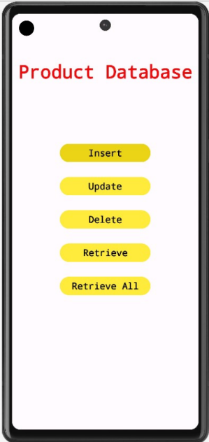 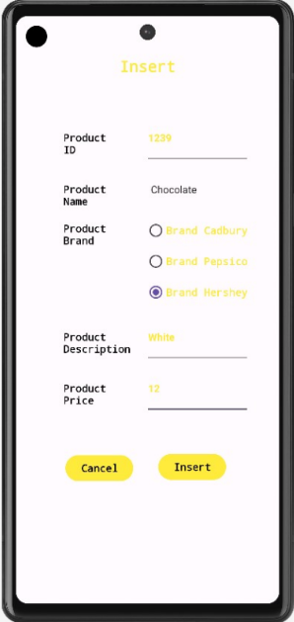

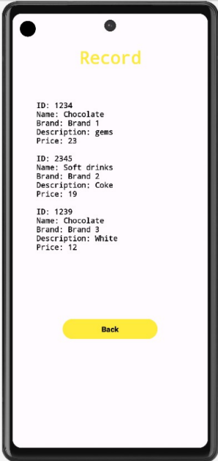 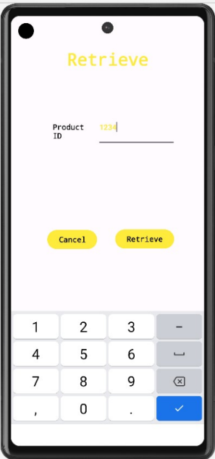

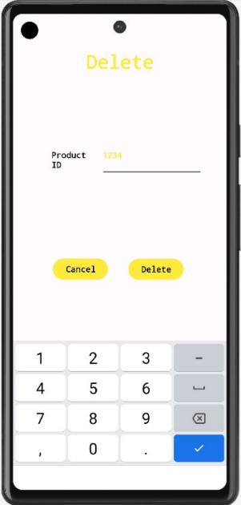 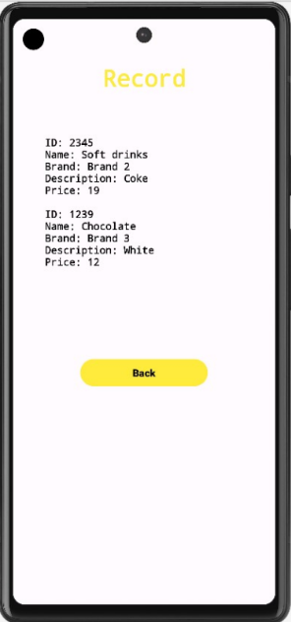

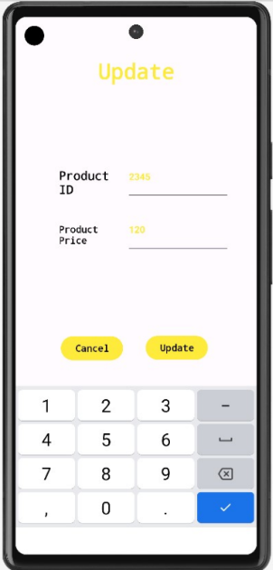 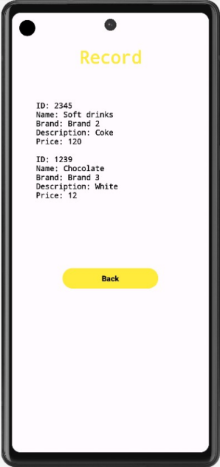

**Best Practices followed :**

1. The naming convention has been followed to name all the variables used in the code
2. Appropriate versions of the java builds are used to run the mobile application
3. Comments explaining the code written have been included.
4. Labels provided for all the input fields
5. Legible display of the form has been maintained.

**Learning Outcomes :**

1. Develop mobile applications using GUI, Layouts and Event Listener
2. Learnt to perform CRUD operations using SQLite database.
3. Learnt to switch between activities.

**Ex. No. 5 Android Application using Multithreading**

**Objective :**

To develop an android application to perform multithreading. Define 3 threads to run concurrently when the “start” button is clicked. The first thread should change the color of the text indefinitely The second thread should implement a moving banner The third thread should display a counter starting from 0 to 1000 When the “Stop” button is pressed all the threads should be stopped

**Android widgets used :**

1. TextView for display
2. Buttons to add functionality

**Source Code:**

**Activity_main.xml**

<?xml version="1.0" encoding="utf-8"?>

<androidx.constraintlayout.widget.ConstraintLayout

xmlns:android="<http://schemas.android.com/apk/res/android>"

xmlns:app="<http://schemas.android.com/apk/res-auto>"

xmlns:tools="<http://schemas.android.com/tools>"

android:layout_width="match_parent"

android:layout_height="match_parent"

tools:context=".MainActivity"

tools:layout_editor_absoluteX="-1dp"

tools:layout_editor_absoluteY="-83dp">

<TextView

android:id="@+id/t1"

android:layout_width="wrap_content"

android:layout_height="wrap_content"

android:text="Hello World!"

android:textSize="24sp"

app:layout_constraintBottom_toBottomOf="parent"

app:layout_constraintHorizontal_bias="0.498"

app:layout_constraintLeft_toLeftOf="parent"

app:layout_constraintRight_toRightOf="parent"

app:layout_constraintTop_toTopOf="parent"

app:layout_constraintVertical_bias="0.383" />

<TextView

android:id="@+id/t2"

android:layout_width="wrap_content"

android:layout_height="wrap_content"

android:text="Hello World!"

android:textSize="24sp"

app:layout_constraintBottom_toBottomOf="parent"

app:layout_constraintHorizontal_bias="0.501"

app:layout_constraintLeft_toLeftOf="parent"

app:layout_constraintRight_toRightOf="parent"

app:layout_constraintTop_toTopOf="parent"

app:layout_constraintVertical_bias="0.266" />

<TextView

android:id="@+id/t3"

android:layout_width="wrap_content"

android:layout_height="wrap_content"

android:text="0"

android:textSize="24sp"

app:layout_constraintBottom_toBottomOf="parent"

app:layout_constraintHorizontal_bias="0.498"

app:layout_constraintLeft_toLeftOf="parent"

app:layout_constraintRight_toRightOf="parent"

app:layout_constraintTop_toTopOf="parent"

app:layout_constraintVertical_bias="0.155" />

<Button

android:id="@+id/stop"

android:layout_width="wrap_content"

android:layout_height="wrap_content"

android:layout_marginTop="76dp"

android:text="Stop"

app:layout_constraintEnd_toEndOf="parent"

app:layout_constraintHorizontal_bias="0.684"

app:layout_constraintStart_toStartOf="parent"

app:layout_constraintTop_toBottomOf="@+id/t1" />

<Button

android:id="@+id/start"

android:layout_width="wrap_content"

android:layout_height="wrap_content"

android:layout_marginTop="76dp"

android:text="Start"

app:layout_constraintEnd_toEndOf="parent"

app:layout_constraintHorizontal_bias="0.236"

app:layout_constraintStart_toStartOf="parent"

app:layout_constraintTop_toBottomOf="@+id/t1" />

</androidx.constraintlayout.widget.ConstraintLayout>

**MainActivity.java:**

package com.example.ex5;

import androidx.appcompat.app.AppCompatActivity;

import android.graphics.Color;

import android.os.Bundle;

import android.util.Log;

import android.view.View;

import android.widget.Button;

import android.widget.TextView;

public class MainActivity extends AppCompatActivity {

@Override

protected void onCreate(Bundle savedInstanceState) {

super.onCreate(savedInstanceState);

setContentView(R.layout.activity_main);

TextView t1 = findViewById(R.id.t1);

Thread1 th1 = new Thread1(t1);

TextView t2 = findViewById(R.id.t2);

Thread2 th2 = new Thread2(t2);

TextView t3 = findViewById(R.id.t3);

Thread3 th3 = new Thread3(t3);

final boolean[] init = {false};

Button start = findViewById(R.id.start);

start.setOnClickListener(new View.OnClickListener() {

@Override

public void onClick(View v) {

if(!init[0]){

th1.start();

th2.start();

th3.start();

init[0] = true;

}

else{

Log.d("debug","hello");

th1.pause(false);

th2.pause(false);

th3.pause(false);

}

}

});

Button stop = findViewById(R.id.stop);

stop.setOnClickListener(new View.OnClickListener() {

@Override

public void onClick(View v) {

th1.pause(true);

th2.pause(true);

th3.pause(true);

}

});

}

}

**Thread1.java:**

package com.example.ex5;

import android.graphics.Color;

import android.util.Log;

import android.widget.TextView;

public class Thread1 extends Thread{

TextView t;

int red = 120;

int green = 120;

int blue = 120;

boolean paused = false;

Object lock = new Object();

Thread1(TextView t){

this.t=t;

}

public void pause(boolean paused){

synchronized (lock){

if(paused)

this.paused = true;

else{

this.paused = false;

lock.notifyAll();

}

}

Log.d("Debug",""+paused);

}

public void run(){

while(true) {

try {

int color = Color.rgb(red, green, blue);

t.setTextColor(color);

red = (red + 20) % 255;

green = (green + 10) % 255;

blue = (blue + 5) % 255;

Thread.sleep(500);

synchronized (lock){

while(paused){

try{

lock.wait();

}catch(InterruptedException e){

}

}

}

} catch (InterruptedException e) {

e.printStackTrace();

}

}

}

}

**Thread2.java:**

package com.example.ex5;

import android.util.Log;

import android.view.animation.TranslateAnimation;

import android.widget.TextView;

public class Thread2 extends Thread{

TextView t;

int dir = 1;

int translationDistance = 300;

boolean paused=false;

Object lock = new Object();

Thread2(TextView t){

this.t=t;

}

public void pause(boolean paused){

synchronized (lock){

if(paused)

this.paused = true;

else{

this.paused = false;

lock.notifyAll();

}

}

Log.d("Debug",""+paused);

}

public void run(){

while (!paused) {

try {

TranslateAnimation animation;

if (dir == 1) {

animation = new TranslateAnimation(-translationDistance,translationDistance, 0, 0);

} else {

animation = new TranslateAnimation(translationDistance,-translationDistance, 0, 0);

}

animation.setDuration(3000);

animation.setFillAfter(true);

t.startAnimation(animation);

Thread.sleep(3000);

dir = 1 - dir;

synchronized (lock){

while(paused){

try{

lock.wait();

}catch(InterruptedException e){

}

}

}

} catch (InterruptedException e) {

e.printStackTrace();

}

}

}

}

**Thread3.java:**

package com.example.ex5;

import android.util.Log;

import android.widget.TextView;

public class Thread3 extends Thread{

TextView t;

int ctr=0;

boolean paused = false;

Object lock = new Object();

Thread3(TextView t){

this.t=t;

}

public void pause(boolean paused){

synchronized (lock){

if(paused)

this.paused = true;

else{

this.paused = false;

lock.notifyAll();

}

}

Log.d("Debug",""+paused);

}

public void run(){

while (ctr < 3000 && !paused) {

try {

Thread.sleep(1000);

ctr += 1;

t.post(new Runnable() {

@Override

public void run() {

t.setText(Integer.toString(ctr));

}

});

synchronized (lock){

while(paused){

try{

lock.wait();

}catch(InterruptedException e){

}

}

}

} catch (InterruptedException e) {

paused = true;

e.printStackTrace();

}

}

}

}

**Output Screenshots :**

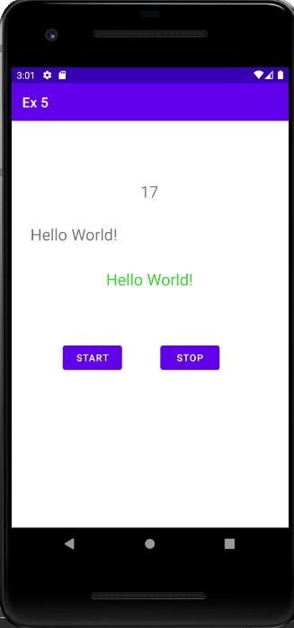

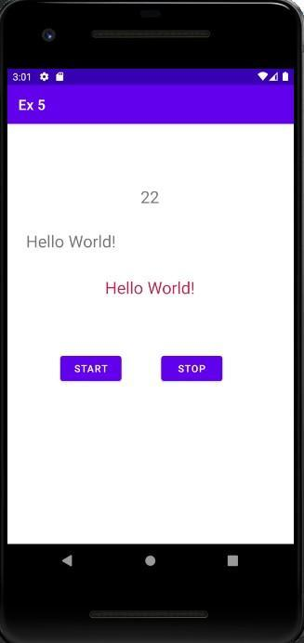

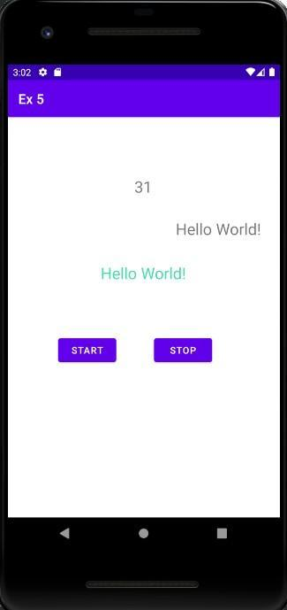

**Best Practices followed :**

1. Names for ids of buttons were set meaningfully
2. Implemented pause and resume in a single function
3. Handled exceptions

**Learning Outcomes :**

1. Learnt to implement multithreading
2. Learnt to start, stop and resume threads

**Ex. No. 6 Android Application for Location Tracking**

**Objective :**

1. To develop an Android Application that uses Geographical Positioning System (GPS) to display the user’s current location in terms of Latitude and Longitude.
2. To develop a mobile app to display the Geolocation of a given place.

**Android widgets used :**

1. TextView - display longitude and latitude
2. EditText - for location input
3. Buttons - trigger functions

**Source Code:**

**AndroidManifest.xml**

<uses-permission android:name="android.permission.ACCESS_FINE_LOCATION" />

<uses-permission android:name="android.permission.ACCESS_COARSE_LOCATION" />

**Activity_main.xml**

<?xml version="1.0" encoding="utf-8"?>

<RelativeLayout xmlns:android="http://schemas.android.com/apk/res/android"

xmlns:app="http://schemas.android.com/apk/res-auto"

xmlns:tools="http://schemas.android.com/tools"

android:layout_width="match_parent"

android:layout_height="match_parent"

android:padding="16dp"

tools:context=".MainActivity">

<TextView

android:id="@+id/latitudeText"

android:layout_width="wrap_content"

android:layout_height="wrap_content"

android:layout_centerHorizontal="true"

android:text="Latitude: "

android:textSize="18sp" />

<TextView

android:id="@+id/longitudeText"

android:layout_width="wrap_content"

android:layout_height="wrap_content"

android:text="Longitude: "

android:textSize="18sp"

android:layout_below="@+id/latitudeText"

android:layout_centerHorizontal="true"

android:layout_marginTop="16dp"/>

<Button

android:id="@+id/getLocationButton"

android:layout_width="wrap_content"

android:layout_height="wrap_content"

android:layout_below="@+id/longitudeText"

android:layout_centerHorizontal="true"

android:layout_marginTop="32dp"

android:text="Get Location" />

<EditText

android:id="@+id/placeEditText"

android:layout_width="wrap_content"

android:layout_height="wrap_content"

android:layout_below="@+id/getLocationButton"

android:layout_centerHorizontal="true"

android:layout_marginTop="55dp"

android:ems="10"

android:inputType="textPersonName"

android:text="" />

<TextView

android:id="@+id/textView"

android:layout_width="wrap_content"

android:layout_height="wrap_content"

android:layout_below="@+id/getLocationButton"

android:layout_marginLeft="86dp"

android:layout_marginTop="33dp"

android:text="Enter Place" />

<TextView

android:id="@+id/latitudeText2"

android:layout_width="wrap_content"

android:layout_height="wrap_content"

android:layout_below="@+id/geocodeButton"

android:layout_centerHorizontal="true"

android:text="Latitude: "

android:textSize="18sp" />

<TextView

android:id="@+id/longitudeText2"

android:layout_width="wrap_content"

android:layout_height="wrap_content"

android:text="Longitude: "

android:textSize="18sp"

android:layout_below="@+id/latitudeText2"

android:layout_centerHorizontal="true"

android:layout_marginTop="16dp"/>

<Button

android:id="@+id/geocodeButton"

android:layout_width="wrap_content"

android:layout_height="wrap_content"

android:layout_below="@+id/placeEditText"

android:layout_centerHorizontal="true"

android:text="Find Location" />

</RelativeLayout>

**MainActivity.java**

package com.example.gpsappl;

import android.Manifest;

import android.content.pm.PackageManager;

import android.location.Location;

import android.os.Bundle;

import android.view.View;

import android.widget.Button;

import android.widget.TextView;

import android.widget.EditText;

import androidx.annotation.NonNull;

import androidx.appcompat.app.AppCompatActivity;

import androidx.core.app.ActivityCompat;

import androidx.core.content.ContextCompat;

import com.google.android.gms.location.FusedLocationProviderClient;

import com.google.android.gms.location.LocationServices;

import com.google.android.gms.tasks.OnSuccessListener;

import java.io.IOException;

import java.util.List;

import java.util.Locale;

import android.location.Address;

import android.location.Geocoder;

public class MainActivity extends AppCompatActivity {

private static final int LOCATION_PERMISSION_REQUEST_CODE = 1001;

private TextView latitudeText;

private TextView longitudeText;

private Button getLocationButton;

private FusedLocationProviderClient fusedLocationClient;

private EditText placeEditText;

private Button geocodeButton;

private TextView latitudeText2;

private TextView longitudeText2;

private Geocoder geocoder;

@Override

protected void onCreate(Bundle savedInstanceState) {

super.onCreate(savedInstanceState);

setContentView(R.layout.activity_main);

latitudeText = findViewById(R.id.latitudeText);

longitudeText = findViewById(R.id.longitudeText);

getLocationButton = findViewById(R.id.getLocationButton);

getLocationButton.setOnClickListener(new View.OnClickListener() {

@Override

public void onClick(View v) {

requestLocationPermission();

}

});

placeEditText = findViewById(R.id.placeEditText);

geocodeButton = findViewById(R.id.geocodeButton);

latitudeText2 = findViewById(R.id.latitudeText2);

longitudeText2 = findViewById(R.id.longitudeText2);

geocoder = new Geocoder(this, Locale.getDefault());

geocodeButton.setOnClickListener(new View.OnClickListener() {

@Override

public void onClick(View v) {

geocodePlace();

}

});

// Initialize the FusedLocationProviderClient

fusedLocationClient = LocationServices.getFusedLocationProviderClient(this);

}

private void requestLocationPermission() {

if (ContextCompat.checkSelfPermission(this,

Manifest.permission.ACCESS_FINE_LOCATION) != PackageManager.PERMISSION_GRANTED) {

ActivityCompat.requestPermissions(this,

new String[]{Manifest.permission.ACCESS_FINE_LOCATION},

LOCATION_PERMISSION_REQUEST_CODE);

} else {

// Permission already granted

getLocation();

}

}

@Override

public void onRequestPermissionsResult(int requestCode, @NonNull String[] permissions,

@NonNull int[] grantResults) {

if (requestCode == LOCATION_PERMISSION_REQUEST_CODE) {

if (grantResults.length > 0 && grantResults[0] == PackageManager.PERMISSION_GRANTED) {

getLocation();

}

}

}

private void getLocation() {

// Check if permission is granted before accessing location

if (ContextCompat.checkSelfPermission(this,

Manifest.permission.ACCESS_FINE_LOCATION) == PackageManager.PERMISSION_GRANTED) {

fusedLocationClient.getLastLocation()

.addOnSuccessListener(this, new OnSuccessListener<Location>() {

@Override

public void onSuccess(Location location) {

if (location != null) {

double latitude = location.getLatitude();

double longitude = location.getLongitude();

latitudeText.setText("Latitude: " + latitude);

longitudeText.setText("Longitude: " + longitude);

}

}

});

}

}

private void geocodePlace() {

String placeName = placeEditText.getText().toString().trim();

try {

List<Address> addresses = geocoder.getFromLocationName(placeName, 1);

if (!addresses.isEmpty()) {

Address address = addresses.get(0);

double latitude = address.getLatitude();

double longitude = address.getLongitude();

latitudeText2.setText("Latitude: " + latitude);

longitudeText2.setText("Longitude: " + longitude);

} else {

latitudeText2.setText("Latitude: N/A");

longitudeText2.setText("Longitude: N/A");

}

} catch (IOException e) {

e.printStackTrace();

latitudeText2.setText("Latitude: N/A");

longitudeText2.setText("Longitude: N/A");

}

}

}

**Output Screenshots:**

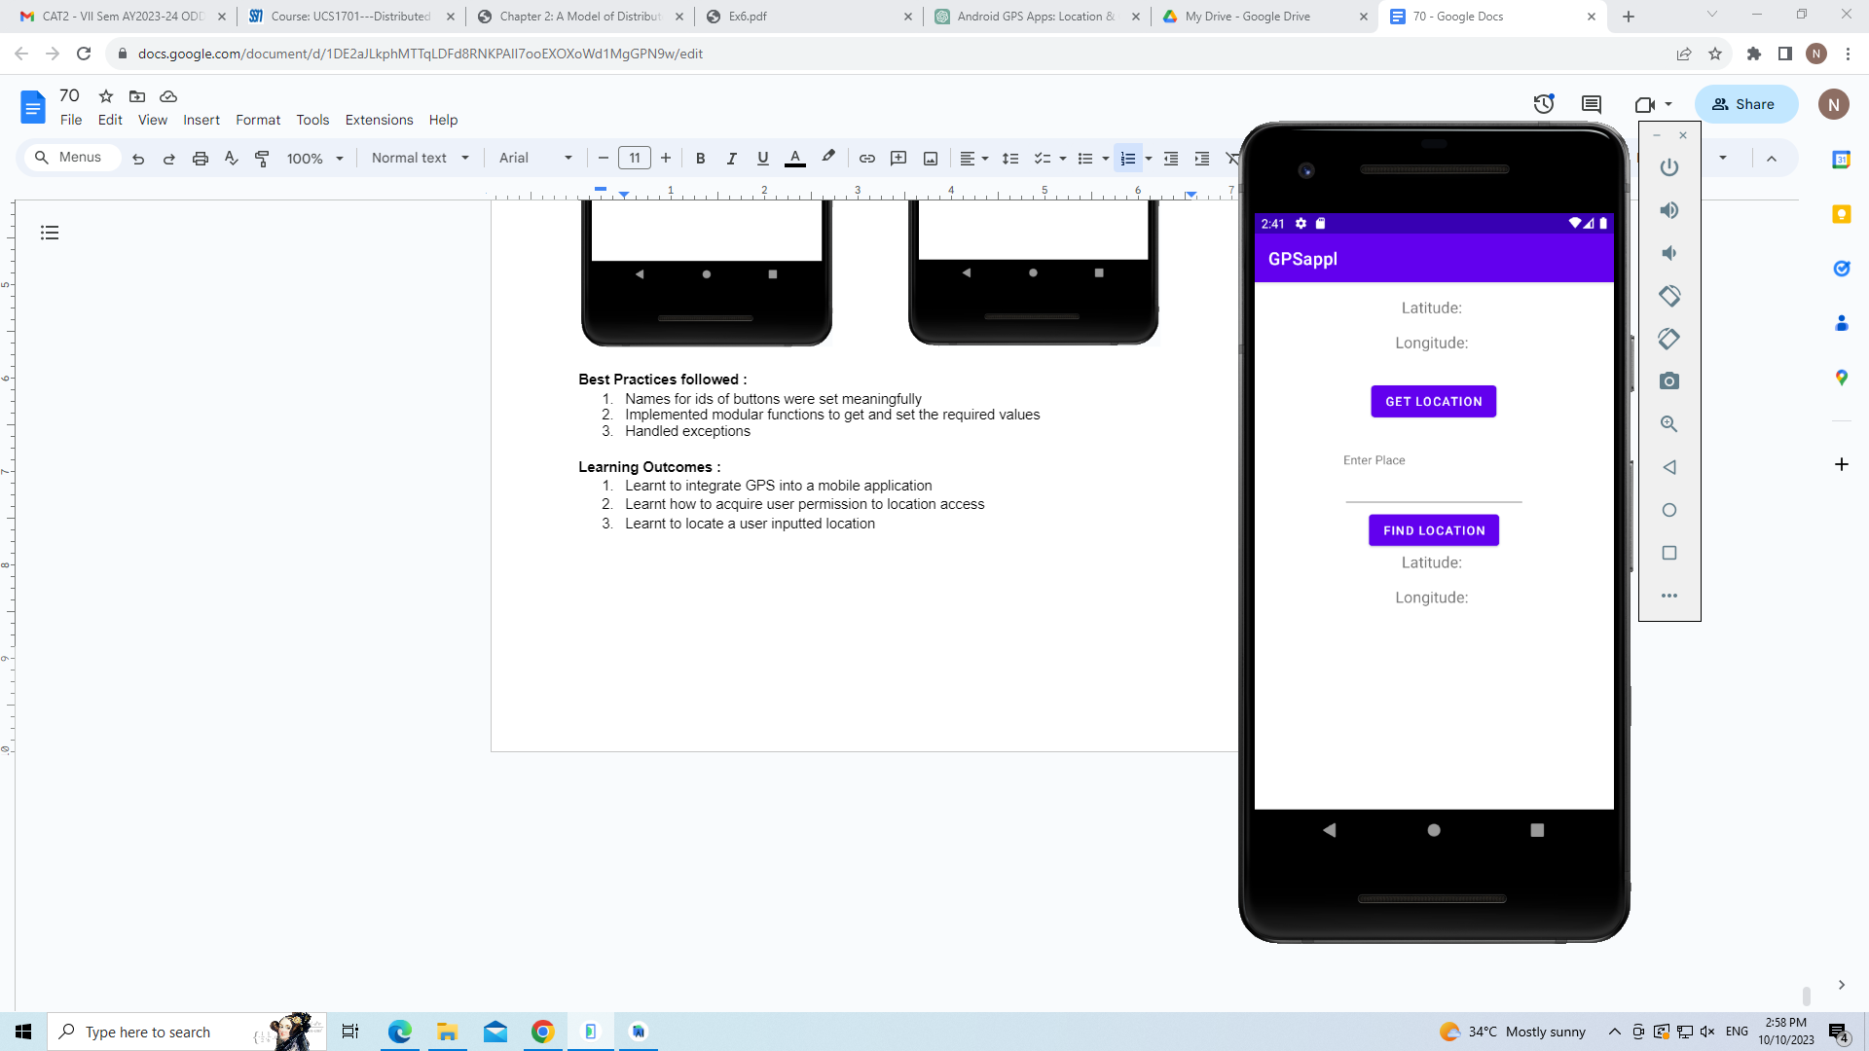 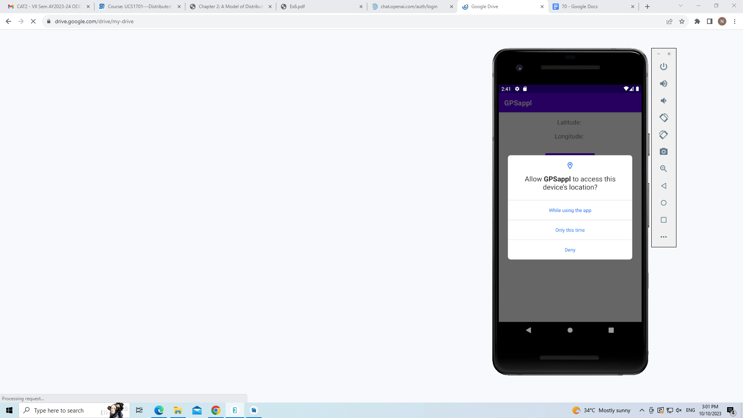

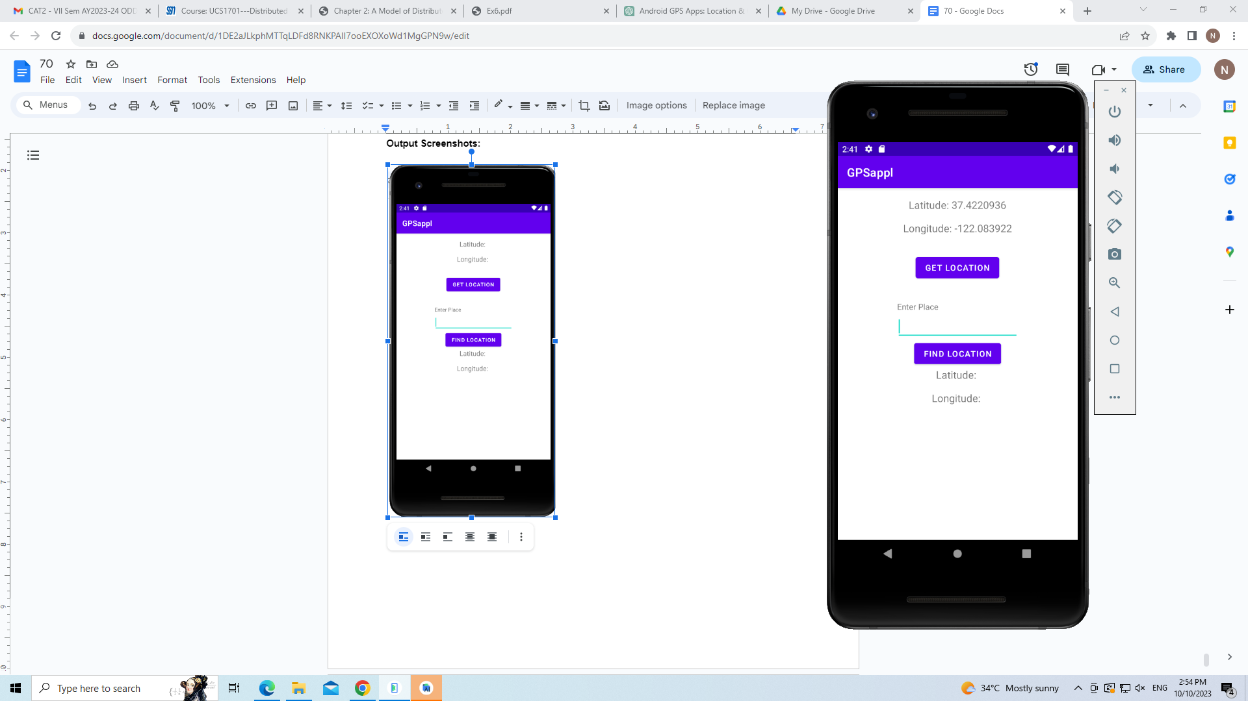 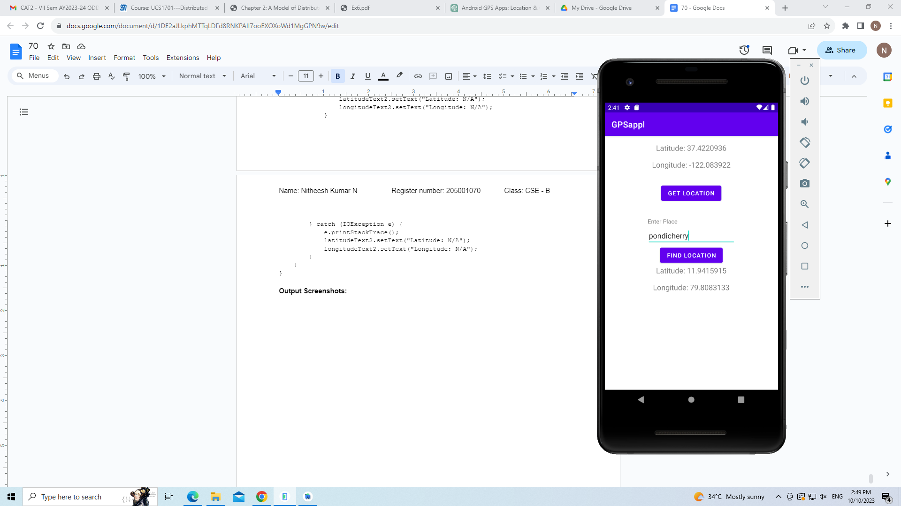

**Best Practices followed :**

1. Names for ids of buttons were set meaningfully
2. Implemented modular functions to get and set the required values
3. Handled exceptions

**Learning Outcomes :**

1. Learnt to integrate GPS into a mobile application
2. Learnt how to acquire user permission to location access
3. Learnt to locate a user inputted location

**Ex 7: Android Application to write/read a file to/from the SD Card**

**Objective :**

Develop an Android Application to write/read some contents to/from the SD Card.

1. In a TextView write the contents of the file.

2. Use another TextView to read the file name from the user.

3. On clicking ‘Write’ Button,

* Create a file mentioned in 2nd TextView.
* Write the contents (using 1st TextView) in the file.

**Store the file in the SD card**.

4. On clicking ‘Read’ Button,

* Move to a new activity.
* Read the file name(TextView)

Read the contents of the file from SD card and display in a new TextView.

**Layouts Used:** Main Activity and Read Intents. Edit and Text Views.

**Code:**

**MainActivity.java:**

package com.example.ex7;

import android.Manifest;

import android.content.Intent;

import android.content.pm.PackageManager;

import android.os.Bundle;

import android.os.Environment;

import android.util.Log;

import android.view.View;

import android.widget.Button;

import android.widget.EditText;

import android.widget.Toast;

import androidx.annotation.NonNull;

import androidx.appcompat.app.AppCompatActivity;

import androidx.core.app.ActivityCompat;

import androidx.core.content.ContextCompat;

import java.io.File;

import java.io.FileOutputStream;

import java.io.IOException;

public class MainActivity extends AppCompatActivity {

private static final int REQUEST_WRITE_EXTERNAL_STORAGE = 1;

@Override

protected void onCreate(Bundle savedInstanceState) {

super.onCreate(savedInstanceState);

setContentView(R.layout.activity_main);

// Request the WRITE_EXTERNAL_STORAGE permission if not granted

if (ContextCompat.checkSelfPermission(this,

Manifest.permission.WRITE_EXTERNAL_STORAGE)

!= PackageManager.PERMISSION_GRANTED) {

ActivityCompat.requestPermissions(this, new

String[]{Manifest.permission.WRITE_EXTERNAL_STORAGE},

REQUEST_WRITE_EXTERNAL_STORAGE);

} else {

// Permission already granted, perform file operations

Button button = findViewById(R.id.write);

button.setOnClickListener(new View.OnClickListener() {

@Override

public void onClick(View v) {

EditText et1 = findViewById(R.id.et1);

String file = et1.getText().toString();

EditText et2 = findViewById(R.id.et2);

String content = et2.getText().toString();

createAndWriteFileToSDCard(file,content);

}

});

}

Button read = findViewById(R.id.read1);

read.setOnClickListener(new View.OnClickListener() {

@Override

public void onClick(View v) {

Intent intent = new Intent(MainActivity.this,Read.class);

startActivity(intent);

}

});

}

// Handle permission request results

@Override

public void onRequestPermissionsResult(int requestCode, @NonNull String[] permissions, @NonNull int[] grantResults) {

super.onRequestPermissionsResult(requestCode, permissions,

grantResults);

if (requestCode == REQUEST_WRITE_EXTERNAL_STORAGE) {

if (grantResults.length > 0 && grantResults[0] ==

PackageManager.PERMISSION_GRANTED) {

Toast.makeText(this, "Permission granted. Can write to SD card.", Toast.LENGTH_SHORT).show();

Button button = findViewById(R.id.write);

button.setOnClickListener(new View.OnClickListener() {

@Override

public void onClick(View v) {

EditText et1 = findViewById(R.id.et1);

String file = et1.getText().toString();

EditText et2 = findViewById(R.id.et2);

String content = et2.getText().toString();

createAndWriteFileToSDCard(file,content);

}

});

} else {

Toast.makeText(this, "Permission denied. Cannot write to SD card.", Toast.LENGTH_SHORT).show();

}

}

}

private void createAndWriteFileToSDCard(String fileName,String fileContent) { // Check if external storage is available

if (isExternalStorageWritable()) {

File sdCard = Environment.getExternalStorageDirectory();

File directory = new File(sdCard.getAbsolutePath() + "/ex7"); // Change to your desired directory

directory.mkdirs();

File file = new File(directory, fileName+".txt"); // Change the file name as needed

try {

FileOutputStream fos = new FileOutputStream(file);

fos.write(fileContent.getBytes());

fos.close();

Toast.makeText(this, "File created and written to SD card",

Toast.LENGTH_SHORT).show();

} catch (IOException e) {

Log.e("FileWriteError", "Error writing to file on SD card: " +

e.getMessage());

}

} else {

Toast.makeText(this, "SD card is not available for writing.",

Toast.LENGTH_SHORT).show();

}

}

private boolean isExternalStorageWritable() {

String state = Environment.getExternalStorageState();

return Environment.MEDIA_MOUNTED.equals(state);

}

}

**Read.java:**

package com.example.ex7;

import android.Manifest;

import android.content.pm.PackageManager; import android.os.Bundle;

import android.os.Environment;

import android.util.Log;

import android.view.View;

import android.widget.Button;

import android.widget.EditText;

import android.widget.TextView;

import android.widget.Toast;

import androidx.annotation.NonNull;

import androidx.appcompat.app.AppCompatActivity; import androidx.core.app.ActivityCompat; import androidx.core.content.ContextCompat;

import java.io.BufferedReader;

import java.io.File;

import java.io.FileReader;

import java.io.IOException;

public class Read extends AppCompatActivity {

private static final int REQUEST_READ_EXTERNAL_STORAGE = 2;

private TextView fileContentsTextView;

@Override

protected void onCreate(Bundle savedInstanceState) {

super.onCreate(savedInstanceState);

setContentView(R.layout.read);

fileContentsTextView = findViewById(R.id.content);

// Request the READ_EXTERNAL_STORAGE permission if not granted

if (ContextCompat.checkSelfPermission(this,

Manifest.permission.READ_EXTERNAL_STORAGE)

!= PackageManager.PERMISSION_GRANTED) {

ActivityCompat.requestPermissions(this, new

String[]{Manifest.permission.READ_EXTERNAL_STORAGE},

REQUEST_READ_EXTERNAL_STORAGE);

} else {

// Permission already granted, perform file reading

Button readButton = findViewById(R.id.read2);

readButton.setOnClickListener(new View.OnClickListener() {

@Override

public void onClick(View v) {

EditText fileNameEditText = findViewById(R.id.name);

String fileName = fileNameEditText.getText().toString();

readFileFromSDCard(fileName);

}

});

}

}

// Handle permission request results

@Override

public void onRequestPermissionsResult(int requestCode, @NonNull String[] permissions, @NonNull int[] grantResults) {

super.onRequestPermissionsResult(requestCode, permissions,

grantResults);

if (requestCode == REQUEST_READ_EXTERNAL_STORAGE) {

if (grantResults.length > 0 && grantResults[0] ==

PackageManager.PERMISSION_GRANTED) {

Toast.makeText(this, "Permission granted. Can read from SD card.", Toast.LENGTH_SHORT).show();

Button readButton = findViewById(R.id.read2);

readButton.setOnClickListener(new View.OnClickListener() {

@Override

public void onClick(View v) {

EditText fileNameEditText = findViewById(R.id.name);

String fileName = fileNameEditText.getText().toString();

readFileFromSDCard(fileName);

}

});

} else {

Toast.makeText(this, "Permission denied. Cannot read from SD card.", Toast.LENGTH_SHORT).show();

}

}

}

private void readFileFromSDCard(String fileName) {

if (isExternalStorageReadable()) {

File sdCard = Environment.getExternalStorageDirectory();

File directory = new File(sdCard.getAbsolutePath() + "/ex7"); // Change to your directory

File file = new File(directory, fileName + ".txt");

if (file.exists()) {

try {

BufferedReader br = new BufferedReader(new FileReader(file));

StringBuilder text = new StringBuilder();

String line;

while ((line = br.readLine()) != null) {

text.append(line);

text.append('\n');

}

br.close();

fileContentsTextView.setText(text.toString());

} catch (IOException e) {

Log.e("FileReadError", "Error reading file on SD card: " +

e.getMessage());

fileContentsTextView.setText("Error reading file.");

}

} else {

fileContentsTextView.setText("File not found.");

}

} else {

fileContentsTextView.setText("SD card is not available for reading."); }

}

private boolean isExternalStorageReadable() {

String state = Environment.getExternalStorageState();

return Environment.MEDIA_MOUNTED.equals(state) || Environment.MEDIA_MOUNTED_READ_ONLY.equals(state);

}

}

**Activity_main.xml:**

<?xml version="1.0" encoding="utf-8"?>

<androidx.constraintlayout.widget.ConstraintLayout xmlns:android="http://schemas.android.com/apk/res/android"

xmlns:app="http://schemas.android.com/apk/res-auto" xmlns:tools="http://schemas.android.com/tools"

android:layout_width="match_parent"

android:layout_height="match_parent"

tools:context=".MainActivity">

<TextView

android:id="@+id/tv2"

android:layout_width="wrap_content"

android:layout_height="wrap_content"

android:text="Enter text"

android:textSize="24sp"

app:layout_constraintBottom_toBottomOf="parent" app:layout_constraintEnd_toEndOf="parent"

app:layout_constraintHorizontal_bias="0.498" app:layout_constraintStart_toStartOf="parent" app:layout_constraintTop_toTopOf="parent" app:layout_constraintVertical_bias="0.387" />

<EditText

android:id="@+id/et1"

android:layout_width="wrap_content" android:layout_height="wrap_content" android:layout_marginTop="184dp"

android:ems="10"

android:inputType="textPersonName" android:text=""

app:layout_constraintEnd_toEndOf="parent" app:layout_constraintHorizontal_bias="0.497" app:layout_constraintStart_toStartOf="parent" app:layout_constraintTop_toTopOf="parent" />

<EditText

android:id="@+id/et2"

android:layout_width="wrap_content" android:layout_height="wrap_content" android:ems="10"

android:inputType="textPersonName"

android:text=""

app:layout_constraintBottom_toBottomOf="parent" app:layout_constraintEnd_toEndOf="parent" app:layout_constraintHorizontal_bias="0.497" app:layout_constraintStart_toStartOf="parent" app:layout_constraintTop_toTopOf="parent" />

<TextView

android:id="@+id/tv1"

android:layout_width="wrap_content"

android:layout_height="wrap_content"

android:layout_marginTop="128dp"

android:text="Enter file name"

android:textSize="24sp"

app:layout_constraintEnd_toEndOf="parent" app:layout_constraintStart_toStartOf="parent" app:layout_constraintTop_toTopOf="parent" />

<Button

android:id="@+id/write"

android:layout_width="wrap_content"

android:layout_height="wrap_content"

android:text="Write"

app:layout_constraintBottom_toBottomOf="parent" app:layout_constraintEnd_toEndOf="parent" app:layout_constraintHorizontal_bias="0.498" app:layout_constraintStart_toStartOf="parent" app:layout_constraintTop_toTopOf="parent" app:layout_constraintVertical_bias="0.65" />

<Button

android:id="@+id/read1"

android:layout_width="wrap_content"

android:layout_height="wrap_content"

android:layout_marginBottom="156dp"

android:text="Read"

app:layout_constraintBottom_toBottomOf="parent" app:layout_constraintEnd_toEndOf="parent" app:layout_constraintHorizontal_bias="0.498" app:layout_constraintStart_toStartOf="parent" />

</androidx.constraintlayout.widget.ConstraintLayout>

**Read.xml:**

<?xml version="1.0" encoding="utf-8"?>

<androidx.constraintlayout.widget.ConstraintLayout xmlns:android="http://schemas.android.com/apk/res/android"

xmlns:app="http://schemas.android.com/apk/res-auto" xmlns:tools="http://schemas.android.com/tools"

android:layout_width="match_parent"

android:layout_height="match_parent">

<TextView

android:id="@+id/textView3"

android:layout_width="207dp"

android:layout_height="47dp"

android:text="File Content:"

android:textSize="24sp"

app:layout_constraintBottom_toBottomOf="parent" app:layout_constraintEnd_toEndOf="parent"

app:layout_constraintStart_toStartOf="parent"

app:layout_constraintTop_toTopOf="parent"

app:layout_constraintVertical_bias="0.602" />

<TextView

android:id="@+id/textView"

android:layout_width="125dp"

android:layout_height="50dp"

android:text="File Name"

android:textSize="24sp"

app:layout_constraintBottom_toBottomOf="parent" app:layout_constraintEnd_toEndOf="parent" app:layout_constraintHorizontal_bias="0.461" app:layout_constraintStart_toStartOf="parent" app:layout_constraintTop_toTopOf="parent" app:layout_constraintVertical_bias="0.19" />

<EditText

android:id="@+id/name"

android:layout_width="wrap_content"

android:layout_height="wrap_content"

android:ems="10"

android:inputType="textPersonName"

android:text=""

android:textSize="24sp"

app:layout_constraintBottom_toBottomOf="parent" app:layout_constraintEnd_toEndOf="parent" app:layout_constraintHorizontal_bias="0.496" app:layout_constraintStart_toStartOf="parent" app:layout_constraintTop_toTopOf="parent" app:layout_constraintVertical_bias="0.29" />

<EditText

android:id="@+id/content"

android:layout_width="wrap_content"

android:layout_height="wrap_content"

android:ems="10"

android:inputType="textPersonName"

android:text=""

android:textSize="24sp"

app:layout_constraintBottom_toBottomOf="parent" app:layout_constraintEnd_toEndOf="parent" app:layout_constraintHorizontal_bias="0.496" app:layout_constraintStart_toStartOf="parent" app:layout_constraintTop_toTopOf="parent" app:layout_constraintVertical_bias="0.724" />

<Button

android:id="@+id/read2"

android:layout_width="wrap_content"

android:layout_height="wrap_content"

android:text="Read"

app:layout_constraintBottom_toBottomOf="parent" app:layout_constraintEnd_toEndOf="parent" app:layout_constraintHorizontal_bias="0.498"

app:layout_constraintStart_toStartOf="parent"

app:layout_constraintTop_toTopOf="parent"

app:layout_constraintVertical_bias="0.407" />

</androidx.constraintlayout.widget.ConstraintLayout>

**AndroidManifest.xml:**

<?xml version="1.0" encoding="utf-8"?>

<manifest xmlns:android="http://schemas.android.com/apk/res/android" package="com.example.ex7">

<application

android:allowBackup="true"

android:icon="@mipmap/ic_launcher"

android:label="@string/app_name"

android:roundIcon="@mipmap/ic_launcher_round"

android:supportsRtl="true"

android:theme="@style/Theme.Ex7">

<activity

android:name=".MainActivity"

android:exported="true">

<intent-filter>

<action android:name="android.intent.action.MAIN" />

<category android:name="android.intent.category.LAUNCHER" /> </intent-filter>

</activity>

<activity android:name=".Read"></activity>

</application>

<uses-permission

android:name="android.permission.WRITE_EXTERNAL_STORAGE" />

<uses-permission

android:name="android.permission.READ_EXTERNAL_STORAGE" />

<uses-permission

android:name="android.permission.MANAGE_EXTERNAL_STORAGE" />

</manifest>

**Output Screenshots:**

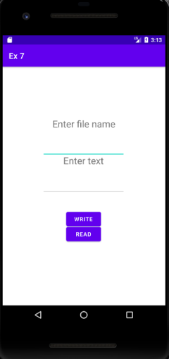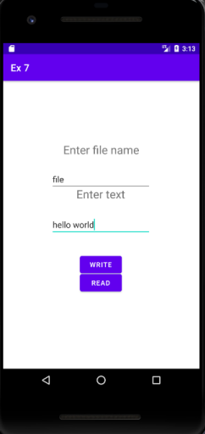

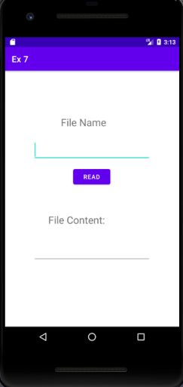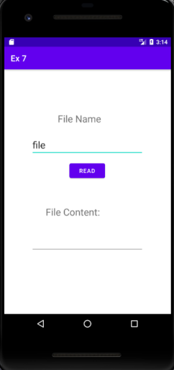

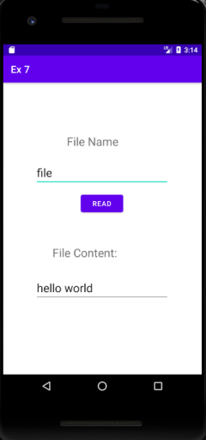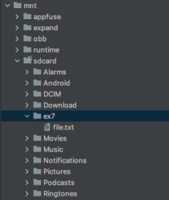

**Best Practices followed :**

1. Used appropriate ids for buttons, views and intents
2. Aligned views.

**Learning Outcomes :**

1. Learnt to create a file
2. Learnt to write to a file and store the file in SD card
3. Learnt to read from a file that is in SD card.

**Ex. No. 8 Android Application to send SMS and Notification**

**Objective :**

To develop an Android Application to send SMS and Notification for the SMS.

**Android widgets used :**

1. TextView - display field labels
2. EditText - for mobile number and message input fields
3. Button - to send message

**Source Code:**

**AndroidManifest.xml**

<uses-permission android:name="android.permission.SEND_SMS" /> <uses-permission android:name="android.permission.RECEIVE_SMS” /> <uses-permission android:name="android.permission.READ_SMS" />

**Activity_main.xml**

<?xml version="1.0" encoding="utf-8"?>

<androidx.constraintlayout.widget.ConstraintLayout

xmlns:android="http://schemas.android.com/apk/res/android"

xmlns:app="http://schemas.android.com/apk/res-auto"

xmlns:tools="http://schemas.android.com/tools"

android:layout_width="match_parent"

android:layout_height="match_parent"

tools:context=".MainActivity">

<TextView

android:id="@+id/sms"

android:layout_width="152dp"

android:layout_height="32dp"

android:layout_marginStart="128dp"

android:layout_marginTop="148dp"

app:layout_constraintStart_toStartOf="parent"

app:layout_constraintTop_toBottomOf="@+id/content" />

<TextView

android:id="@+id/textView2"

android:layout_width="wrap_content"

android:layout_height="wrap_content"

android:text="SMS App"

android:textStyle="bold"

android:textAppearance="@style/TextAppearance.AppCompat.Display1"

android:textColor="#067A6A"

app:layout_constraintBottom_toBottomOf="parent"

app:layout_constraintLeft_toLeftOf="parent"

app:layout_constraintRight_toRightOf="parent"

app:layout_constraintTop_toTopOf="parent"

app:layout_constraintVertical_bias="0.096" />

<TextView

android:id="@+id/textView"

android:layout_width="wrap_content"

android:layout_height="wrap_content"

android:layout_marginTop="28dp"

android:layout_marginEnd="140dp"

android:text="Send an SMS"

android:textAppearance="@style/TextAppearance.AppCompat.Large"

android:textColor="#2F6C19"

app:layout_constraintEnd_toEndOf="parent"

app:layout_constraintTop_toBottomOf="@+id/textView2" />

<TextView

android:id="@+id/phno"

android:layout_width="wrap_content"

android:layout_height="wrap_content"

android:layout_marginStart="44dp"

android:layout_marginTop="44dp"

android:text="Phone Number:"

android:textAppearance="@style/TextAppearance.AppCompat.Medium"

android:textColor="#304FFE"

app:layout_constraintStart_toStartOf="parent"

app:layout_constraintTop_toBottomOf="@+id/textView" />

<TextView

android:id="@+id/smstv"

android:layout_width="wrap_content"

android:layout_height="wrap_content"

android:layout_marginStart="44dp"

android:layout_marginTop="104dp"

android:text="SMS Message:"

android:textAppearance="@style/TextAppearance.AppCompat.Medium"

android:textColor="#304FFE"

app:layout_constraintStart_toStartOf="parent"

app:layout_constraintTop_toBottomOf="@+id/textView" />

<EditText

android:id="@+id/phone"

android:layout_width="199dp"

android:layout_height="48dp"

android:layout_marginStart="12dp"

android:layout_marginTop="36dp"

android:ems="10"

android:hint="phone"

android:inputType="phone"

android:textAppearance="@style/TextAppearance.AppCompat.Body1"

app:layout_constraintStart_toEndOf="@+id/phno"

app:layout_constraintTop_toBottomOf="@+id/textView" />

<EditText

android:id="@+id/content"

android:layout_width="341dp"

android:layout_height="123dp"

android:layout_marginTop="20dp"

android:layout_marginEnd="32dp"

android:ems="10"

android:gravity="start|top"

android:hint="Type here"

android:inputType="textMultiLine"

android:textAppearance="@style/TextAppearance.AppCompat.Body1"

app:layout_constraintEnd_toEndOf="parent"

app:layout_constraintTop_toBottomOf="@+id/smstv" />

<Button

android:id="@+id/send"

android:layout_width="wrap_content"

android:layout_height="wrap_content"

android:layout_marginTop="48dp"

android:layout_marginEnd="160dp"

android:backgroundTint="#00BFA5"

android:text="SEND"

app:layout_constraintEnd_toEndOf="parent"

app:layout_constraintTop_toBottomOf="@+id/content" />

</androidx.constraintlayout.widget.ConstraintLayout>

**MainActivity.java**

package com.example.smsapp;

import androidx.appcompat.app.AppCompatActivity;

import androidx.core.app.ActivityCompat;

import androidx.core.app.NotificationCompat;

import androidx.core.content.ContextCompat;

import android.Manifest;

import android.app.NotificationChannel;

import android.app.NotificationManager;

import android.app.PendingIntent;

import android.content.BroadcastReceiver;

import android.content.Context;

import android.content.Intent;

import android.content.IntentFilter;

import android.content.pm.PackageManager;

import android.graphics.Color;

import android.os.Build;

import android.os.Bundle;

import android.telephony.SmsManager;

import android.view.View;

import android.widget.Button;

import android.widget.EditText;

import android.widget.TextView;

public class MainActivity extends AppCompatActivity

{

IntentFilter intentFilter;

private BroadcastReceiver intentReceiver = new BroadcastReceiver()

{

@Override

public void onReceive(Context context, Intent intent)

{

TextView sms = (TextView)findViewById(R.id.sms);

sms.setText(intent.getExtras().getString("message"));

}

};

@Override

protected void onCreate(Bundle savedInstanceState)

{

super.onCreate(savedInstanceState);

setContentView(R.layout.activity_main);

intentFilter = new IntentFilter();

intentFilter.addAction("SMS_RECEIVED_ACTION");

EditText contact = (EditText)findViewById(R.id.phone);

EditText message = (EditText)findViewById(R.id.content);

Button send = (Button)findViewById(R.id.send);

if (Build.VERSION.SDK_INT >= Build.VERSION_CODES.TIRAMISU)

{

if (ContextCompat.checkSelfPermission(MainActivity.this, Manifest.permission.POST_NOTIFICATIONS) != PackageManager.PERMISSION_GRANTED)

{

ActivityCompat.requestPermissions(MainActivity.this, new String[]{Manifest.permission.POST_NOTIFICATIONS}, 101);

}

}

send.setOnClickListener(new View.OnClickListener() {

@Override

public void

onClick(View view)

{

String msg = message.getText().toString();

String contactno = contact.getText().toString();

sendMsg(contactno, msg);

makeNotification(msg);

}

});

}

protected

void sendMsg(String contactno, String msg)

{

String SENT = "Message Sent";

String DELIVERED = "Message Delivered";

PendingIntent sentPI = PendingIntent.getBroadcast(this, 0, new Intent(SENT), PendingIntent.FLAG_IMMUTABLE);

PendingIntent deliveredPI = PendingIntent.getBroadcast(this, 0, new Intent(DELIVERED), PendingIntent.FLAG_IMMUTABLE);

SmsManager smsManager = SmsManager.getDefault();

smsManager.sendTextMessage(contactno, null, msg, sentPI,

deliveredPI);

}

@Override

protected void onResume()

{

registerReceiver(intentReceiver, intentFilter);

super.onResume();

}

@Override

protected void onPause()

{

unregisterReceiver(intentReceiver);

super.onPause();

}

public void makeNotification(String msg)

{

String channelID = "CHANNEL_ID_NOTIFICATION";

NotificationCompat.Builder builder = new NotificationCompat.Builder(getApplicationContext(), channelID);

builder.setSmallIcon(R.drawable.ic_notifications)

.setContentTitle("Notification")

.setContentText(msg)

.setAutoCancel(true)

.setPriority(NotificationCompat.PRIORITY_DEFAULT);

NotificationManager notificationManager = (NotificationManager)getSystemService(Context.NOTIFICATION_SERVICE);

if (Build.VERSION.SDK_INT >= Build.VERSION_CODES.O)

{

NotificationChannel notificationChannel = notificationManager.getNotificationChannel(channelID);

if (notificationChannel == null)

{

int importance = NotificationManager.IMPORTANCE_HIGH;

notificationChannel = new NotificationChannel(channelID,

"Notification", importance);

notificationChannel.setLightColor(Color.GREEN);

notificationChannel.enableVibration(true);

notificationManager.createNotificationChannel(notificationChannel);

}

}

notificationManager.notify(0, builder.build());

}

}

**MessageReciever.java**

package com.example.smsapp;

import android.content.BroadcastReceiver;

import android.content.Context;

import android.content.Intent;

import android.os.Bundle;

import android.telephony.SmsMessage;

import android.widget.Toast;

public class MessageReceiver extends BroadcastReceiver {

@Override

public void onReceive(Context context, Intent intent) {

Bundle bundle = intent.getExtras();

SmsMessage[] messages;

String str = "";

if(bundle != null) {

Object[] pdus = (Object[]) bundle.get("pdus");

messages = new SmsMessage[pdus != null ? pdus.length : 0];

for(int i = 0; i < messages.length; i++) {

messages[i] = SmsMessage.createFromPdu((byte[]) (pdus != null ? pdus[i] : null));

str += messages[i].getOriginatingAddress() + ": ";

str += messages[i].getMessageBody() + "\n";

}

Toast.makeText(context, str, Toast.LENGTH_SHORT).show();

Intent broadcastIntent = new Intent(); broadcastIntent.setAction("SMS_RECEIVED_ACTION"); broadcastIntent.putExtra("message", str); context.sendBroadcast(broadcastIntent);

}

}

}

**Output Screenshots:**

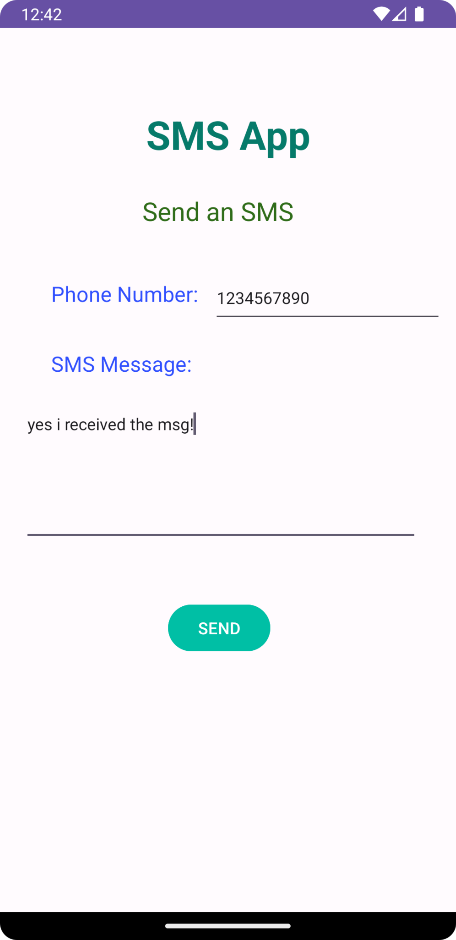 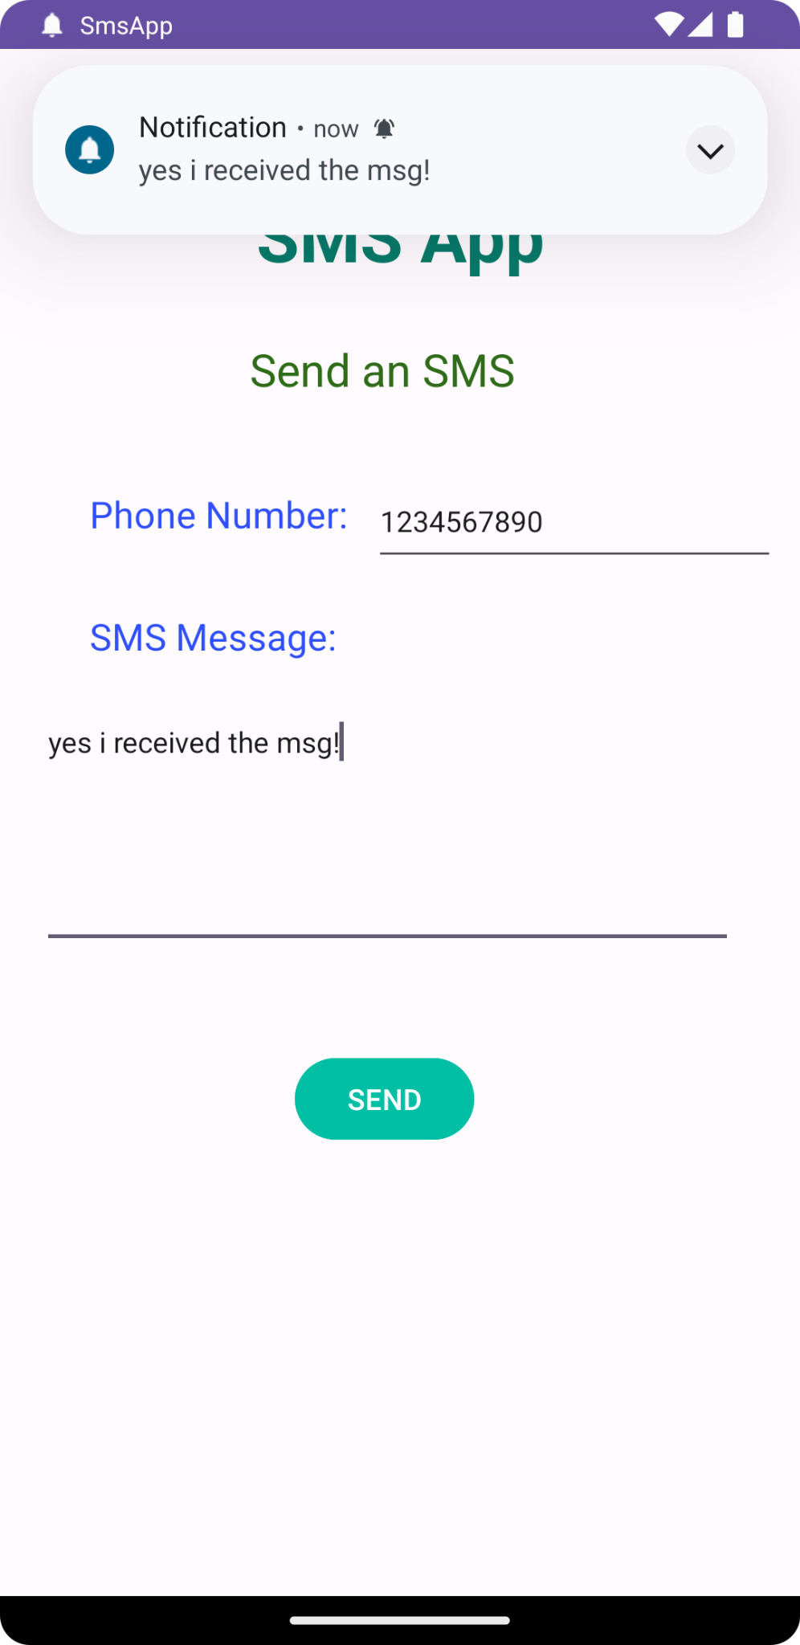 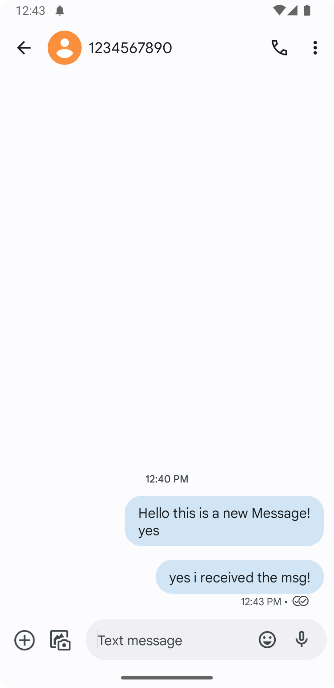

**Best Practices followed :**

1. Names for ids of buttons were set meaningfully
2. Implemented function to send the message
3. Handled exceptions

**Learning Outcomes :**

1. Learnt to integrate SMS feature into a mobile application
2. Learnt how to acquire user permission to send message
3. Learnt to send messages to a specific mobile number.

**Ex. No. 9 Menu driven Android Application**

**Objective :**

Develop a menu driven Android Application to simulate an online shopping app

**Android widgets used :**

1. TextView - to display contents
2. Menu Items - to display a menu in the application

**Source Code:**

**activity_main.xml**

<?xml version="1.0" encoding="utf-8"?>

<androidx.drawerlayout.widget.DrawerLayout xmlns:android="http://schemas.android.com/apk/res/android"

xmlns:app="http://schemas.android.com/apk/res-auto"

xmlns:tools="http://schemas.android.com/tools"

android:id="@+id/drawer_layout"

android:layout_width="match_parent"

android:layout_height="match_parent"

android:fitsSystemWindows="true"

tools:openDrawer="start">

<include

android:id="@+id/app_bar_main"

layout="@layout/app_bar_main"

android:layout_width="match_parent"

android:layout_height="match_parent" />

<com.google.android.material.navigation.NavigationView

android:id="@+id/nav_view"

android:layout_width="wrap_content"

android:layout_height="match_parent"

android:layout_gravity="start"

android:fitsSystemWindows="true"

app:headerLayout="@layout/nav_header_main"

app:menu="@menu/activity_main_drawer" />

</androidx.drawerlayout.widget.DrawerLayout>

**MainActivity.java**

package com.example.exercise9;

import android.os.Bundle;

import android.view.View;

import android.view.Menu;

import com.google.android.material.snackbar.Snackbar;

import com.google.android.material.navigation.NavigationView;

import androidx.navigation.NavController;

import androidx.navigation.Navigation;

import androidx.navigation.ui.AppBarConfiguration;

import androidx.navigation.ui.NavigationUI;

import androidx.drawerlayout.widget.DrawerLayout;

import androidx.appcompat.app.AppCompatActivity;

import com.example.exercise9.databinding.ActivityMainBinding;

public class MainActivity extends AppCompatActivity {

private AppBarConfiguration mAppBarConfiguration;

private ActivityMainBinding binding;

@Override

protected void onCreate(Bundle savedInstanceState) {

super.onCreate(savedInstanceState);

binding = ActivityMainBinding.inflate(getLayoutInflater());

setContentView(binding.getRoot());

setSupportActionBar(binding.appBarMain.toolbar);

binding.appBarMain.fab.setOnClickListener(new View.OnClickListener() {

@Override

public void onClick(View view) {

Snackbar.make(view, "Replace with your own action", Snackbar.LENGTH_LONG)

.setAction("Action", null).show();

}

});

DrawerLayout drawer = binding.drawerLayout;

NavigationView navigationView = binding.navView;

// Passing each menu ID as a set of Ids because each

// menu should be considered as top level destinations.

mAppBarConfiguration = new AppBarConfiguration.Builder(

R.id.nav_home, R.id.nav_gallery, R.id.nav_slideshow)

.setOpenableLayout(drawer)

.build();

NavController navController = Navigation.findNavController(this, R.id.nav_host_fragment_content_main);

NavigationUI.setupActionBarWithNavController(this, navController, mAppBarConfiguration);

NavigationUI.setupWithNavController(navigationView, navController);

}

@Override

public boolean onCreateOptionsMenu(Menu menu) {

// Inflate the menu; this adds items to the action bar if it is present.

getMenuInflater().inflate(R.menu.main, menu);

return true;

}

@Override

public boolean onSupportNavigateUp() {

NavController navController = Navigation.findNavController(this, R.id.nav_host_fragment_content_main);

return NavigationUI.navigateUp(navController, mAppBarConfiguration)

|| super.onSupportNavigateUp();

}

}

**Activity_main_drawer.xml**

<?xml version="1.0" encoding="utf-8"?>

<menu xmlns:android="http://schemas.android.com/apk/res/android"

xmlns:tools="http://schemas.android.com/tools"

tools:showIn="navigation_view">

<group android:checkableBehavior="single">

<item

android:id="@+id/nav_home"

android:icon="@drawable/ic_menu_pastry"

android:title="@string/menu_home" />

<item

android:id="@+id/nav_gallery"

android:icon="@drawable/ic_menu_vege"

android:title="@string/menu_gallery" />

<item

android:id="@+id/nav_slideshow"

android:icon="@drawable/ic_menu_beverage"

android:title="@string/menu_slideshow" />

</group>

</menu>

**main.xml**

<?xml version="1.0" encoding="utf-8"?>

<menu xmlns:android="http://schemas.android.com/apk/res/android"

xmlns:app="http://schemas.android.com/apk/res-auto">

<item

android:id="@+id/action_home"

android:orderInCategory="100"

android:title="@string/action_home"

app:showAsAction="never" />

<item android:id="@+id/acc"

android:orderInCategory="100"

android:title="@string/action_acc"

app:showAsAction="never" />

<item android:id="@+id/bas"

android:orderInCategory="100"

android:title="@string/action_bas"

app:showAsAction="never" />

<item android:id="@+id/sbc"

android:orderInCategory="100"

android:title="@string/action_sbc"

app:showAsAction="never" />

<item android:id="@+id/offer"

android:orderInCategory="100"

android:title="@string/action_offer"

app:showAsAction="never" />

<item android:id="@+id/faq"

android:orderInCategory="100"

android:title="@string/action_faq"

app:showAsAction="never" />

</menu>

**Output Screenshots:**

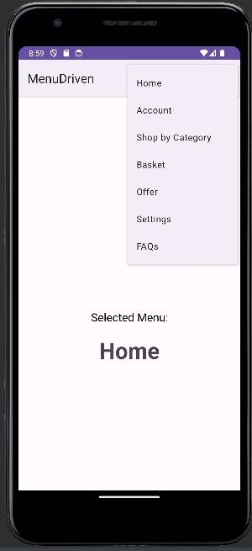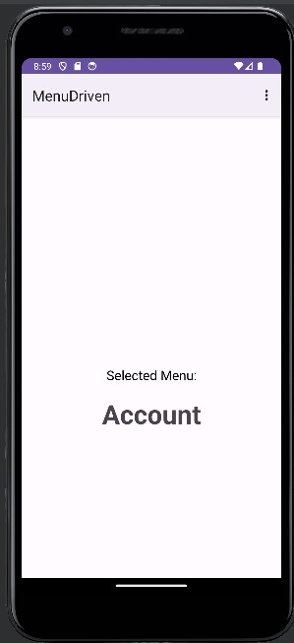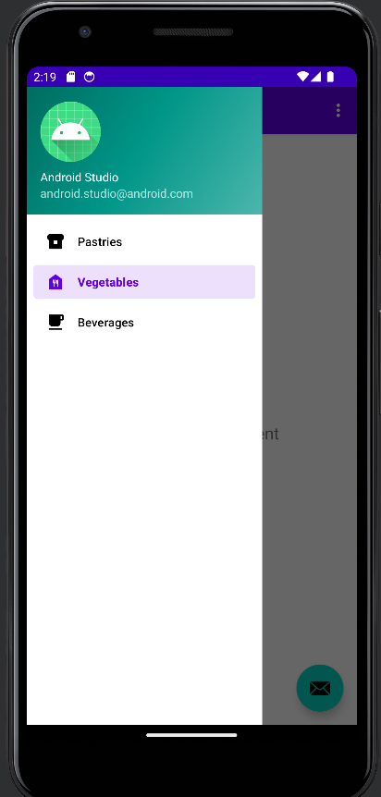

**Best Practices followed :**

1. Keep the index form clean and uncluttered.

2. Use of self explanatory variable names.

3. Ensure the form works on various mobile devices.

**Learning Outcomes :**

1. Learnt how to use UI Elements for Android App development.

2. Learnt how to implement menus in android application

3. Learnt to implement sidebar in android application

**Ex. No. 10 Alarm Clock - Android Application**

**Objective :**

To develop an Alarm Clock Android Application.

1. Use permission for WAKE_LOCK.

2. Have a TimePicker component followed by a ToggleButton to select time and Alarm On / Off. 3. Use the AlarmManager to set the alarm and send notification on alarm trigger.

4. Perform 3 different notifications

a. Show a message to user in the activity UI

b. Play the alarm ringtone

c. Send an Android notification message

**Android widgets used :**

1. TimePicker - to get time as input
2. Button - to set alarm
3. TextView - to label

**Source Code:**

**AndroidManifest.xml**

<?xml version="1.0" encoding="utf-8"?>

<manifest xmlns:android="http://schemas.android.com/apk/res/android" xmlns:tools="http://schemas.android.com/tools">

<uses-permission android:name="android.permission.POST_NOTIFICATIONS" /> <uses-permission android:name="android.permission.WAKE_LOCK" /> <uses-permission android:name="android.permission.VIBRATE" />

<application

android:allowBackup="true"

android:dataExtractionRules="@xml/data_extraction_rules"

android:fullBackupContent="@xml/backup_rules"

android:icon="@mipmap/ic_launcher"

android:label="@string/app_name"

android:roundIcon="@mipmap/ic_launcher_round"

android:supportsRtl="true"

android:theme="@style/Theme.Alarm"

tools:targetApi="31">

<activity

android:name=".MainActivity"

android:exported="true">

<intent-filter>

<action android:name="android.intent.action.MAIN" />

<category android:name="android.intent.category.LAUNCHER" /> </intent-filter>

</activity>

<activity android:name=".In" android:exported="false" />

<receiver android:name=".AlarmReceiver" />

</application>

</manifest>

**Activity_main.xml**

<?xml version="1.0" encoding="utf-8"?>

<RelativeLayout xmlns:android="http://schemas.android.com/apk/res/android" xmlns:app="http://schemas.android.com/apk/res-auto"

xmlns:tools="http://schemas.android.com/tools"

android:layout_width="match_parent"

android:layout_height="match_parent"

tools:context=".MainActivity">

<TimePicker

android:layout_width="wrap_content"

android:layout_height="wrap_content"

android:id="@+id/time"

/>

<ToggleButton

android:id="@+id/set"

android:layout_width="150dp"

android:layout_height="50dp"

android:layout_below="@+id/time"

android:layout_marginLeft="130dp"

/>

</RelativeLayout>

**Display.xml**

<?xml version="1.0" encoding="utf-8"?>

<androidx.constraintlayout.widget.ConstraintLayout

xmlns:android="http://schemas.android.com/apk/res/android"

xmlns:app="http://schemas.android.com/apk/res-auto"

android:layout_width="match_parent"

android:layout_height="match_parent">

<TextView

android:id="@+id/textView"

android:layout_width="wrap_content"

android:layout_height="wrap_content"

android:text="Close App to turn off alarm!"

android:padding="50dp"

android:textSize="20dp"

app:layout_constraintStart_toStartOf="parent"

app:layout_constraintTop_toTopOf="parent" />

</androidx.constraintlayout.widget.ConstraintLayout>

**MainActivity.java**

package com.example.alarm;

import androidx.appcompat.app.AppCompatActivity;

import android.app.AlarmManager;

import android.app.NotificationChannel;

import android.app.NotificationManager;

import android.app.PendingIntent;

import android.content.Intent;

import android.os.Build;

import android.os.Bundle;

import android.text.format.Time;

import android.view.View;

import android.widget.Button;

import android.widget.TimePicker;

import android.widget.Toast;

import android.widget.ToggleButton;

import com.example.alarm.databinding.ActivityMainBinding;

import java.util.Calendar;

public class MainActivity extends AppCompatActivity {

private ActivityMainBinding binding;

@Override

protected void onCreate(Bundle savedInstanceState) {

super.onCreate(savedInstanceState);

setContentView(R.layout.activity_main);

binding = ActivityMainBinding.inflate(getLayoutInflater()); setContentView(binding.getRoot());

createNotificationChannel();

ToggleButton b1 = findViewById(R.id.set);

TimePicker t1 = findViewById(R.id.time);

t1.setIs24HourView(true);

b1.setOnCheckedChangeListener((buttonView, isChecked) -> {

if (isChecked) {

setAlarm();

} else {

cancelAlarm();

}

});

}

private void createNotificationChannel() {

if(Build.VERSION.SDK_INT >= Build.VERSION_CODES.O) {

CharSequence name = "alarm";

String desc = "Channel for alarm";

int importance = NotificationManager.IMPORTANCE_HIGH;

NotificationChannel channel = new NotificationChannel("alarm", name, importance);

channel.setDescription(desc);

NotificationManager notifs =

getSystemService(NotificationManager.class);

notifs.createNotificationChannel(channel);

}

}

public void setAlarm() {

TimePicker timePicker = findViewById(R.id.time);

AlarmManager alarm = (AlarmManager) getSystemService(ALARM_SERVICE);

Intent intent = new Intent(this, AlarmReceiver.class);

PendingIntent pendingIntent =

PendingIntent.getBroadcast(this.getApplicationContext(), 234, intent, PendingIntent.FLAG_IMMUTABLE);

int hour = timePicker.getHour();

int minute = timePicker.getMinute();

Calendar calendar = Calendar.getInstance();

calendar.set(Calendar.HOUR_OF_DAY, hour);

calendar.set(Calendar.MINUTE, minute);

calendar.set(Calendar.SECOND, 0);

long triggerTime = calendar.getTimeInMillis();

int timeInSec = 1;

alarm.set(AlarmManager.RTC_WAKEUP, triggerTime, pendingIntent); Toast.makeText(this, "Alarm set for " + hour + ":" + minute, Toast.LENGTH_SHORT).show();

}

public void cancelAlarm() {

AlarmManager alarm = (AlarmManager) getSystemService(ALARM_SERVICE);

Intent intent = new Intent(this, AlarmReceiver.class);

PendingIntent pendingIntent =

PendingIntent.getBroadcast(this.getApplicationContext(), 234, intent, PendingIntent.FLAG_IMMUTABLE);

if(alarm != null) {

alarm.cancel(pendingIntent);

}

Toast.makeText(this, “Alarm unset!", Toast.LENGTH_SHORT).show();

}

}

**AlarmReciever.java**

package com.example.alarm;

import static androidx.core.content.ContextCompat.startActivity;

import android.app.AlarmManager;

import android.app.Notification;

import android.app.NotificationChannel;

import android.app.NotificationManager;

import android.app.PendingIntent;

import android.content.BroadcastReceiver;

import android.content.Context;

import android.content.Intent;

import android.content.pm.PackageManager;

import android.media.Ringtone;

import android.media.RingtoneManager;

import android.net.Uri;

import android.os.Build;

import android.widget.Toast;

import androidx.appcompat.app.AppCompatActivity;

import androidx.core.app.ActivityCompat;

import androidx.core.app.NotificationCompat;

import androidx.core.app.NotificationManagerCompat;

public class AlarmReceiver extends BroadcastReceiver {

static Uri alarmrt1 =

RingtoneManager.getDefaultUri(RingtoneManager.TYPE_ALARM);

@Override

public void onReceive(Context context, Intent intent) {

Toast.makeText(context, "INSIDE WOHOOO", Toast.LENGTH_LONG).show();

Intent i = new Intent(context, In.class);

intent.setFlags(Intent.FLAG_ACTIVITY_NEW_TASK |

Intent.FLAG_ACTIVITY_CLEAR_TASK);

PendingIntent p = PendingIntent.getActivity(context, 0, i, PendingIntent.FLAG_IMMUTABLE);

NotificationCompat.Builder builder = new

NotificationCompat.Builder(context, "alarm")

.setSmallIcon(R.drawable.ic_launcher_foreground)

.setContentTitle("Your Alarm is going off!!!")

.setContentInfo("You set this alarm!")

.setAutoCancel(true)

.setDefaults(NotificationCompat.DEFAULT_ALL)

.setPriority(NotificationCompat.PRIORITY_HIGH)

.setContentIntent(p);

NotificationManagerCompat notifications =

NotificationManagerCompat.from(context);

if (ActivityCompat.checkSelfPermission(context,

android.Manifest.permission.POST_NOTIFICATIONS) !=

PackageManager.PERMISSION_GRANTED) {

return;

}

else {

notifications.notify(123, builder.build());

}

Ringtone ringtone =

RingtoneManager.getRingtone(context.getApplicationContext(), alarmrt1);

intent.putExtra("RINGTONE_URI", alarmrt1);

ringtone.play();

}

public static Uri getInstant() {

return alarmrt1;

}

}

**In.java**

package com.example.alarm;

import android.content.Intent;

import android.media.Ringtone;

import android.media.RingtoneManager;

import android.net.Uri;

import android.os.Bundle;

import android.widget.Toast;

import androidx.appcompat.app.AppCompatActivity;

public class In extends AppCompatActivity {

@Override

protected void onCreate(Bundle savedInstanceState) {

super.onCreate(savedInstanceState);

setContentView(R.layout.display);

Intent intent = getIntent();

Uri ringtoneUri = intent.getParcelableExtra("RINGTONE_URI"); Ringtone ringtone = RingtoneManager.getRingtone(In.this, ringtoneUri);

if (ringtone.isPlaying()) {

Toast.makeText(In.this, "yes", Toast.LENGTH_SHORT).show(); ringtone.stop();

}

else {

Toast.makeText(In.this, "no", Toast.LENGTH_SHORT).show();

}

}

}

**Output Screenshots:**

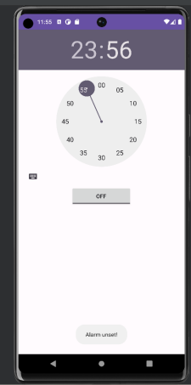 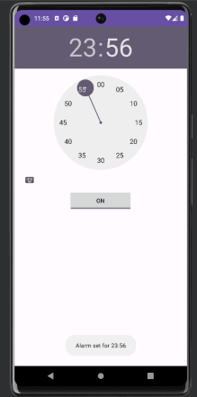

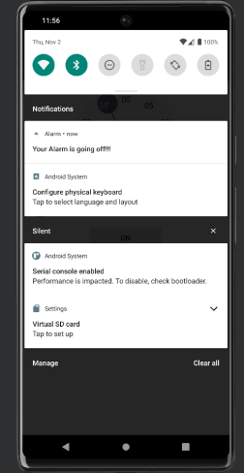 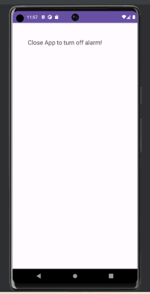

**Best Practices followed :**

1. Keep the index form clean and uncluttered.

2. Use default ringtone as it is known by everyone.

3. Ensure the form works on various mobile devices.

**Learning Outcomes :**

1. Learnt how to use UI Elements for Android App development.

2. Learnt how to use Phone shared storage.

3. Learnt how to play rigtones in mobile.

**Ex. No. 11 Hybrid mobile App**

**Objective :**

To Develop an android application to display a static web page with contents that uses all

formatting HTML tags. Also should load and display the contents of url specified.

**Android widgets used :**

1. LinearLayout - to arrange multiple fields
2. TextView - to display label of URL
3. EditText - to input url from user
4. Button - to get contents from URL specified.

**Source Code:**

**Activity_main.xml**

<?xml version="1.0" encoding="utf-8"?>

<LinearLayout xmlns:android="http://schemas.android.com/apk/res/android"

xmlns:app="http://schemas.android.com/apk/res-auto"

xmlns:tools="http://schemas.android.com/tools"

android:layout_width="match_parent"

android:layout_height="match_parent"

android:padding="10dp"

tools:context=".MainActivity">

<LinearLayout

android:layout_width="match_parent"

android:layout_height="match_parent"

android:orientation="vertical">

<LinearLayout

android:layout_width="match_parent"

android:layout_height="wrap_content"

android:orientation="horizontal">

<TextView

android:id="@+id/textView"

android:layout_width="60dp"

android:layout_height="wrap_content"

android:paddingBottom="10dp"

android:paddingLeft="15dp"

android:textStyle="bold"

android:text="URL:" />

<EditText

android:id="@+id/url"

android:layout_width="237dp"

android:layout_height="wrap_content"

android:layout_weight="1"

android:ems="10"

android:inputType="text" />

<Button

android:id="@+id/load"

android:layout_width="wrap_content"

android:layout_height="wrap_content"

android:layout_weight="1"

android:text="GET" />

</LinearLayout>

<WebView

android:id="@+id/webView"

android:layout_width="match_parent"

android:layout_height="match_parent">

</WebView>

</LinearLayout>

</LinearLayout>

**MainActivity.java**

package com.example.webpage;

import androidx.appcompat.app.AppCompatActivity;

import android.os.Bundle;

import android.view.View;

import android.webkit.WebView;

import android.webkit.WebViewClient;

import android.widget.Button;

import android.widget.EditText;

public class MainActivity extends AppCompatActivity {

private WebView webView;

private EditText url;

private Button getButton;

@Override

protected void onCreate(Bundle savedInstanceState) {

super.onCreate(savedInstanceState);

setContentView(R.layout.activity_main);

webView = findViewById(R.id.webView);

url = findViewById(R.id.url);

getButton = findViewById(R.id.load);

webView.getSettings().setJavaScriptEnabled(true);

// Load static HTML content

String staticHtml = "<html>\n" +

"<body>\n" +

"\n" +

"<h1 style=\"color:red; font-family:sans-serif\">This is a HTML" +

"Site</h1>\n" +

"\n" +

"<p style=\"color:red;\">A red paragraph.</p>\n" +

"\n" +

"<h2>An Unordered HTML List</h2>\n" +

"\n" +

"<ul>\n" +

" <li>MAD lab</li>\n" +

" <li>GML lab</li>\n" +

" <li>SNA lab</li>\n" +

"</ul>\n" +

"\n" +

"</body>\n" +

"</html>";

webView.loadData(staticHtml, "text/html", "UTF-8");

webView.setWebViewClient(new WebViewClient()

{

@Override

public boolean shouldOverrideUrlLoading(WebView view, String url)

{

//view.loadUrl(url);

System.out.println("hello");

return false;

}

});

getButton.setOnClickListener(new View.OnClickListener() {

@Override

public void onClick(View v) {

webView.loadUrl("https://" + url.getText().toString());

}

});

}

}

**AndroidManifest.xml**

<uses-permission android:name="android.permission.INTERNET"/>

**Output Screenshots:**

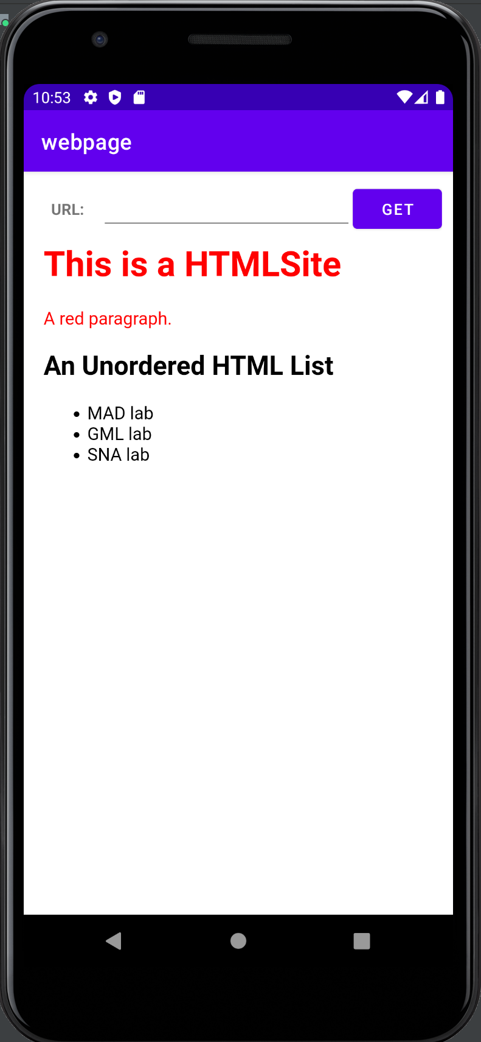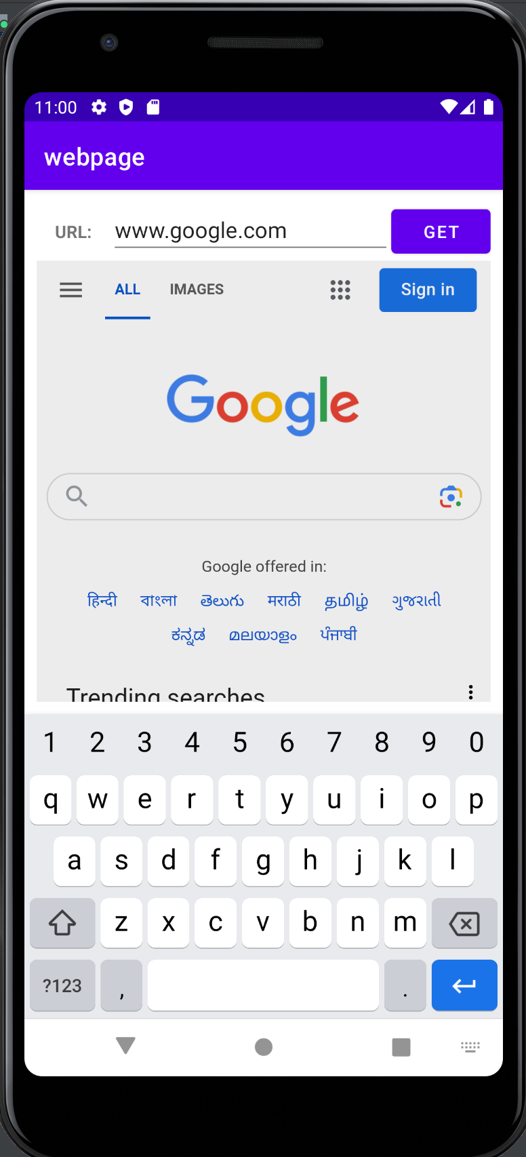

**Best Practices followed :**

1. Self explaining method names have been used.
2. Handled exceptions of content unavailable.
3. Variables with suitable names have been used.
4. Modular functions implemented to retrieve information from web.

**Learning Outcomes :**

1. Learnt to access internet.
2. Learnt how to parse URLs.
3. Learnt how to display web contents in mobile phone.